Name

Mathematics Advanced Year 11
Trigonometry with
Angles of any Magnitude

Book 1 |  | Version: 261020  Feedback:  https://MrDingMaths.com
Contents
Syllabus Content 2
Learning Intention 3

Syllabus Content
MAV-11-04 applies trigonometry to solve problems involving geometric shapes
Trigonometry with angles of any magnitude
- Represent angles of any magnitude using rays from the origin in the Cartesian plane and describe how one ray represents infinitely many angles
- Develop the definitions $\cos{θ}=\frac{x}{r}$, $\sin{θ}=\frac{y}{r}$ and $\tan{θ}=\frac{y}{x}$, where $(x,y)$ is a point on the circle of radius $r$, centred at the origin, and $θ$ is the angle between the positive $x$-axis and the radius drawn to this point
- Use the definitions $\cos{θ}=\frac{x}{r}$, $\sin{θ}=\frac{y}{r}$ and $\tan{θ}=\frac{y}{x}$ to evaluate $\sin{θ}$, $\cos{θ}$ and $\tan{θ}$ where $θ$ is a multiple of $90°$, and identify the values of $θ$ for which these ratios are undefined
- Extend and apply the definitions $\cos{θ}=\frac{x}{r}$, $\sin{θ}=\frac{y}{r}$ and $\tan{θ}=\frac{y}{x}$ for angles of any magnitude
- Identify the related angle of an angle of any magnitude, excluding multiples of $90°$, as the acute angle between the ray and the $x$-axis and obtain the values of the trigonometric functions of an angle of any magnitude from the trigonometric functions of the related angle
- Develop and use the trigonometric ratios for angles that can be written in the form $θ=180°±A$, and $θ=360°-A$, where $0°<A<90°$
- Establish and use the results $\cos{(-θ)}=\cos{θ}$, $\sin{(-θ)}=-\sin{θ}$ and $\tan{(-θ)}=-\tan{θ}$
- Examine the proof of the sine rule $\frac{a}{\sin{A}}=\frac{b}{\sin{B} }=\frac{c}{\sin{C}}$ , cosine rule $c^{2}=a^{2}+b^{2}-2ab\cos{C}$ and the area of a triangle formula $A=\frac{1}{2}ab\sin{C}$ for a given triangle $ABC$
- Use graphing applications or geometric construction to examine the ambiguous case of the sine rule, in which there are two possible solutions for an angle, and the condition for it to arise
- Apply the sine rule, cosine rule and formula for the area of a triangle to solve problems where angles are measured in degrees, or degrees and minutes

Exact Values of Trigonometric Ratios (Acute Angles)

- Investigation Exact values for 45°
Consider a unit square cut in half along the diagonal.
- Label the sides and angles of the triangle. | - Determine the exact values of$:$  $$\sin{45°}=$$  $$\cos{45°}=$$  $$\tan{45°}=$$
Consider a unit equilateral triangle cut in half along the altitude.
- Label the sides and angles of the triangle. | - Determine the exact values of:
  $$\sin{30°}=$$  $$\cos{30°}=$$  $$\tan{30°}=$$ | $$\sin{60°}=$$  $$\cos{60°}=$$  $$\tan{60°}=$$
Consider a right-angled triangle with the two non-right angles $=0°$ and $=90°$.
- A triangle doesn’t exist when an angle is $0°$, we are finding the values of the ratios.
Determine the exact values of:
$$\sin{0°}=$$  $$\cos{0°}=$$  $$\tan{0°}=$$ | $$\sin{90°}=$$  $$\cos{90°}=$$  $$\tan{90°}=$$

- Exact Values of the Trigonometric Ratios (0° 30° 45° 60° 90°)
 | $$0°$$ | $$30°$$ | $$45°$$ | $$60°$$ | $$90°$$
$$\sin{θ}$$ | 0 | $$\frac{1}{2}$$ | $$\frac{1}{\sqrt{2}}$$ | $$\frac{\sqrt{3}}{2}$$ | 1
$$\cos{θ}$$ | 1 | $$\frac{\sqrt{3}}{2}$$ | $$\frac{1}{\sqrt{2}}$$ | $$\frac{1}{2}$$ | 0
$$\tan{θ}$$ | 0 | $$\frac{1}{\sqrt{3}}$$ | $$1$$ | $$\sqrt{3}$$ | undefined

- You must memorise these exact values and be able to recall them quickly.

Foundation
- Complete the table.
 | $$0°$$ | $$30°$$ | $$45°$$ | $$60°$$ | $$90°$$
$$\sin{θ}$$ | 0 | $$\frac{1}{2}$$ | $$\frac{1}{\sqrt{2}}$$ | $$\frac{\sqrt{3}}{2}$$ | 1
$$\cos{θ}$$ | 1 | $$\frac{\sqrt{3}}{2}$$ | $$\frac{1}{\sqrt{2}}$$ | $$\frac{1}{2}$$ | 0
$$\tan{θ}$$ | 0 | $$\frac{1}{\sqrt{3}}$$ | $$1$$ | $$\sqrt{3}$$ | undefined

- State the exact value of the following.
- $\cos{60°}$  $$\frac{1}{2}$$ | - $\tan{30°}$  $$\frac{1}{\sqrt{3}}$$ | - $\sin{60°}$  $$\frac{\sqrt{3}}{2}$$ | - $\cos{30°}$  $$\frac{\sqrt{3}}{2}$$
- $\tan{60°}$  $$\sqrt{3}$$ | - $\sin{30°}$  $$\frac{1}{2}$$ | - $\cos{60°}$  $$\frac{1}{2}$$ | - $\tan{30°}$  $$\frac{1}{\sqrt{3}}$$
- $\sin{30°}$  $$\frac{1}{2}$$ | - $\cos{30°}$  $$\frac{\sqrt{3}}{2}$$ | - $\tan{60°}$  $$\sqrt{3}$$ | - $\sin{60°}$  $$\frac{\sqrt{3}}{2}$$
- $\cos{60°}$  $$\frac{1}{2}$$ | - $\tan{30°}$  $$\frac{1}{\sqrt{3}}$$ | - $\sin{30°}$  $$\frac{1}{2}$$ | - $\cos{30°}$  $$\frac{\sqrt{3}}{2}$$

- State the exact value of the following.
- $\cos{45°}$  $$\frac{1}{\sqrt{2}}$$ | - $\tan{0°}$  $$0$$ | - $\sin{90°}$  $$1$$ | - $\cos{0°}$  $$1$$
- $\tan{45°}$  $$1$$ | - $\sin{45°}$  $$\frac{1}{\sqrt{2}}$$ | - $\cos{90°}$  $$0$$ | - $\tan{90°}$  0
- $\sin{0°}$  $$0$$ | - $\tan{0°}$  $$0$$ | - $\cos{45°}$  $$\frac{1}{\sqrt{2}}$$ | - $\sin{45°}$  $$\frac{1}{\sqrt{2}}$$
- $\tan{45°}$  $$1$$ | - $\sin{90°}$  $$1$$ | - $\cos{0°}$  $$1$$ | - $\cos{45°}$  $$\frac{1}{\sqrt{2}}$$

- State the exact value of the following.
- $\sin{0°}$  0 | - $\cos{30°}$  $$\frac{\sqrt{3}}{2}$$ | - $\sin{45°}$  $$\frac{1}{\sqrt{2}}$$ | - $\cos{60°}$  $$\frac{1}{2}$$
- $\sin{30°}$  $$\frac{1}{2}$$ | - $\tan{90°}$  undefined | - $\sin{90°}$  1 | - $\sin{30°}$  $$\frac{1}{2}$$
- $\tan{60°}$  $$\sqrt{3}$$ | - $\cos{45°}$  $$\frac{1}{\sqrt{2}}$$ | - $\cos{60°}$  $$\frac{1}{2}$$ | - $\tan{0°}$  1
- $\tan{0°}$  0 | - $\cos{0°}$  1 | - $\cos{90°}$  0 | - $\cos{90°}$  0
- $\tan{30°}$  $$\frac{1}{\sqrt{3}}$$ | - $\tan{45°}$  $$1$$ | - $\tan{60°}$  $$\sqrt{3}$$ | - $\sin{90°}$  1
- $\tan{45°}$  $$1$$ | - $\cos{45°}$  $$\frac{1}{\sqrt{2}}$$ | - $\sin{60°}$  $$\frac{\sqrt{3}}{2}$$ | - $\tan{90°}$  undefined
- $\tan{60°}$  $$\sqrt{3}$$ | - $\sin{30°}$  $$\frac{1}{2}$$ | - $\cos{45°}$  $$\frac{1}{\sqrt{2}}$$ | - $\tan{60°}$  $$\sqrt{3}$$

- Find the lengths of the sides labelled with letters in exact form.
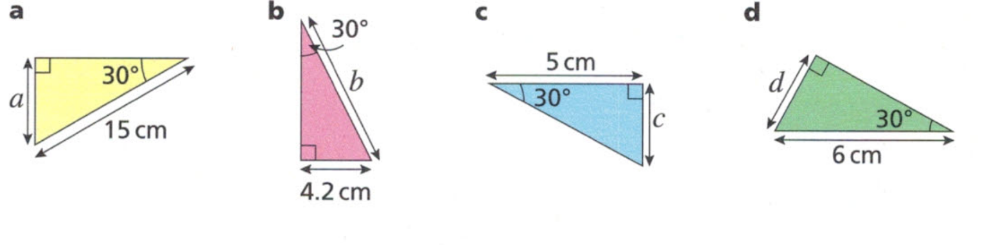  $$\sin{30°}=\frac{1}{2}=\frac{a}{15}$$  $$a=7.5 cm$$ | $$\sin{30°}=\frac{1}{2}=\frac{4.2}{b}$$  $$b=8.4 cm$$ | $$\tan{30°}=\frac{1}{\sqrt{3}}=\frac{c}{5}$$  $$c=\frac{5}{\sqrt{3}} cm$$ | $$\sin{30°}=\frac{1}{2}=\frac{d}{6},$$  $$d=3 cm$$

Development
- Find the exact value of $x$ in each diagram. No calculators required.
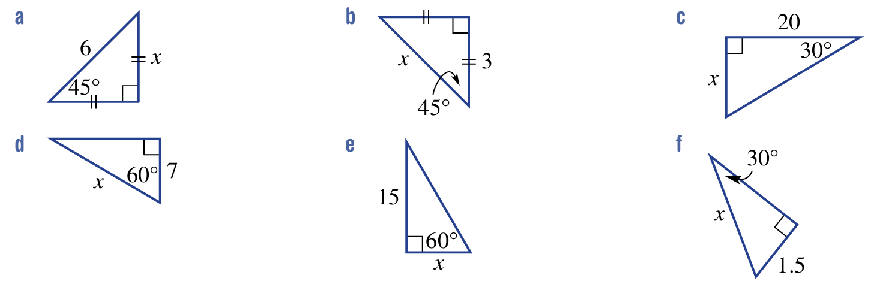  $$3\sqrt{2}$$ | $$3\sqrt{2}$$ | $$\frac{20\sqrt{3}}{3}$$
14 | $$5\sqrt{3}$$ | 3

- Find the exact value of $θ$ in each diagram. No calculators required.
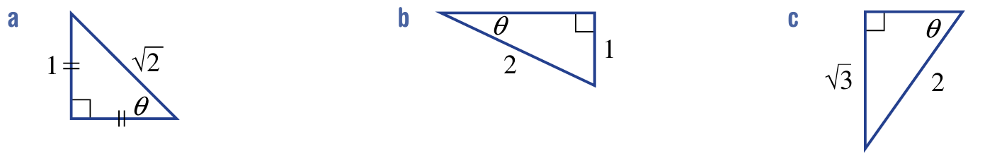  45° | 30° | 60°

- Find the exact value of $x$ in each diagram. No calculators required.
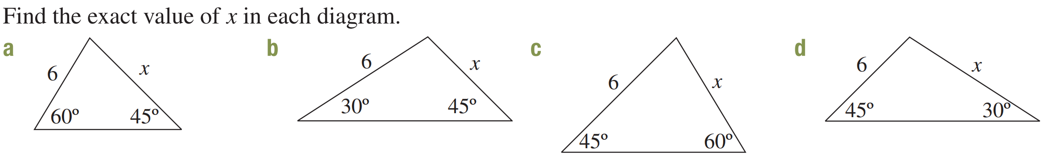  $$3\sqrt{6}$$ | $$3\sqrt{2}$$
$$2\sqrt{6}$$ | $$6\sqrt{2}$$

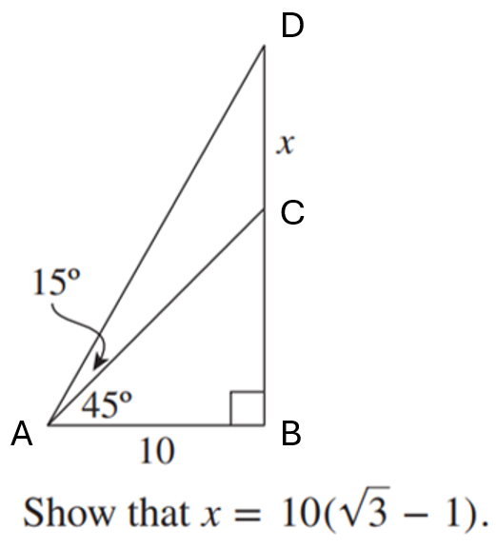  $$\tan{60°}=\frac{BD}{10} \\ BD=10\tan{60°} \\ =10\sqrt{3} \\ \tan{45°}=\frac{BC}{10} \\ BC=10\tan{45°} \\ =10 \\ x=BD-BC \\ =10\sqrt{3}-10 \\ =10\left(\sqrt{3}-1\right)$$ | 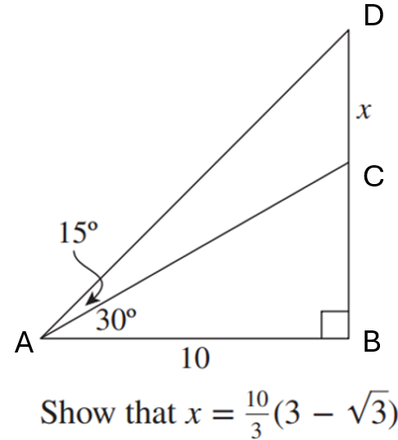  $$\tan{45°}=\frac{BD}{10} \\ BD=10\tan{45°} \\ =10 \\ \tan{30°}=\frac{BC}{10} \\ BC=10\tan{30°} \\ =\frac{10}{\sqrt{3}} \\ x=BD-BC \\ =\frac{10}{3}\left(3-\sqrt{3}\right)$$ | 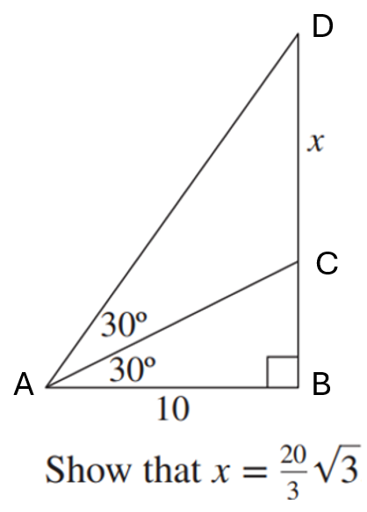  $$\tan{60°}=\frac{BD}{10} \\ BD=10\tan{60°} \\ =10\sqrt{3} \\ \tan{30°}=\frac{BC}{10} \\ BC=10\tan{30°} \\ =\frac{10}{\sqrt{3}} \\ x=BC-BC \\ =10\sqrt{3}-\frac{10}{\sqrt{3}} \\ =10\sqrt{3}-\frac{10\sqrt{3}}{3} \\ =\frac{20\sqrt{3}}{3}$$

- Find the exact value of:
- $\sin{45°}+\cos{30°}$  $$\frac{\sqrt{2}+\sqrt{3}}{2}$$ | - $\cos{45°}+\sin{60°}$  $$\frac{\sqrt{2}+\sqrt{3}}{2}$$
- $\sin{45°}\cos{45°}+\sin{30°}$  1 | - $\sin{60°}\cos{30°}-\cos{60°}\sin{30°}$  $$\frac{1}{2}$$
- $1+\tan^{2}{60°}$  4 | - $\frac{1}{\sin^{2}{30°}}-\frac{1}{\tan^{2}{30°}}$  1

- Find the exact value of $x$ in these diagrams.
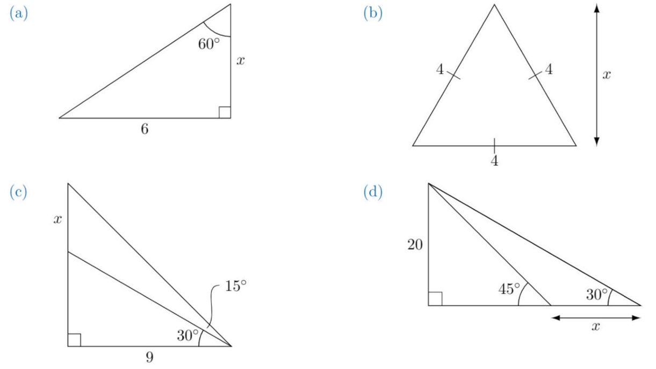  $$2\sqrt{3}$$ | $$2\sqrt{3}$$
$$9-3\sqrt{3}$$ | $$20\sqrt{3}-20$$

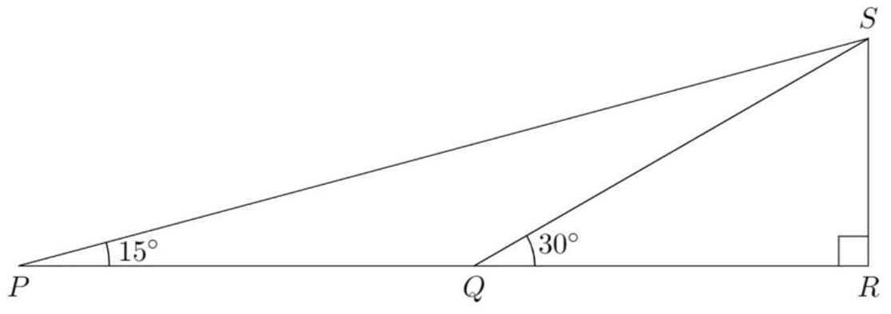
- Consider the diagram.
  - Show that $PQ=QS$
  - Given that the length of $SR$ is 1 unit,
write the lengths of $QR,QS,$ and $PQ$
  - Deduce that $\tan{15°}=2-\sqrt{3}$

$$a) ∠PQS=150° \left(angles on a straight line\right)$$
$∠PSQ=180-150-15=15°$
$$∴PQ=QS \left(sides opposite equal angles in isosceles triangles equal\right)$$
$$b) \sin{30°}=\frac{1}{2}=\frac{SR}{SQ}=\frac{1}{SQ}, ∴SQ=2, PQ=2$$
$$\tan{30°}=\frac{1}{\sqrt{3}}=\frac{1}{QR}, ∴QR=\sqrt{3}$$
$$c)\tan{15°}=\frac{SR}{PQ}=\frac{1}{2+\sqrt{3}} \frac{×2-\sqrt{3}}{×2-\sqrt{3}}=2-\sqrt{3}$$

Mastery
- Show that:
- $2\sin{30°}\cos{30°}=\sin{60°}$  $$LHS=2\left(\frac{1}{2}\right)\left(\frac{\sqrt{3}}{2}\right) \\ =\frac{2\sqrt{3}}{4} \\ =\frac{\sqrt{3}}{2}=RHS$$ | - $\cos^{2}{60°}-\cos^{2}{30°}=-$ $\frac{1}{2}$  $$LHS={\left(\frac{1}{2}\right)}^{2}-{\left(\frac{\sqrt{3}}{2}\right)}^{2} \\ =\frac{1}{4}-\frac{3}{4} \\ =-\frac{2}{4} \\ =-\frac{1}{2}=RHS$$
- $\sin{60°}\cos{45°}-\cos{60°}\sin{45°}=$ $\frac{\sqrt{6}-\sqrt{2}}{4}$  $$LHS=\frac{\sqrt{3}}{2}×\frac{1}{\sqrt{2}}-\frac{1}{2}×\frac{1}{\sqrt{2}} \\ =\frac{\sqrt{3}-1}{2\sqrt{2}} \frac{×\sqrt{2}}{×\sqrt{2}} \\ =\frac{6-\sqrt{2}}{4}=RHS$$ | - $\frac{\tan{60°}-\tan{45°}}{1+\tan{60°}\tan{45°}}$ $=2-\sqrt{3}$  $$LHS=\frac{\sqrt{3}-1}{1+\sqrt{3}} \frac{×1-\sqrt{3}}{×1-\sqrt{3}} \\ =\frac{4-2\sqrt{3}}{2} \\ =2-\sqrt{3}=RHS$$
- $\frac{1}{\frac{1}{\cos{30°}} - \tan{30°}}=$ $\sqrt{3}$  $$LHS=\frac{1}{\left(\frac{2}{\sqrt{3}}-\frac{1}{\sqrt{3}}\right)} \\ =\frac{1}{\left(\frac{1}{\sqrt{3}}\right)} \\ =\sqrt{3}=RHS$$ | - $\frac{1+\tan{30°}}{1-\tan{30°}}$ $=2+\sqrt{3}$  $$LHS=\frac{\left(1+\frac{1}{\sqrt{3}}\right)}{\left(1-\frac{1}{\sqrt{3}}\right)} \\ =\frac{\left(\frac{\sqrt{3}+1}{\sqrt{3}}\right)}{\left(\frac{\sqrt{3}-1}{\sqrt{3}}\right)} \\ =\frac{\sqrt{3}+1}{\sqrt{3}-1} \frac{×\left(\sqrt{3}+1\right)}{×\left(\sqrt{3}+1\right)} \\ =\frac{4+2\sqrt{3}}{2} \\ =2+\sqrt{3}=RHS$$

- For this question, use the identity $\tan{2θ}=$ $\frac{2\tan{θ}}{1-\tan^{2}{θ}}$
  - Let $t=\tan{15°}.$ Show that $\frac{2t}{1-t^{2}}=\frac{1}{\sqrt{3}}$
  - Show that $t^{2}+2\sqrt{3}t-1=0$
  - Hence show that $\tan{15°}=2-\sqrt{3}$
  - Use a similar technique to find the exact value for $\tan{22.5°}.$

$$a) Let θ=15°, \tan{30°}=\frac{2\tan{15°}}{1-\tan^{2}{15°}}=\frac{1}{\sqrt{3}}$$
$$∴\frac{2t}{1-t^{2}}=\frac{1}{\sqrt{3}}$$
$$b) cross multiply$$
$$2\sqrt{3}t=1-t^{2}$$
$$∴t^{2}+2\sqrt{3}t-1=0$$
$$c) using quadratic for t$$
$$t=\frac{-2\sqrt{3}±\sqrt{12+4}}{2}$$
$$=-\sqrt{3}±2$$
$$∴\tan{15°}=-\sqrt{3}+2, \left(ignore negative as\tan{15°}>0\right)$$
$$d) \sqrt{2}-1$$
- For this question, use the identity $\cos{2θ}=1-2\sin^{2}{θ}$
  - Let $s=\sin{15°}$. Show that $s=$ $\frac{\sqrt{2-\sqrt{3}}}{2}$
  - Expand and simplify $\frac{{\left(\sqrt{3}-1\right)}^{2}}{2}$
  - Hence, show that $\sin{15°}=$ $\frac{\sqrt{3}-1}{2\sqrt{2}}$

$$a) Let θ=15°, \cos{30°}=\frac{\sqrt{3}}{2}=1-2\sin^{2}{15°}$$
$$\frac{\sqrt{3}}{2}=1-2s^{2}$$
$$2s^{2}=1-\frac{\sqrt{3}}{2}$$
$$2s^{2}=\frac{2-\sqrt{3}}{2}$$
$$s^{2}=\frac{2-\sqrt{3}}{4}$$
$$s=\frac{\sqrt{2-\sqrt{3}}}{2} \left(ignore negative as\sin{15°}>0\right)$$

$$b)\frac{{\left(\sqrt{3}-1\right)}^{2}}{2}= \frac{3-2\sqrt{3}+1}{2}=2-\sqrt{3}$$

$$c) s^{2}=\frac{2-\sqrt{3}}{4}=\frac{\left(\frac{{\left(\sqrt{3}-1\right)}^{2}}{2}\right)}{4}=\frac{{\left(\sqrt{3}-1\right)}^{2}}{8}$$
$$∴s=\frac{\sqrt{3}-1}{\sqrt{8}}=\frac{\sqrt{3}-1}{2\sqrt{2}}$$

Complementary Angle Identities

- Complementary Angle Identities
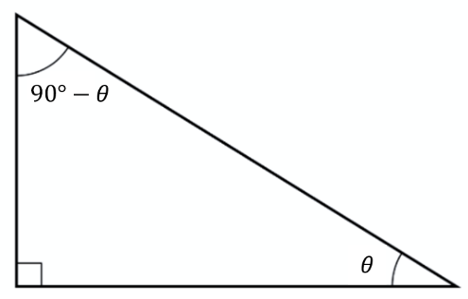
For an acute angle $θ,$ the sine of an angle equals the cosine of its complement.

$$\sin{θ}=\cos{(90°-θ)} \\ \cos{θ}=\sin{(90°-θ)}$$

- 'cosine’ is an abbreviation for ‘complement of sine’

- Convert between sine and cosine
$$\sin{10°}=\cos{80°}$$ | $$\sin{80°}=\cos{10°}$$ | $$\cos{72°}=\sin{18°}$$
Find the value of $θ$:
- $\sin{35°}=\cos{θ}$ | - $\sin{55°}=\cos{θ}$ | - $\cos{12°}=\sin{θ}$
- $\cos{15°}=\sin{θ}$ | - $\sin{89°}=\cos{θ}$ | - $\sin{θ}=\cos{θ}$

Foundation
- $θ$ is acute. Find its value.
- $\sin{10°}=\cos{θ}$  $$80°$$ | - $\sin{28°}=\cos{θ}$  $$62°$$ | - $\cos{54°}=\sin{θ}$  $$36°$$
- $\sin{59°}=\cos{θ}$  $$31°$$ | - $\cos{73°}=\sin{θ}$  $$17°$$ | - $\cos{83°}=\sin{θ}$  $$7°$$

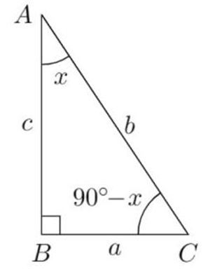
- Use the diagram to write a ratio for the following:
- $\sin{x}$  $$\frac{a}{b}$$ | - $\cos{x}$  $$\frac{c}{b}$$ | - $\tan{x}$  $$\frac{a}{c}$$
- $\sin\left(90-x\right)$  $$\frac{c}{b}$$ | - $\cos{(90-x)}$  $$\frac{a}{b}$$ | - $\tan\left(90-x\right)$  $$\frac{c}{a}$$

- What is the relationship between $\tan{x}$ and $\tan\left(90-x\right)?$

They are reciprocals of each other.
- Simplify without a calculator.
- $\cos{22°}-\sin{68°}$  $$0$$ | - $\frac{-\sin{57°}}{\cos{53°}}$  $$-1$$ | - $\frac{\cos{28°}+\sin{62°}}{\sin{62°}}$  $$2$$
- $\frac{\sin{20° }+\cos{70°}}{\sin{20°}}$  $$2$$ | - $\frac{\cos{42°}+2\sin{48°}}{5\sin{48°}}$  $$\frac{3}{5}$$ | - $\sin{20°}\cos{70°}$  $$\sin^{2}{20°}$$

- For this question, simplify using the fact that $\tan{(90-x)}=$ $\frac{1}{\tan{x}}$
- $\tan{20°}+$ $\frac{1}{\tan{70°}}$  $$2\tan{20°}$$ | - $\tan{30°}\tan{60°}$  1 | - $\tan{35°}-$ $\frac{1}{\tan{55°}}$  0

Angle of Inclination

- Angle of Inclination
The angle of inclination $θ$ is measured anticlockwise from the positive $x$-axis to a line.
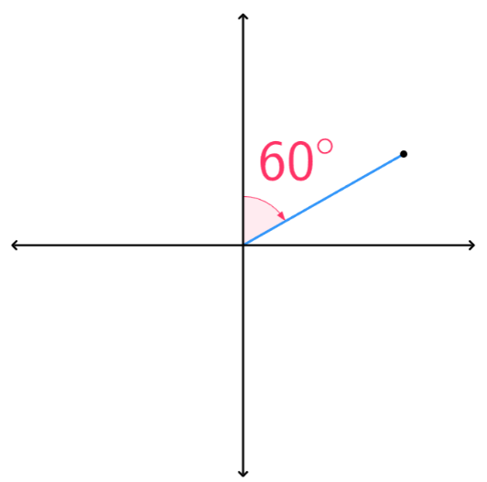  ✖ | 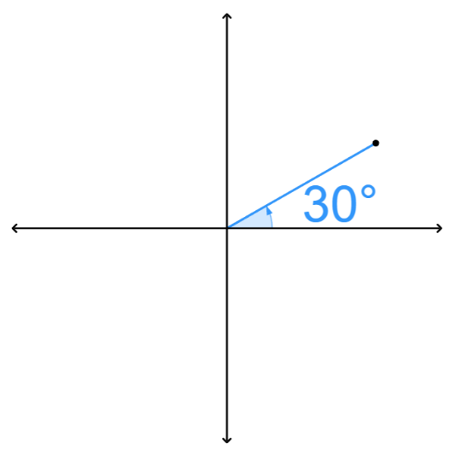  ✔ | 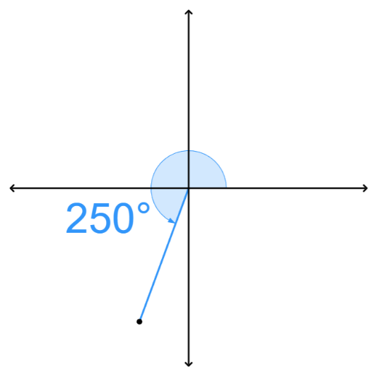  ✔ | 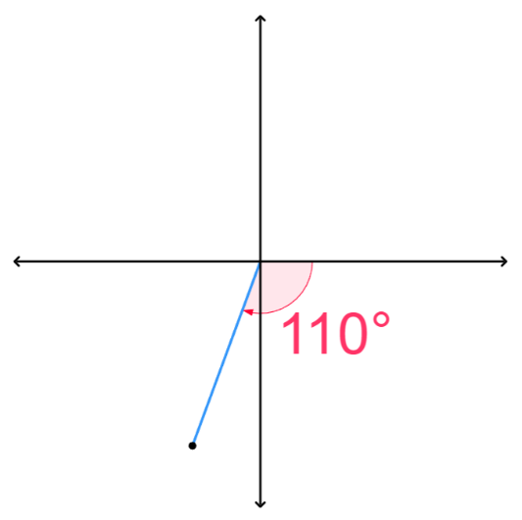  ✖
- In this booklet, unless specifically labelled otherwise, $θ$ will refer to the angle of inclination.

- Quadrants
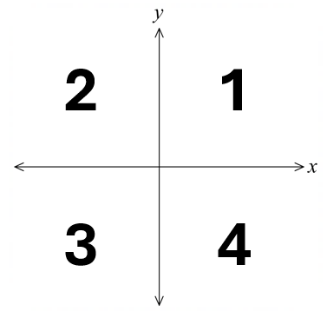
The $x$ and $y$ axes split the Cartesian plane into four quadrants:

Q1: $0°<θ<90°$
Q2: $90°<θ<180°$
Q3: $180°<θ<270°$
Q4: $270°<θ<360°$

Angles of $0°, 90°, 180°, 270°$ are the boundary angles.

- Key Ideas
- The angle of ……………… measures the rotation from the ……………… $x$-axis in an ………………… direction.
- The Cartesian plane is divided into four ……………………

Foundation
- Sketch these angles of inclination:
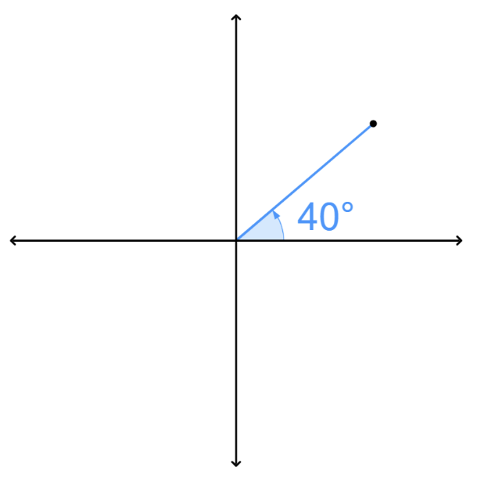  - 40° | - 70°  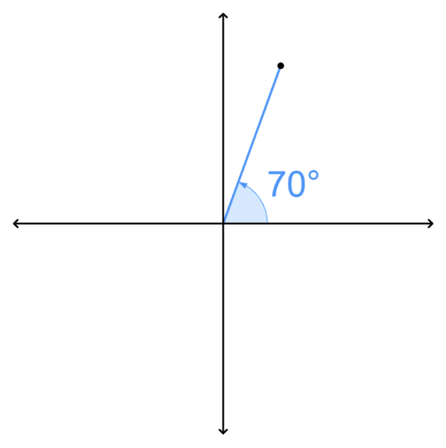 | 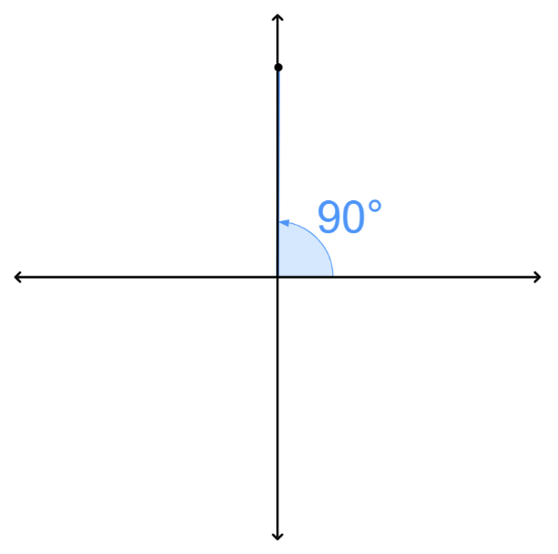  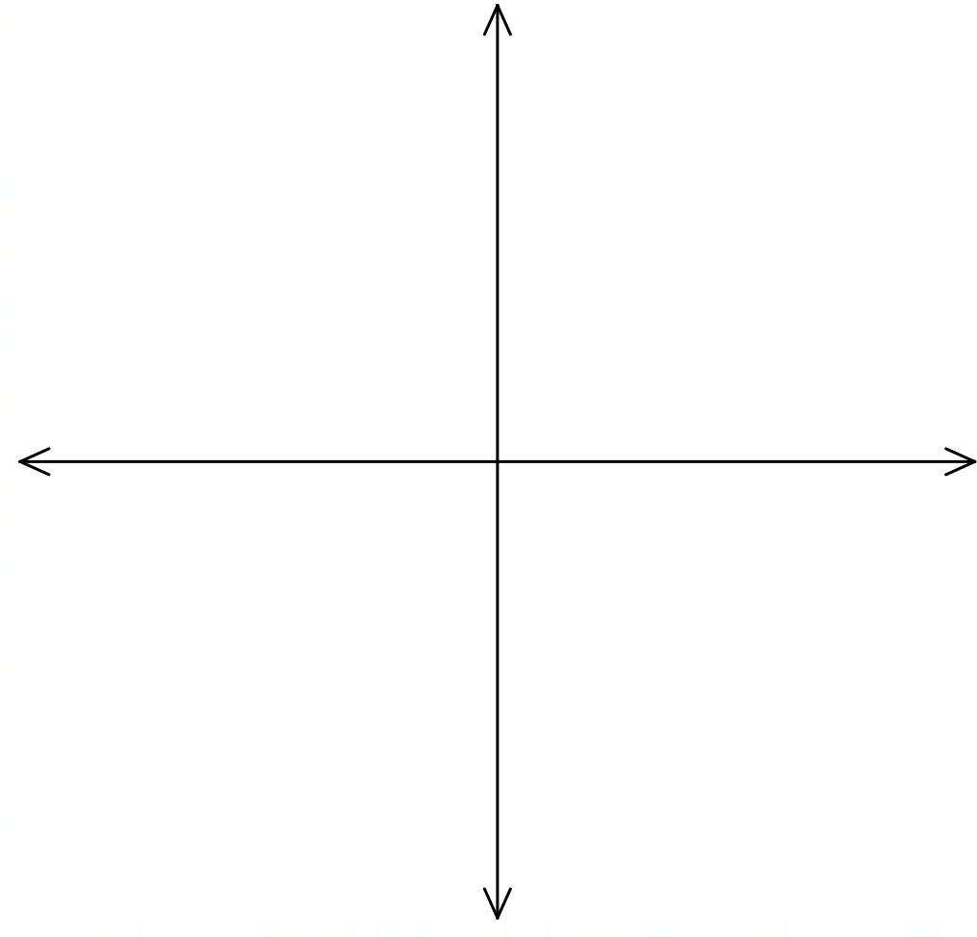  - 90°
- 135°  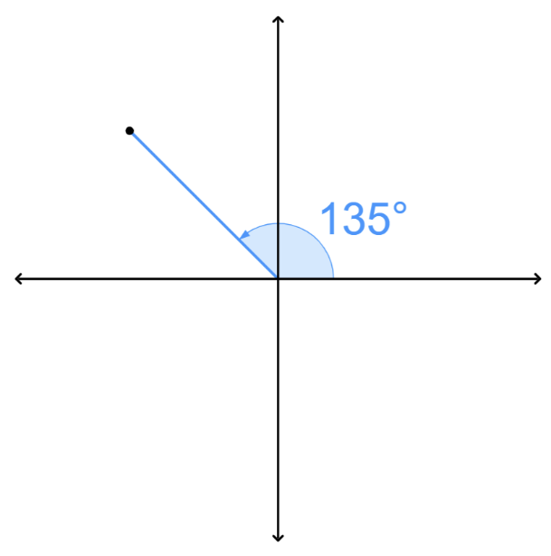 | - 180°  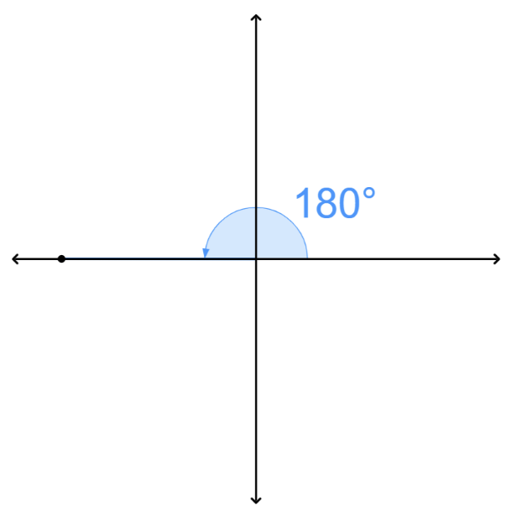 | - 240°  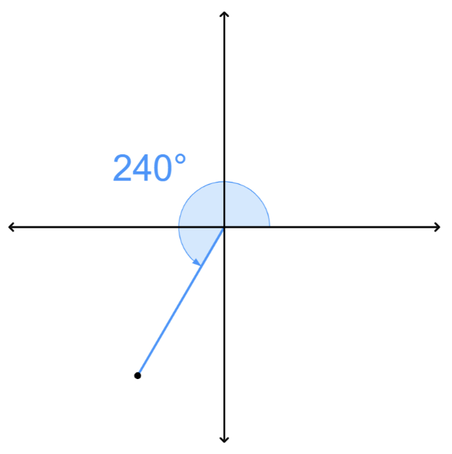
- 330°  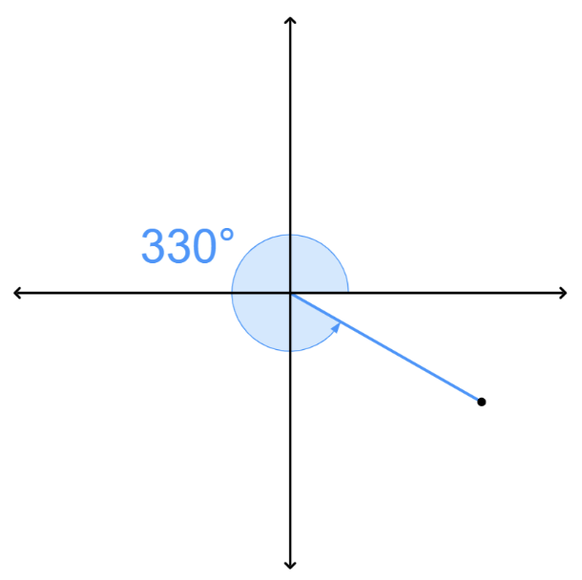 | - 225°  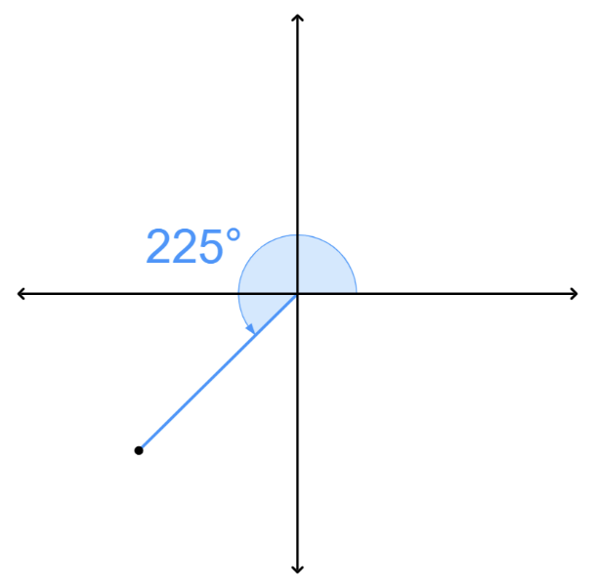 | - 355°  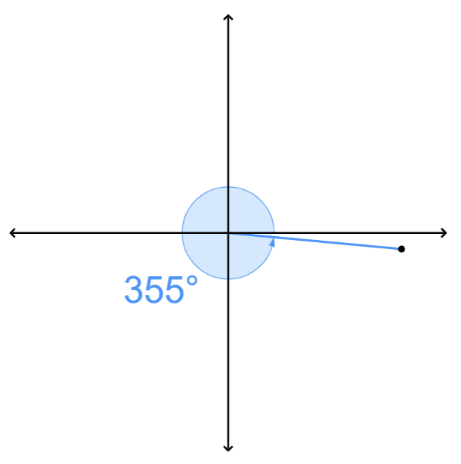
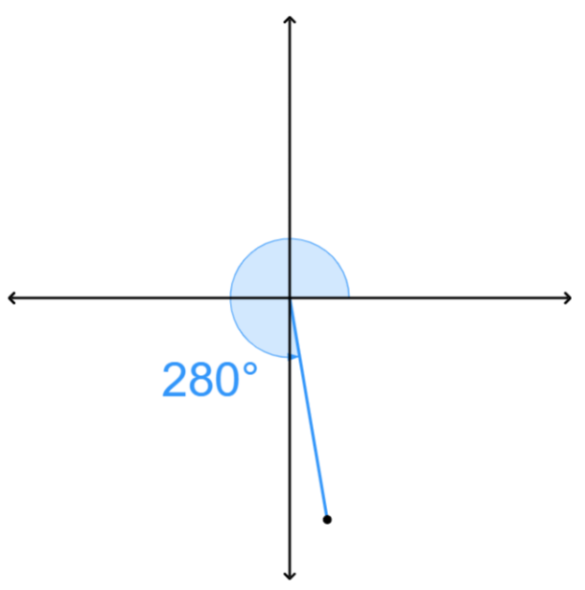  - 280° | - 110°  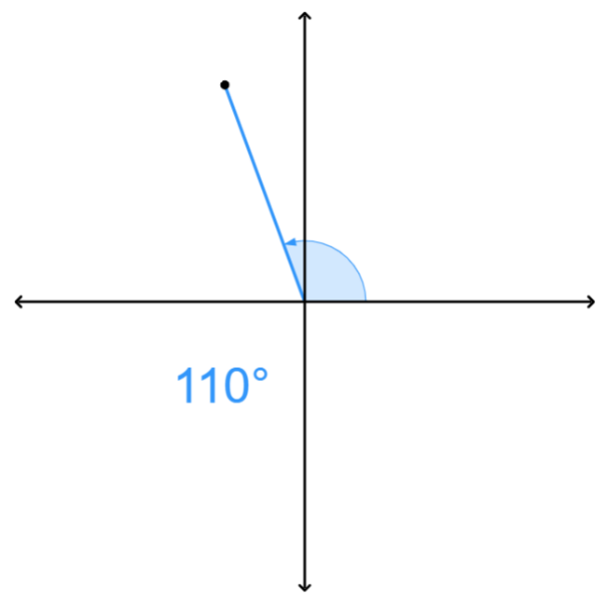 | 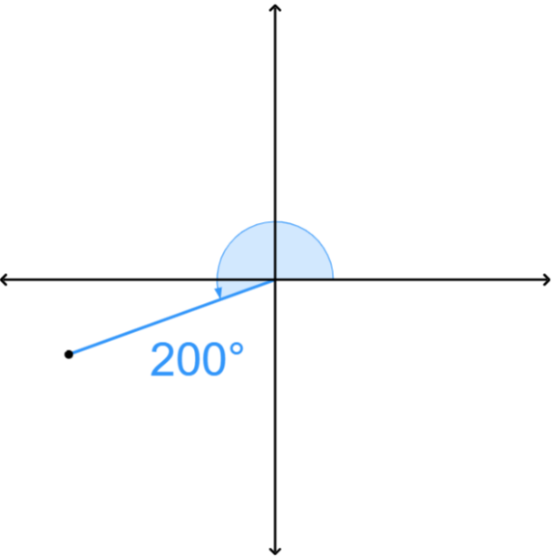  - 200°

- What is the angle of inclination between the positive $x$-axis and each line?
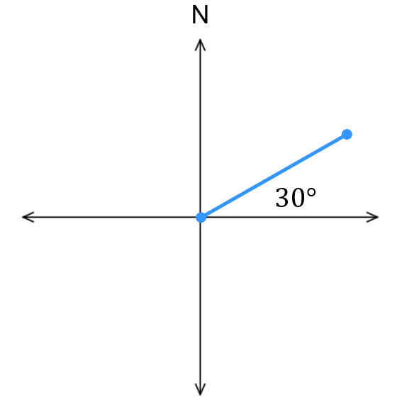  30° | 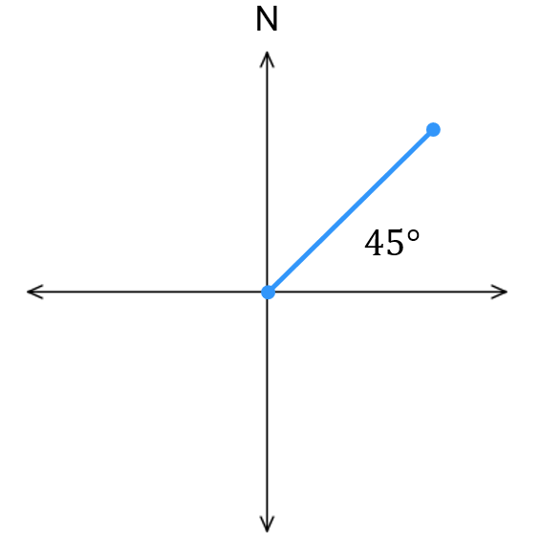  45° | 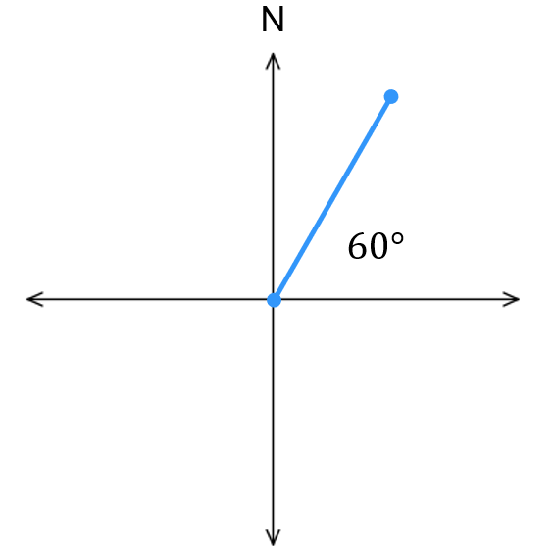  60°
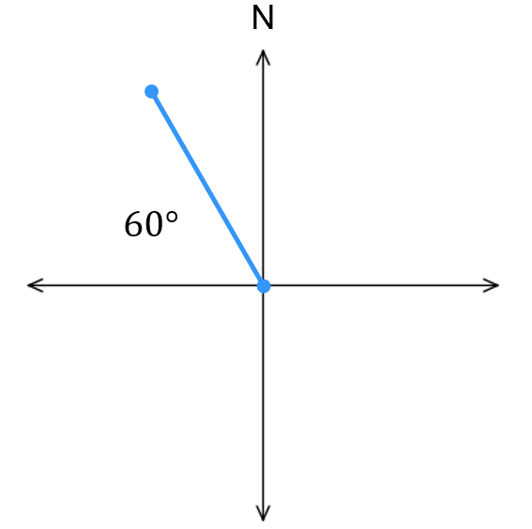  120° | 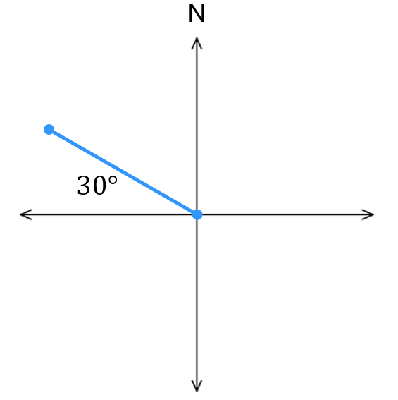  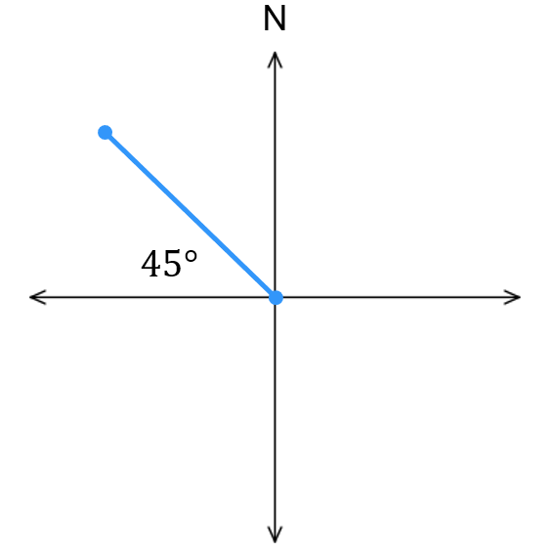  135° | 150°
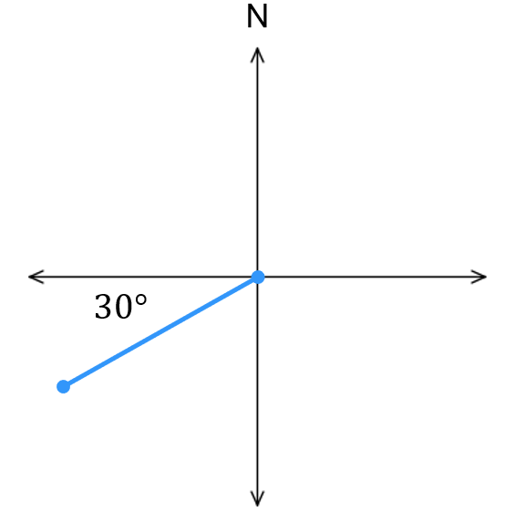  210° | 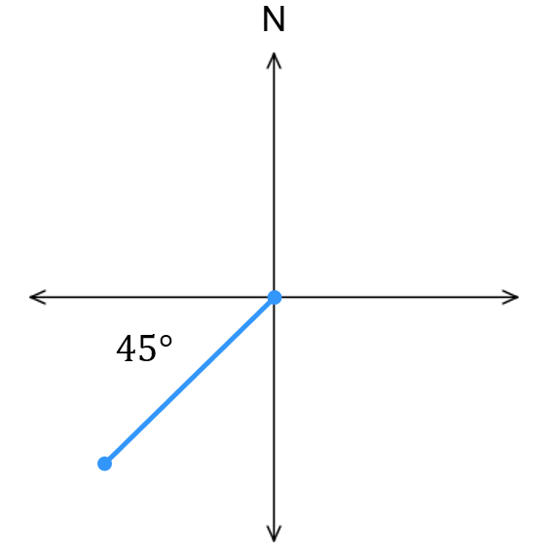  225° | 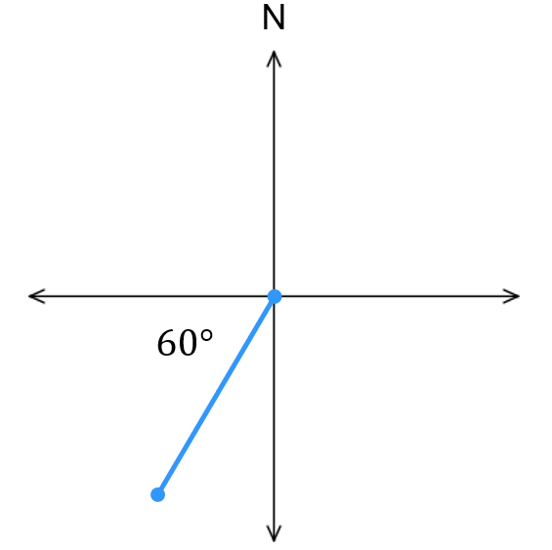  240°
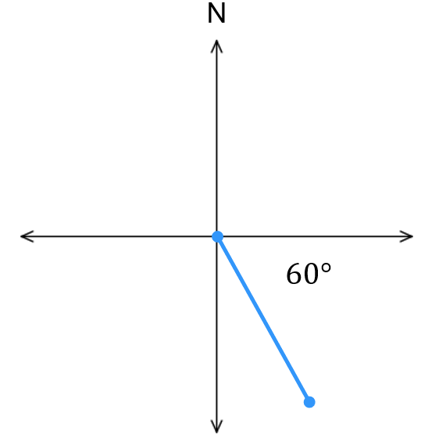  300° | 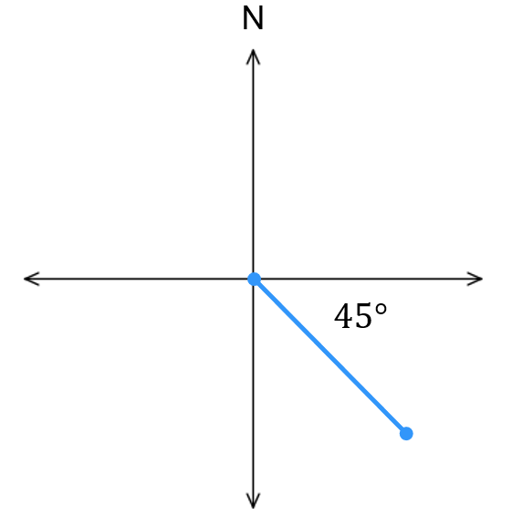  315° | 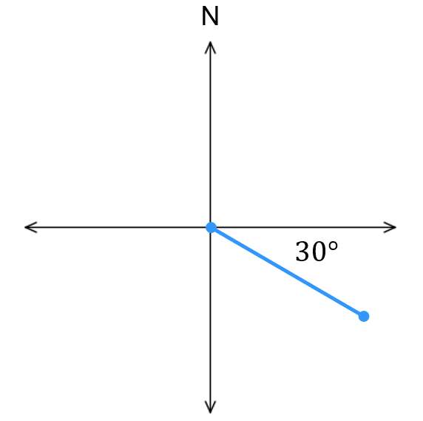  330°

- Convert these true bearings to angles of inclination
- $070°$  20° | - $180°$  270° | - $315°$  135°

Periodicity

- Periodicity
To turn more than 360$°$, continue rotating around the circle.
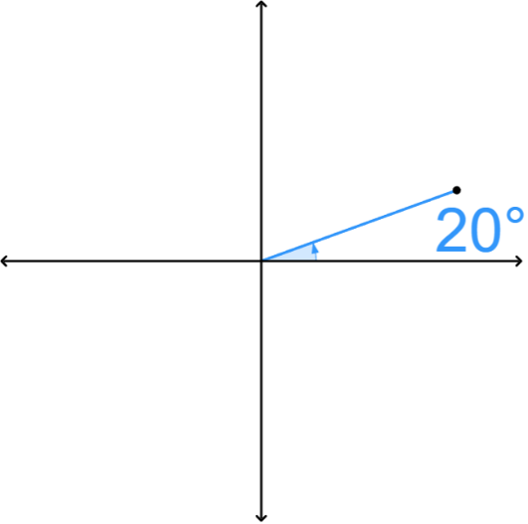
To turn a negative angle, rotate clockwise (instead of anticlockwise).
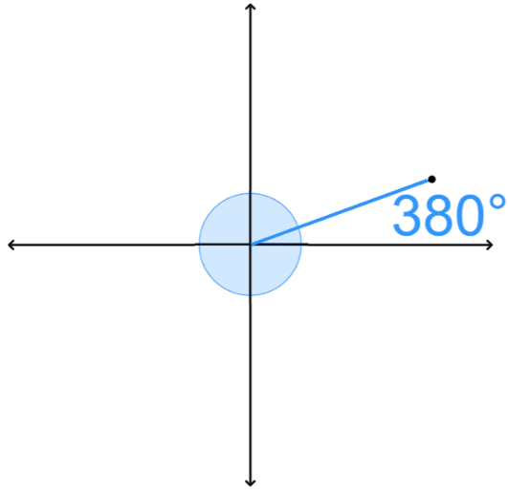
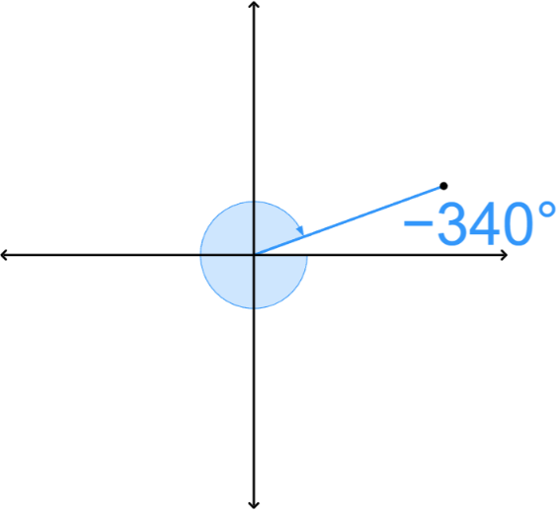

Any angle can be rewritten as an equivalent angle between 0° and 360°.
If $θ≥360°$  Subtract 360° repeatedly | If $θ<0$  Add 360° repeatedly

- Rewrite angles to be between 0 and 360 degrees.
$$410°≡410°-360° \\ ≡50°$$  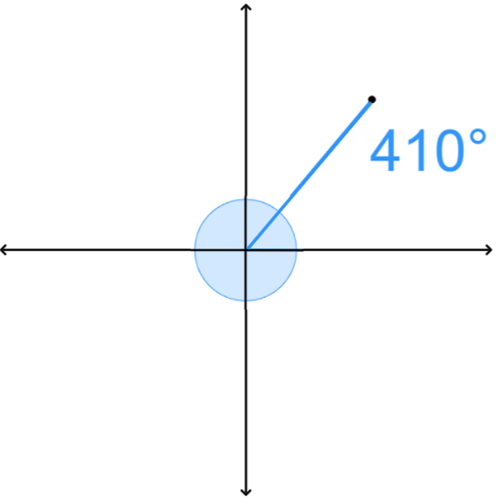 |  | $$-110°≡-110°+360° \\ ≡250°$$  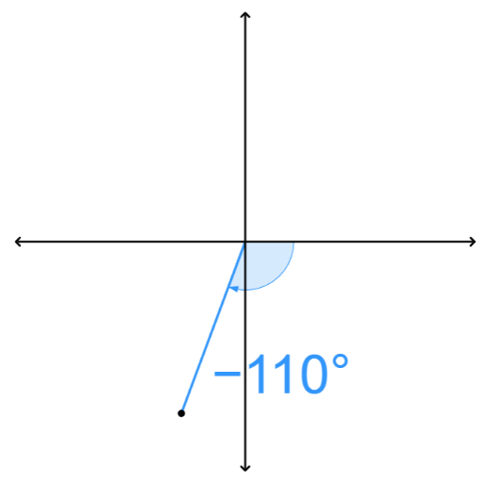
Rewrite these angles as an equivalent angle where $0≤θ<360°$
- $400°$ | - $-50°$ |  | - $720°$
- $-200°$ | - $900°$ |  | - $-1000°$

- Key Ideas
- A full rotation around a circle is ……°, this means angles that differ by 360° represent the ……………… angle.
- A negative angle represents rotation in the ………………… direction.
- To rewrite an angle to the range $0≤θ<360°:$
  - If an angle is ≥ 360°, ……………… 360° repeatedly.
  - If an angle is < 0, …………… 360° repeatedly.

Foundation
- Rewrite these angles of inclination as an angle $0°≤θ<360°$.
- $361°$  1° | - $-10°$  350° | - $720°$  0°
- $-500°$  220° | - $895°$  175° | - $-90°$  270°
- $1000°$  280° | - $-1000°$  80° | - $-45°$  315°
- $540°$  180° | - $-135°$  225° | - $-315°$  45°
- $660°$  300° | - $-45°$  315° | - $540°$  180°
- $-720°$  0° | - $-300°$  60° | - $1080°$  0°

  - List 6 possible angles of inclination that this ray could represent.

Many answers possible, $θ=30±360n$, where $n$ is an integer.
  - Is there a limit to how many angles this ray could represent?

No.

Redefining Trigonometry using the Unit Circle

- Investigation Redefining trigonometry
A unit circle is a circle centred at the origin (0,0) with radius 1.
On a unit circle, consider a point $P$ at angle of inclination $θ$.
Draw a right triangle by dropping a perpendicular from P to the $x$-axis.
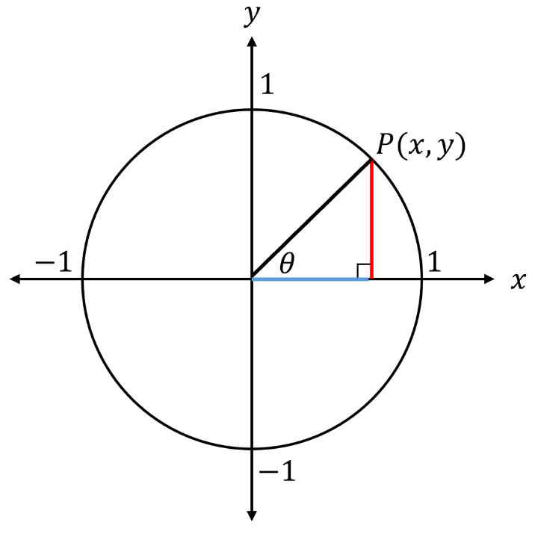
The hypotenuse is the radius = 1.

The horizontal leg equals the $x$-coordinate of $P$.
The vertical leg equals the $y$-coordinate of $P$.

- $\sin{θ}=\frac{Opp}{Hyp}=$

$∴\sin{θ}=$

- $\cos{θ}=\frac{Adj}{Hyp}=$

$∴\cos{θ}=$

- $\tan{θ}=\frac{Opp}{Adj}=$

$∴\tan{θ}=$

On a unit circle, consider a point $P\left(x,y\right)$ with angle of inclination $θ$.
- cos θ is the $x$-coordinate of $P$.
- sin θ is the $y$-coordinate of $P$.
- tan θ is the gradient of the line $OP$.

On a unit circle, the $x$-coordinate equals …………… and the$y$-coordinate equals ……………
sin θ is the …-coordinate on the unit circle, cos θ is the …-coordinate on the unit circle
tan θ is the ……………… of the line.

- https://www.geogebra.org/m/jzu5mddx

- Trigonometry on a Unit Circle
$P(\cos{θ},\sin{θ})$ is a point on a unit circle.
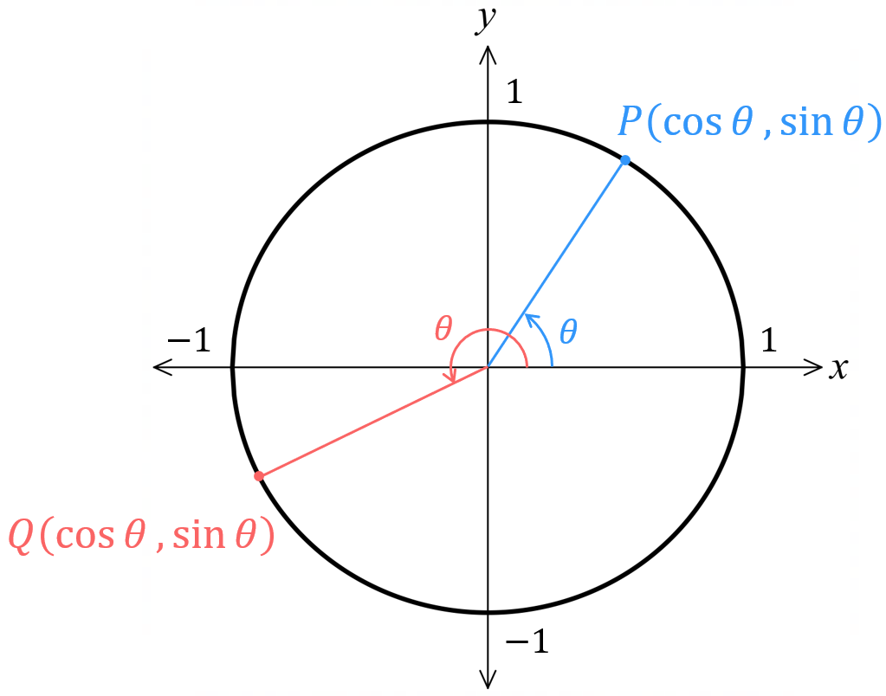
- The radius extends from the centre to $P$.
- $θ$ is the angle of inclination between the positive $x$-axis and the radius.
- $\cos{θ}$ is the $x$-coordinate, $\sin{θ}$ is the $y$-coordinate.
- $\tan{θ}$ is the gradient of the line $OP$.

$$x=\cos{θ}$$ | $$y=\sin{θ}$$ | $$\tan{θ}=\frac{y}{x}=\frac{\sin{θ}}{\cos{θ}}$$

- Identify Sine and cosine ratios as points on a unit circle
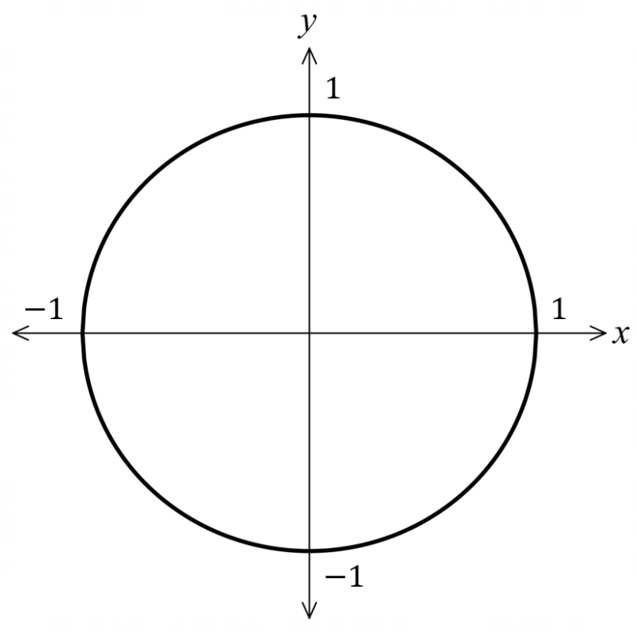
Show the approximate location of these points on the unit circle.
- $A\left(\cos{60°},\sin{60°}\right)$
- $B\left(\cos{90°},\sin{90°}\right)$
- $C(\cos{150°,}\sin{150°)}$
- $D\left(\cos{250°},\sin{250°}\right)$
- $E\left(\cos{300°,\sin{300°}}\right)$

Write the coordinates of these points.
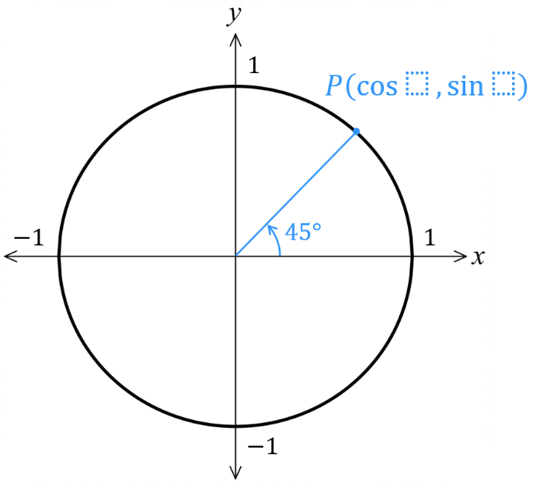 | 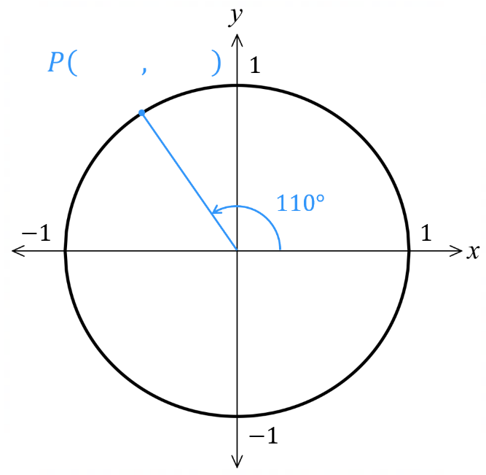 | 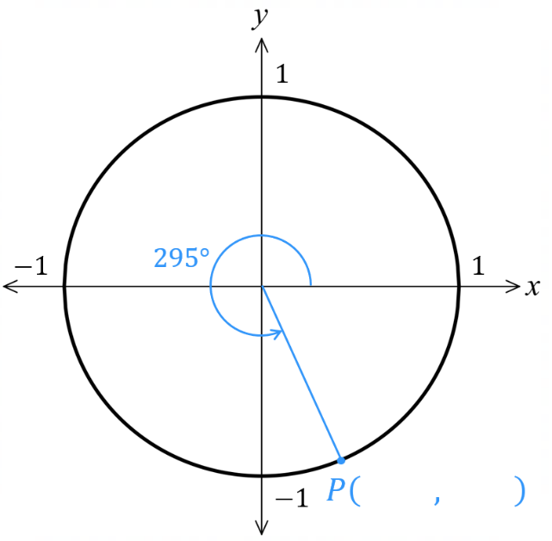
- Interpret Sine and cosine ratios as points on a unit circle
Using the given angle of inclination, plot the point, then find the value of $x$ and $y.$
- $θ=0°$  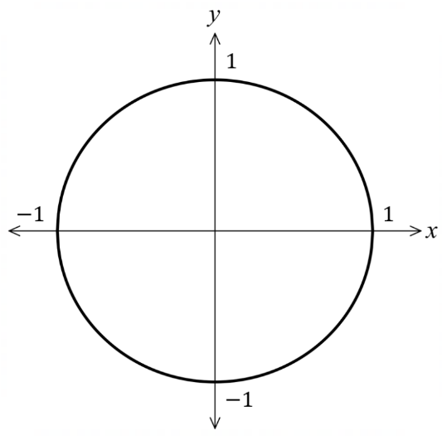  $∴P=($……, ……) | - $θ=90°$  $∴P=($……, ……) | - $θ=180°$  $∴P=($……, ……)
  $x=\cos{θ}$  $=\cos{…}$  $=$ …… | $y=\sin{θ}$  $=\sin{…}$  $=$ ……
  $x=\cos{θ}$  $=\cos{…}$  $=$ …… | $y=\sin{θ}$  $=\sin{…}$  $=$ ……
  $x=\cos{θ}$  $=\cos{…}$  $=$ …… | $y=\sin{θ}$  $=\sin{…}$  $=$ ……
- $θ=270°$  $∴P=($……, ……) | - $θ=30°$  $∴P=($……, ……) | - $θ=60°$  $∴P=($……, ……)
  $x=\cos{…}$  $=$ …… | $y=\sin{…}$  $=$ ……
  $x=\cos{…}$  $=$ …… | $y=\sin{…}$  $=$ ……
  $x=\cos{…}$  $=$ …… | $y=\sin{…}$  $=$ ……
- $θ=45°$  $∴P=($……, ……) | - $θ=390°$  $∴P=($……, ……) | - $θ=-90°$  $∴P=($……, ……)
  $x=$ | $y=$
  $x=$ | $y=$
  $x=$ | $y=$

Foundation
- Find the coordinates of the point $P\left(\cos{θ},\sin{θ}\right)$ on these unit circles.
Round your answer to 2 d.p. where necessary.
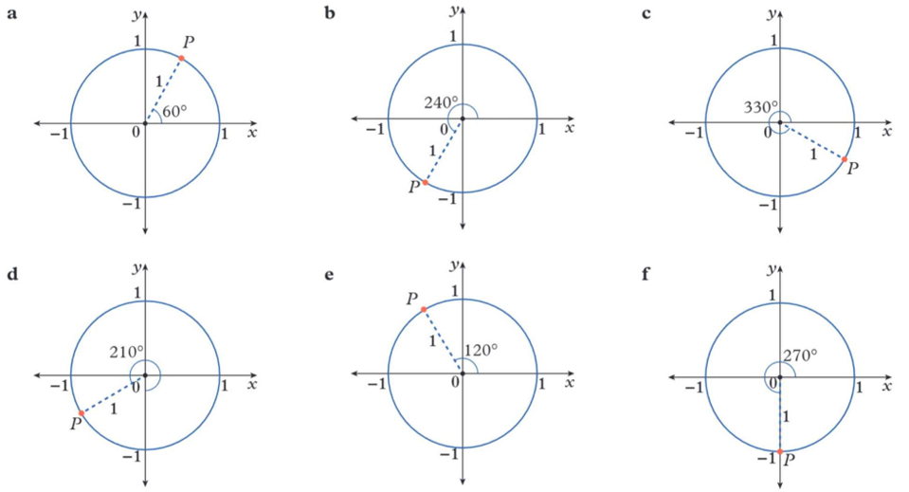  $$\left(0.5, 0.87\right)$$ | $$\left(-0.5, -0.87\right)$$ | $$\left(0.87, -0.5\right)$$
$$\left(-0.87, -0.5\right)$$ | $$\left(-0.5, -0.87\right)$$ | $$\left(0,-1\right)$$

- Identify these points on the unit circle, showing the radius and angle of inclination.
The first question has been done for you.
- $\left(\cos{70°},\sin{70°}\right)$ | - $\left(\cos{25°},\sin{25°}\right)$  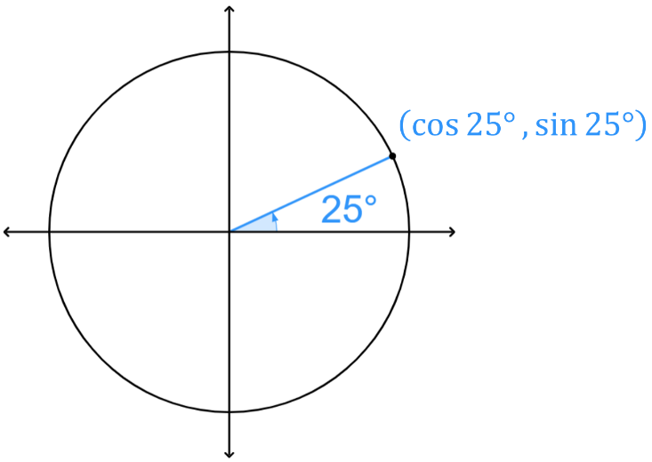  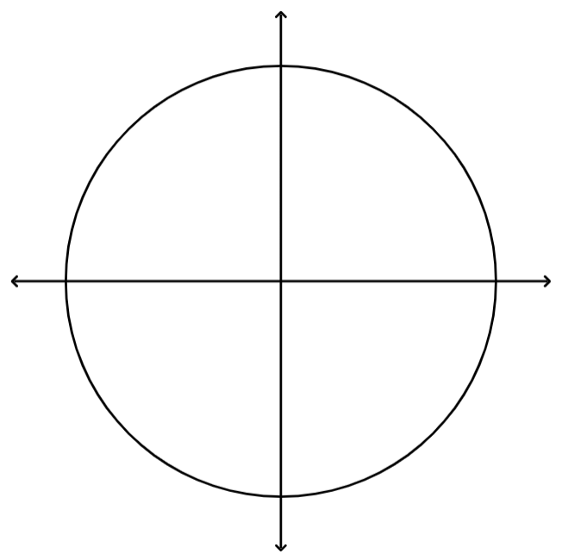 | - $\left(\cos{130°},\sin{130°}\right)$  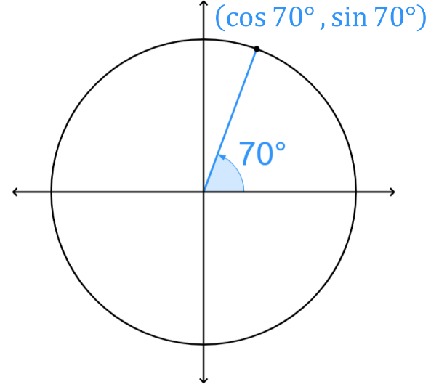  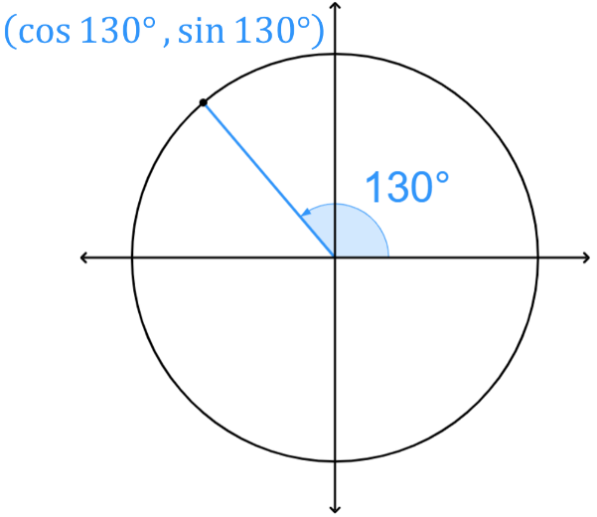
- $\left(\cos{230°},\sin{230°}\right)$  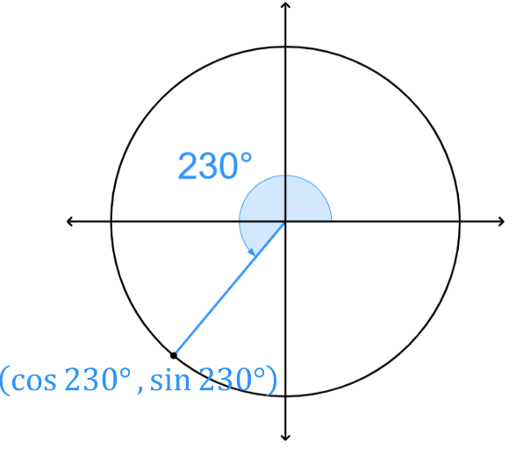 | - $\left(\cos{300°},\sin{300°}\right)$  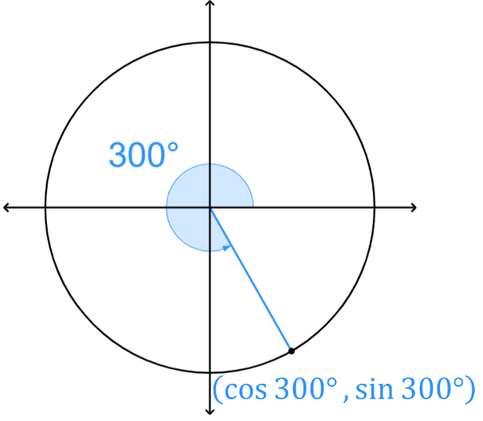 | - $\left(\cos{180°},\sin{180°}\right)$  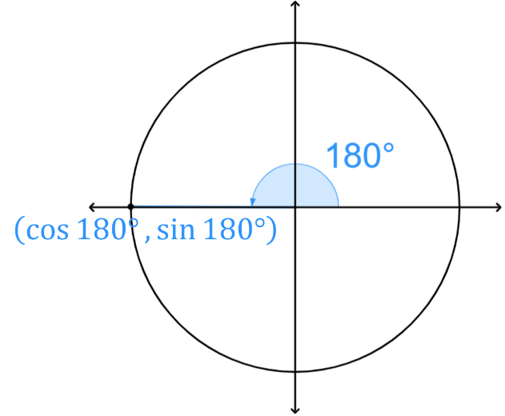

Reference Angles

- Reference Angles
The reference angle $A$ is the acute angle between the $x$-axis and the radius.
Q1  $$A=θ$$  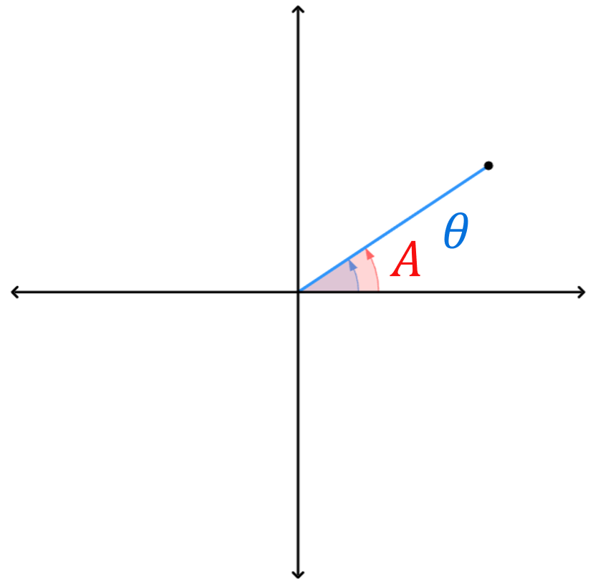 | Q2  $$A=180°-θ$$  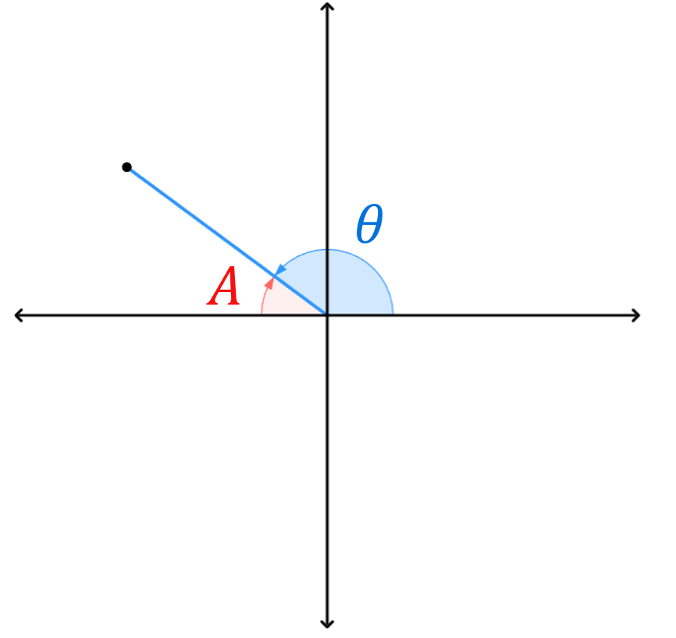
Q3  $$A=θ-180°$$  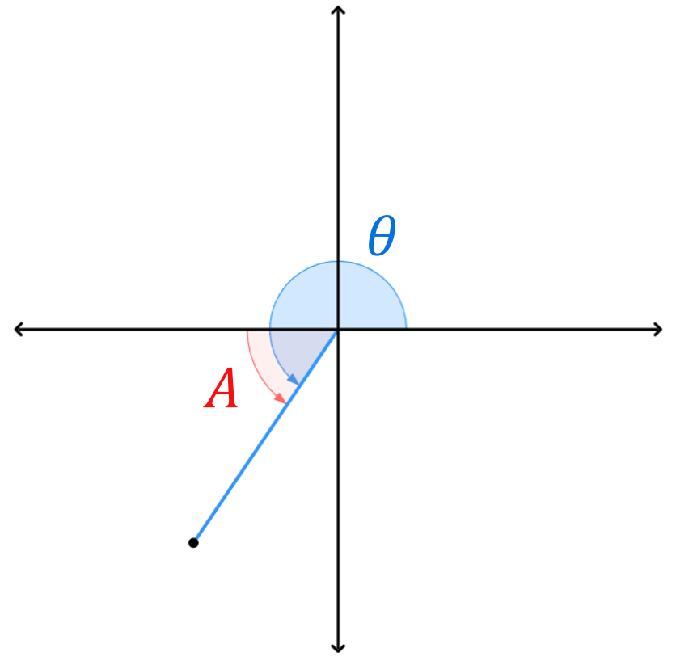 | Q4  $$A=360°-θ$$  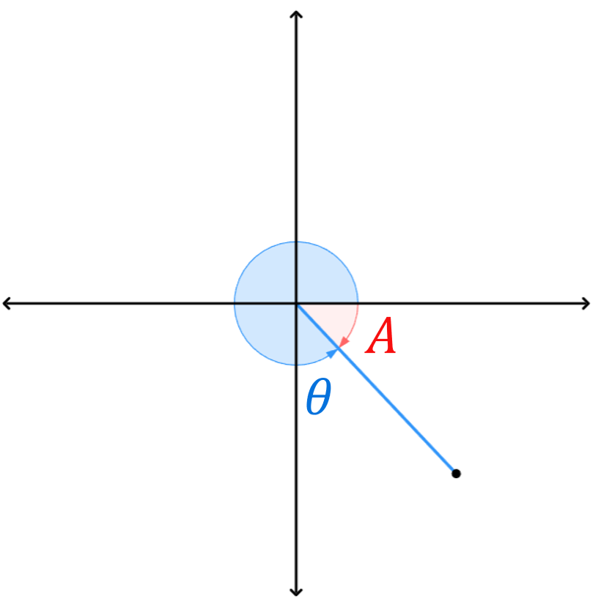
- In this booklet $θ$ refers to the angle of inclination and $A$ the reference angle.

- Key Ideas
- The angle of inclination is how much to turn ………………… from the positive …-axis
- The reference angle is the ……………… angle from either side of the …-axis

- Rewrite Angles of inclination as a reference angle
$$θ=120°$$  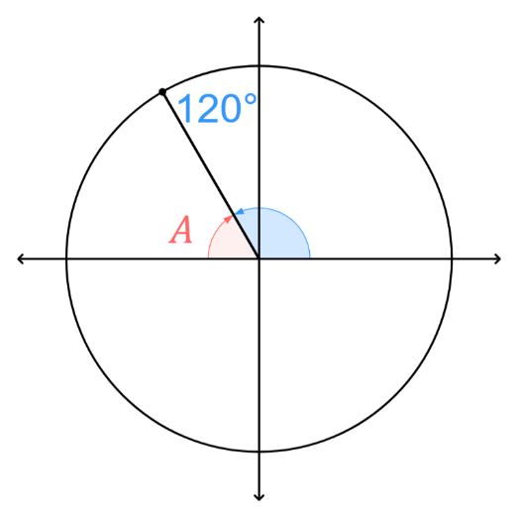  $$A=180°-120° \\ =60°$$ | $$θ=320°$$  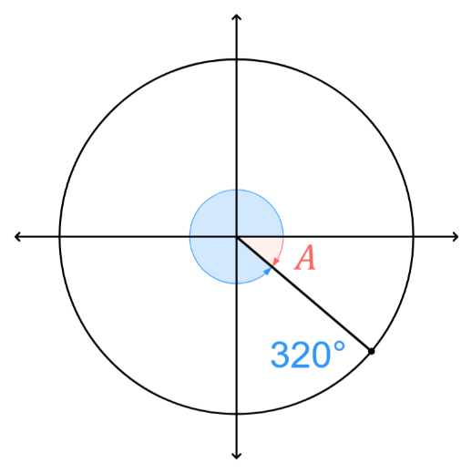  $$A=360°-320° \\ =40°$$ | $$θ=45°$$  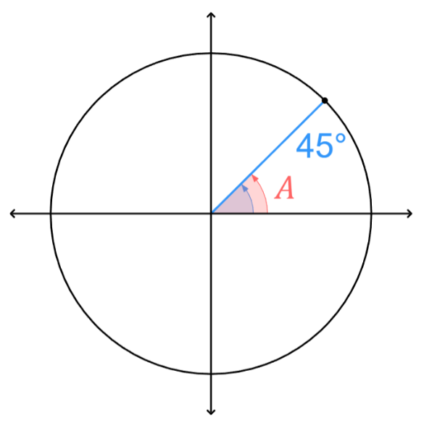  $$A=45°$$
Determine the reference angle for these angles of inclination.
- $θ=140°$ | - $θ=215°$ | 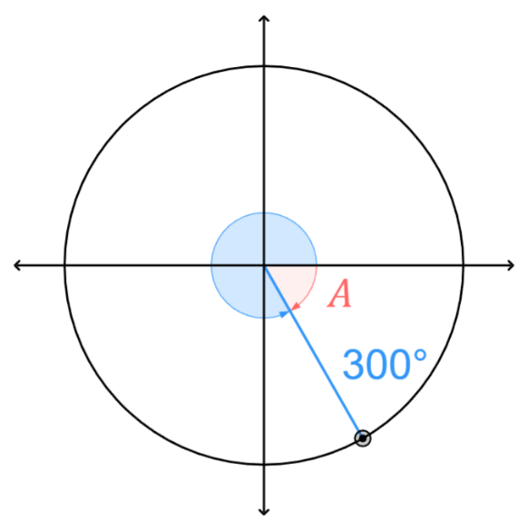  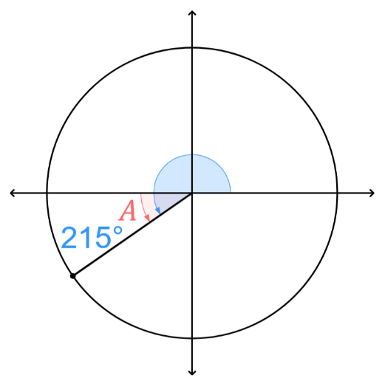  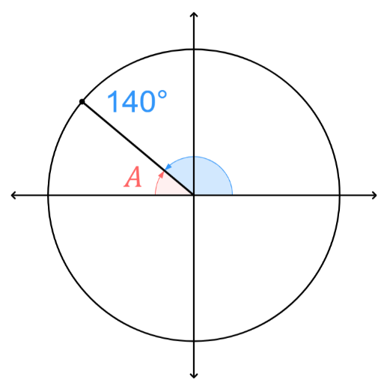  - $θ=300°$
- $θ=150°$ | - $θ=290°$ | - $θ=410°$

Foundation
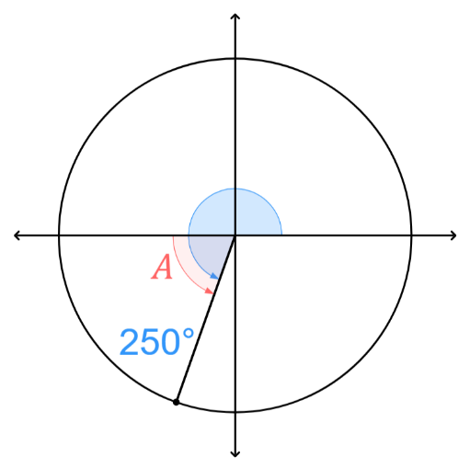
- Find the reference angle, or related angle, of these angles of inclination. A sketch will help.
- $θ=160°$  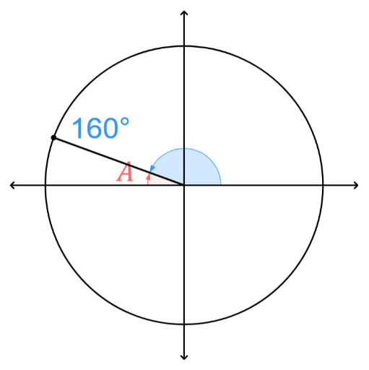  20° | - $θ=250°$  70° | - $θ=310°$  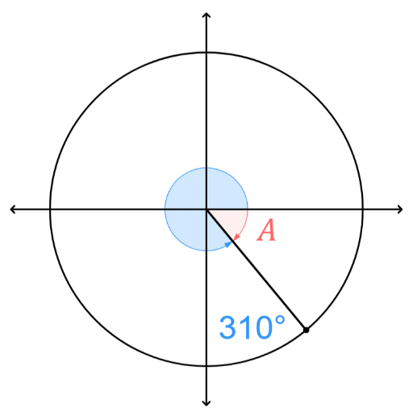  50°
- $θ=200°$  20° | - $θ=290°$  70° | - $θ=250°$  70°
- $θ=10°$  10° | - $θ=215°$  35° | - $θ=240°$  60°
- $θ=300°$  60° | - $θ=135°$  45° | - $θ=120°$  60°
- $θ=315°$  45° | - $θ=135°$  45° | - $θ=150°$  30°
- $θ=100°$  80° | - $θ=350°$  10° | - $θ=160°$  20°
- $θ=225°$  45° | - $θ=210°$  30° | - $θ=300°$  60°
- $θ=420°$  60° | - $θ=-300°$  60° | - $θ=-135°$  45°
- $θ=495°$  45° | - $θ=-30°$  30° | - $θ=675°$  45°

Trigonometric Ratios of Obtuse Angles

- Investigation Sign of trigonometric ratios in Q2
In Q2, the point P has a negative x-coordinate and a positive y-coordinate.
Since cos θ = $x$-coordinate, and $x$ is negative in Q2, cos θ is negative.
Since sin θ = $y$-coordinate, and $y$ is positive in Q2, sin θ is positive.
Since $\tan{θ}=$ $\frac{\sin{θ}}{\cos{θ}}$ $=$ $\frac{positive}{negative}$, tan θ is negative.
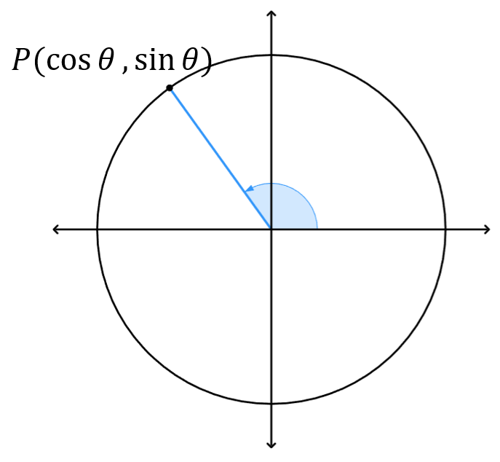

In Q2, sin is ………………, cos is ………………, tan is ……………….
The only positive trig ratio in Q2 is ……………

- Investigation Trigonometric ratios for obtuse angles
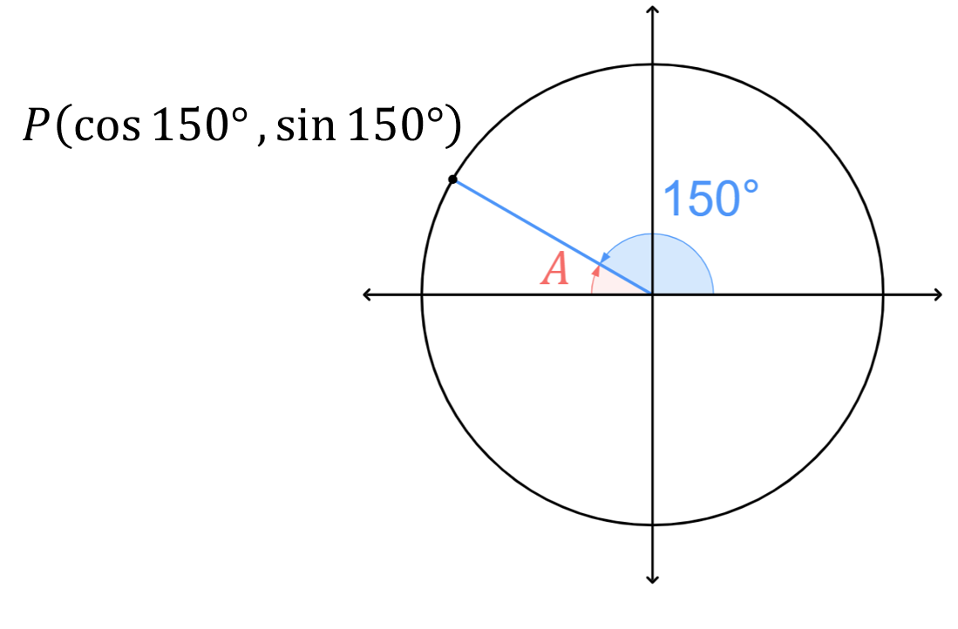
Consider θ = 150°.

The reference angle is $A=$ ……………

Construct a right-angled triangle with angle $A$in the diagram to the right.

What do you notice about the value of $\sin{30°}$ and $\sin{150°}$?
$\sin{150°}$ is ………… to the value of $\sin{30°}$.

What do you notice about the value of $\cos{30°}$ and $\cos{150°}$?
$\cos{150°}$ is ………… to the value of $\cos{30°},$ except it is ……………………

Therefore, we can write:
$$\sin{150°}=\sin{30°} \\ \cos{150°}=-\cos{30°} \\ \tan{150°=\frac{\sin{150°}}{\cos{150°}}=}$$

- Trigonometric Ratios for Obtuse Angles
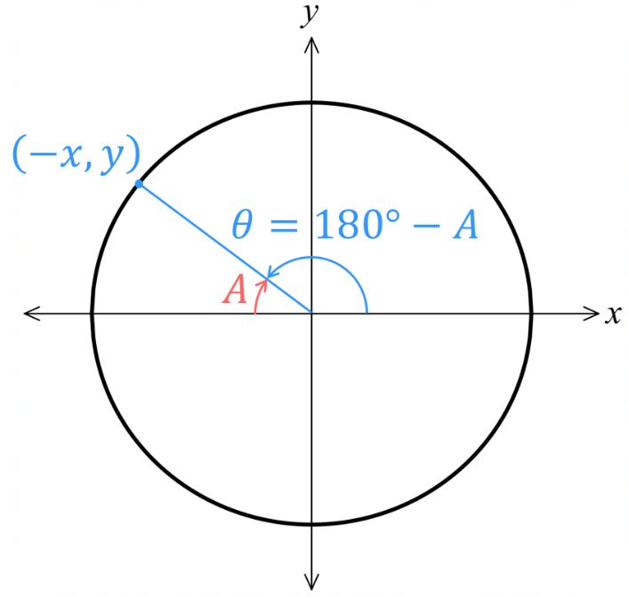
We express trigonometric ratios for obtuse angles $θ$
according to its acute reference angle $A$:
$\sin{θ}=\sin{A}$ $\cos{θ}=-\cos{A}$ $\tan{θ}=-\tan{A}$

To rewrite trigonometric ratios with the reference angle:
- Find the reference angle (in Q2, $A=180°-θ$).
- Determine the sign (in Q2, sin is positive, cos and tan are negative).
- Rewrite trig ratio with acute reference angle and the correct sign.

- Example Rewrite trigonometric ratios with the acute reference angle (2nd quadrant).
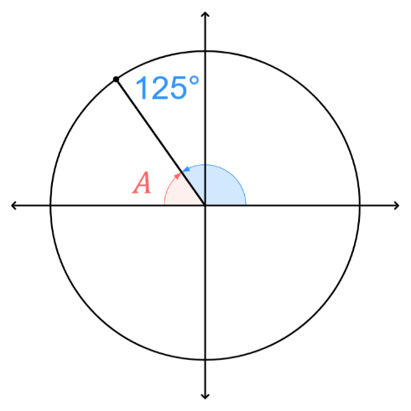  Write $\sin{125°}$ using its reference angle.  1. $A=55°$  2. sin is positive in Q2  3. $\sin{125°}=\sin{55°}$ | How did we know $A=55°$?  Angles on a ……………-line sum to ………  Why is $\sin{125°}$positive?  The …-coordinate in the …………… quadrant of a unit circle is positive.
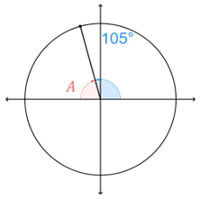  Write $\cos{105°}$ using its reference angle.  1. $A=75°$  2. cos is negative in Q2  3. $\cos{105°}=-\cos{75°}$ | Why is $\cos{105°}$ negative?  The …-coordinate in the …………… quadrant of a unit circle is negative.

- Guided Practice
Rewrite these trigonometric ratios in terms of its acute reference angle.
- $\sin{160°}$  1. $A=$  2. sign:  3. $\sin{160°}=$  $$\sin{20°}$$ | - $\cos{120°}$  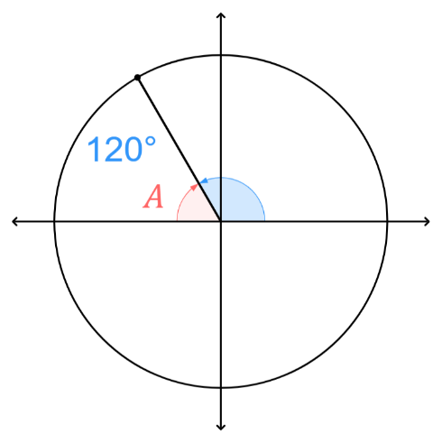  $$-\cos{60°}$$ | 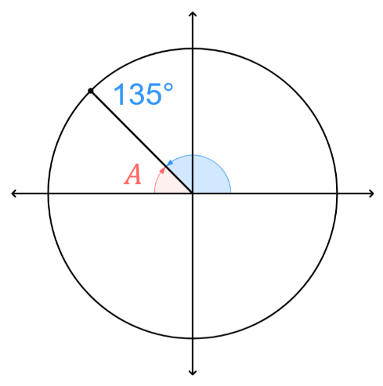  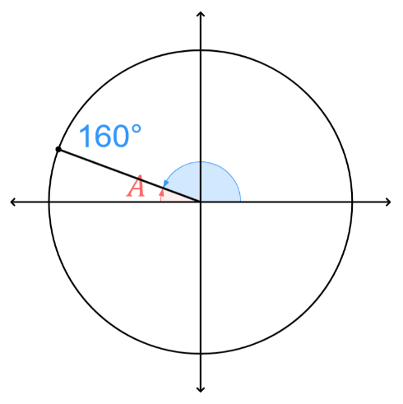  - $\tan{135°}$  $$-\tan{45°}$$

Foundation
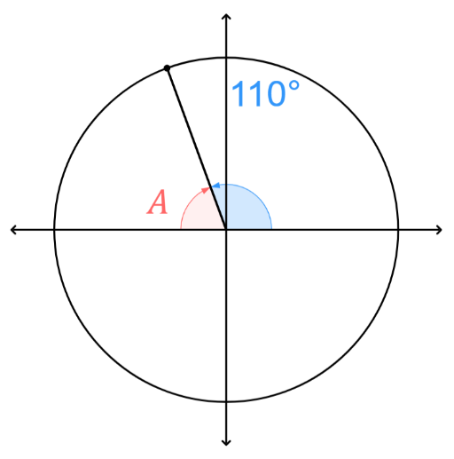
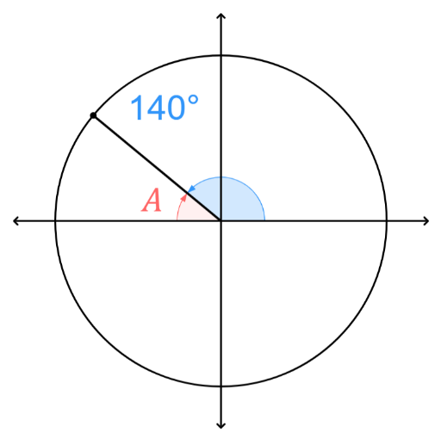
- Rewrite these trigonometric ratios in terms of its acute reference angle.
- $\cos{140°}$  –cos40° | - $\sin{110°}$  sin70° | - $\cos{125°}$  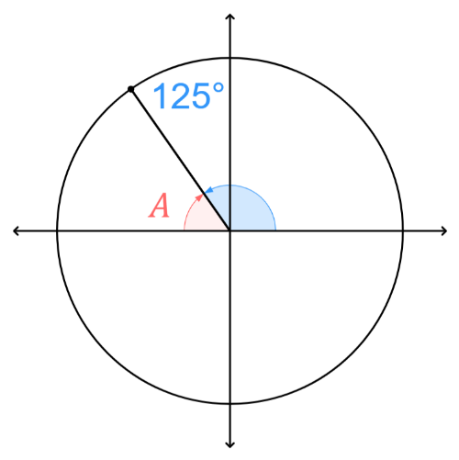  –cos55°
- $\cos{175°}$  –cos5° | - $\tan{170°}$  –tan10° | - $\tan{95°}$  –tan85°
- $\sin{175°}$  sin5° | - $\sin{180°}$  sin0° | - $\cos{155°}$  –cos25°
- $\tan{120°}$  –tan60° | - $\cos{150°}$  –cos30° | - $\sin{160°}$  sin20°
- $\sin{140°}$  sin40° | - $\cos{125°}$  –cos55° | - $\tan{123°}$  –tan57°
- $\tan{105°}$  –tan75° | - $\cos{155°}$  –cos25° | - $\tan{100°}$  –tan80°
- $\cos{148°}$  –cos32° | - $\sin{167°}$  sin13° | - $\tan{129°}$  –tan51°

- Find the exact values of these trigonometric ratios by first rewriting them with the acute reference angle.
- $\sin{150°}$  $=\sin{30°}$  $=$ ………  $$\frac{1}{2}$$ | - $\cos{150°}$  $=-cos{30°}$  $=$ ………  $$-\frac{\sqrt{3}}{2}$$ | - $\tan{120°}$  $$-\sqrt{3}$$
- $\cos{135°}$  $$-\frac{1}{\sqrt{2}}$$ | - $\sin{120°}$  $$\frac{\sqrt{3}}{2}$$ | - $\cos{120°}$  $$-\frac{1}{2}$$
- $\tan{150°}$  $$-\frac{1}{\sqrt{3}}$$ | - $\sin{135°}$  $$\frac{1}{\sqrt{2}}$$ | - $\tan{135°}$  –1

Trigonometric Ratios of Angles of Any Magnitude

- Angles of Any Magnitude
You can express trigonometric ratios of any angle using the acute reference angle $A$.
Q1  $$A=θ$$  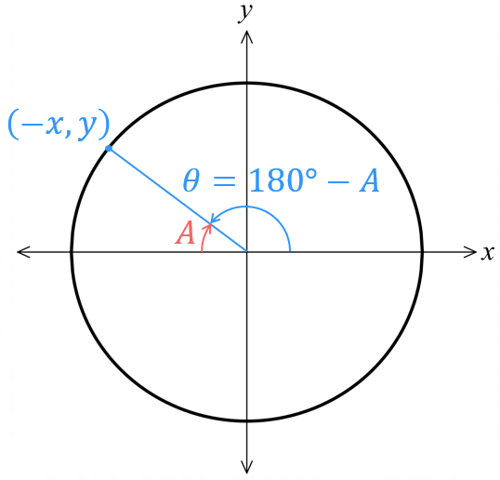  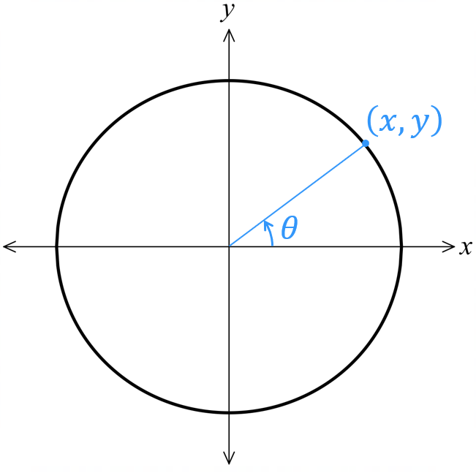  $$\sin{θ}=\sin{A} \\ \cos{θ}=\cos{A}$$$\tan{θ}=\tan{A}$ | Q2  $$A=180°-θ$$  $$θ=180°-A$$  $$\sin{(180°-A)}=\sin{A} \\ \cos{(180°-A)}=-\cos{A} \\ \tan{(180°-A)}=-\tan{A}$$
Q3  $$A=θ-180°$$  $$θ=180°+A$$  $$\sin{(180°+A)}=-\sin{A} \\ \cos{(180°+A)}=-\cos{A} \\ \tan{(180°+A)}=\tan{A}$$ | Q4  $$A=360°-θ$$  $$θ=360°-A$$  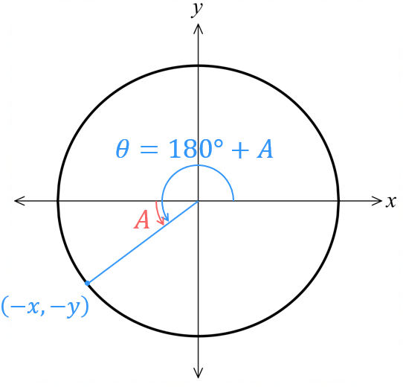  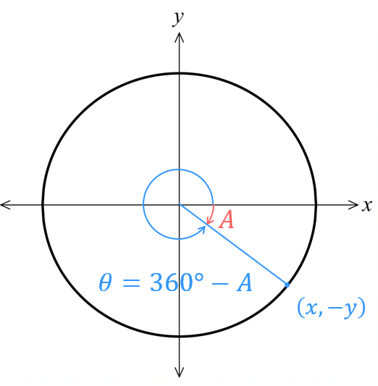  $$\sin{(360°-A)}=-\sin{A} \\ \cos{(360°-A)}=\cos{A} \\ \tan{(360°-A)}=-\tan{A}$$

- ASTC
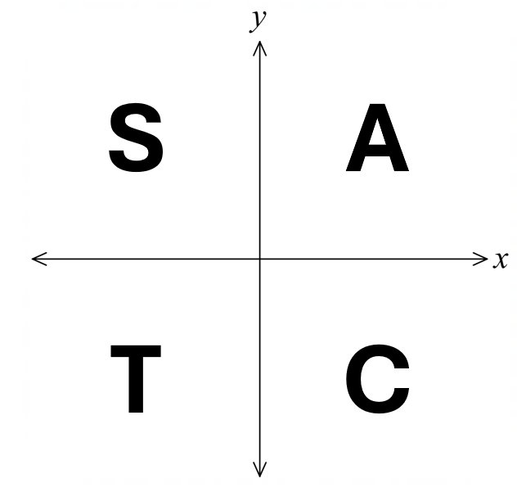
All the identities on the previous page can be memorised using ASTC:

All positive in 1st quadrant.
Sin positive in 2nd quadrant; others are negative.
Tan positive in 3rd quadrant; others are negative.
Cos positive in 4th quadrant; others are negative.

Q1  $$θ=180-A$$  $$A=180-θ$$  All positive | Q2  $$θ=180+A$$  $$A=θ-180$$  Sin positive,  others negative | Q3  $$θ=180+A$$  $$A=θ-180$$  Tan positive,  others negative | Q4  $$θ=360-A$$  $$A=360-θ$$  Cos positive,  others negative

- Identify sign of trigonometric ratios of any angle
Determining the sign:
            - Identify the quadrant of $θ.$
            - Use ASTC to determine if the ratio is positive or negative.
$$\sin{200°}$$  $200°$ is in Q3  $∴\sin{200°}$ is negative | $$\tan{200°}$$  $200°$ is in Q3  $∴\tan{200°}$ is positive | $$\cos{320°}$$  $320°$ is in Q4  $∴\cos{320°}$ is positive
Determine the sign of these trigonometric ratios
- $\sin{320°}$ | - $\cos{250°}$ | - $\tan{140°}$
- $\cos{60°}$ | - $\cos\left(-50°\right)$ | - $\sin\left(700°\right)$

- Rewriting Trigonometric Ratios with Acute Reference Angle
To rewrite trigonometric ratios with the reference angle:
- Find the reference angle.
- Determine the sign (using ASTC).
- Rewrite trig ratio with acute reference angle and the correct sign.

- Example Rewrite trigonometric ratios with the acute reference angle (All quadrants).
Write $\sin{200°}$ using its reference angle.  1. $A=20°$  2. sin is negative in Q3  3. $\sin{200°}=-\sin{20°}$ | 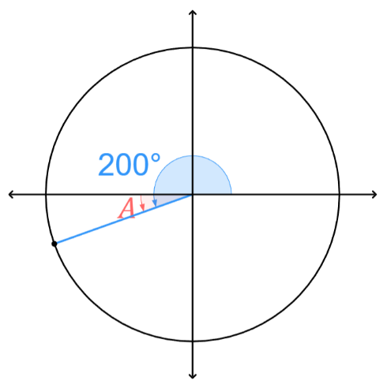  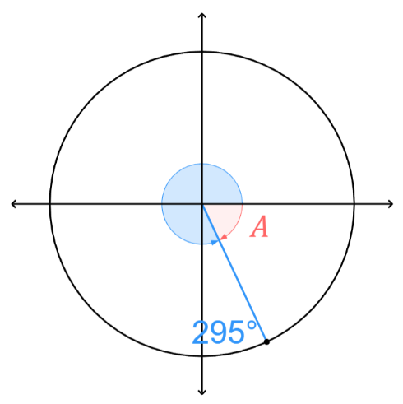  Write $\cos{295°}$ using its reference angle.  1. $A=75°$  2. cos is positive in Q4  3. $\cos{295°}=\cos{75°}$

- Guided Practice
Rewrite these trigonometric ratios in terms of its acute reference angle.
- $\sin{300°}$  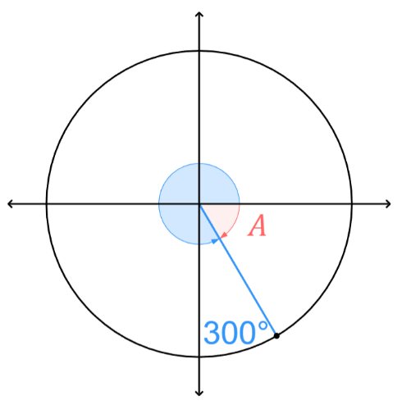  1. $A=$  2. sign:  3. $\sin{300°}=$  $$-\sin{60°}$$ | - $\cos{260°}$  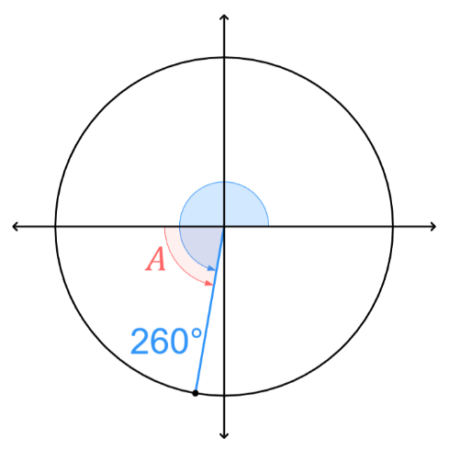  $$-\cos{80°}$$ | 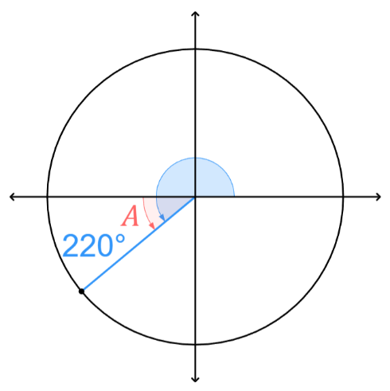  - $\tan{220°}$  $$\tan{40°}$$

- Key Ideas
- In quadrant 1, ……… ratios are positive.
- In quadrant 2, only ………… is positive.
- In quadrant 3, only ………… is positive.
- In quadrant 4, only ………… is positive.
- We can rewrite a trigonometric ratio of any angle using its acute ……………… angle by considering the quadrant and sign.

Foundation
- In which quadrants are these statements true?
- sin θ is positive  quadrants 1 and 2 | - tan θ is negative  2 and 4 | - cos θ is negative  2 and 3
- cos θ is positive  1 and 4 | - tan θ is positive  1 and 3 | - sin θ is negative  3 and 4

- Use ASTC to determine whether these trigonometric ratios are positive or negative.
- $\sin{20°}$  p | - $\cos{50°}$  p | - $\cos{100°}$  n | - $\tan{140°}$  n
- $\tan{250°}$  p | - $\sin{310°}$  n | - $\sin{200°}$  n | - $\cos{280°}$  p
- $\sin{340°}$  n | - $\cos{350°}$  p | - $\tan{290°}$  n | - $\cos{190°}$  n
- $\tan{170°}$  n | - $\sin{110°}$  p | - $\tan{80°}$  p | - $\cos{170°}$  n

- Rewrite these trigonometric ratios in terms of its acute reference angle.
- $\tan{130°}$  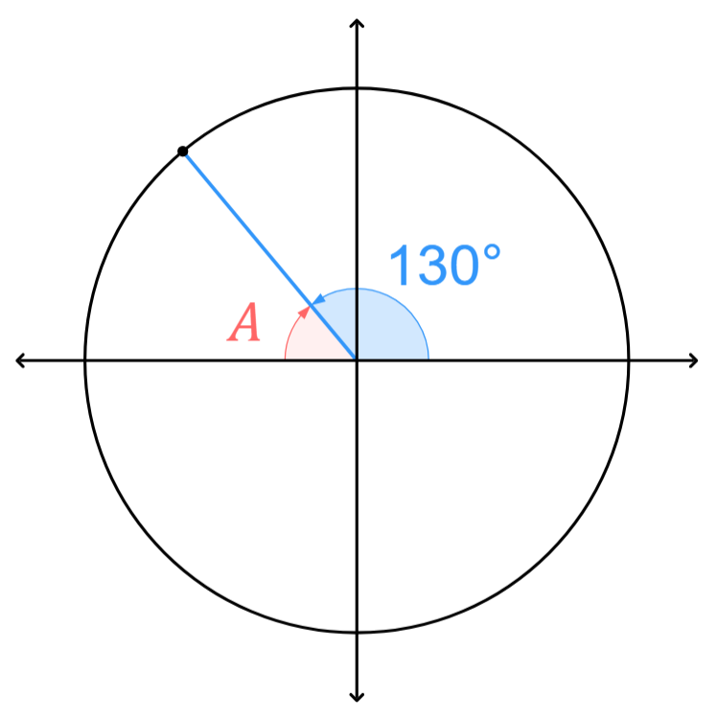  −tan 50° | - $\cos{310°}$  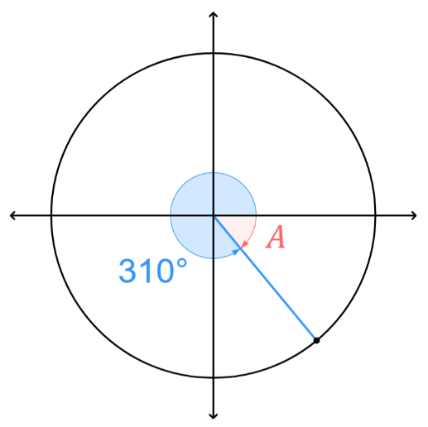  cos 50° | - $\sin{220°}$  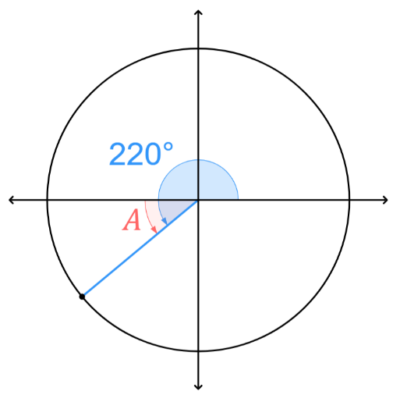  −sin 40°
- $\tan{210°}$  tan 30° | - $\tan{315°}$  −tan 45° | - $\cos{240°}$  −cos 60°
- $\tan{260°}$  tan 80° | - $\cos{170°}$  −cos 10° | - $\sin{320°}$  −sin 40°
- $\cos{185°}$  −cos 5° | - $\sin{125°}$  sin 55° | - $\tan{325°}$  −tan 35°
- $\sin{85°}$  sin 85° | - $\cos{95°}$  −cos 85° | - $\tan{205°}$  tan 25°

Development
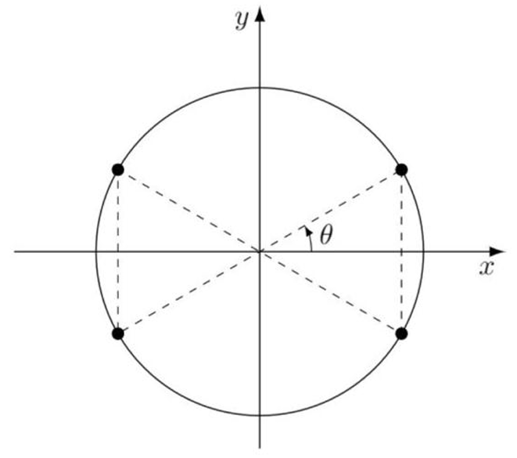
- Use the diagram to write these trigonometric ratios in terms of the acute angle, $θ$.
- $\sin\left(180-θ\right)$  sin θ | - $\cos\left(180-θ\right)$  -cos θ | - $\tan\left(180-θ\right)$  -tan θ
- $\sin{(180+θ)}$  -sin θ | - $\cos\left(180+θ\right)$  -cos θ | - $\tan{(180+θ)}$  tan θ
- $\sin\left(360-θ\right)$  -sin θ | - $\cos\left(360-θ\right)$  cos θ | - $\tan\left(360-θ\right)$  -tan θ
- $\sin{(-θ)}$  -sin θ | - $\cos\left(-θ\right)$  cos θ | - $\tan\left(-θ\right)$  -tan θ

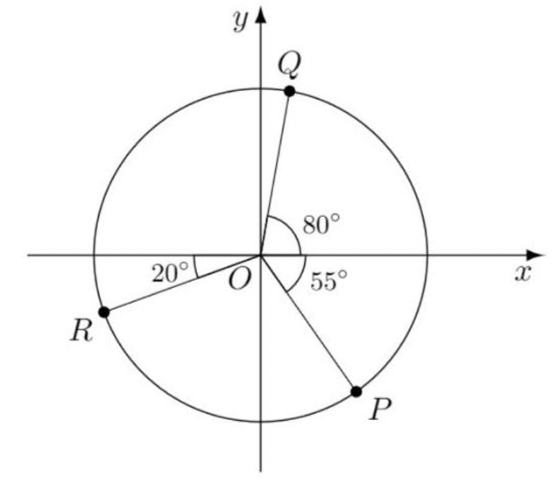
- The points $P,Q,R$ are on the unit circle. $O$ is the origin.
Find the coordinates of $P,Q,R$
Leave your answer in terms of $\cos{θ}$ and $\sin{θ}$, where $θ$ is the acute reference angle.

P (cos 55°, $-$sin 55°)
Q (cos 80°, sin 80°)
R ($-$cos 20°, $-$sin 20°)
- Simplify:
- $\frac{\sin\left(180°+β\right)}{\cos{(360°-β)}}$  $$-\tan{β}$$ | - $\frac{\cos\left(180°-β\right)}{\sin{(90°-β)}}$  $$-1$$ | - $\sin\left(180°+β\right)\cos{(90°-β)}$  $$-\sin^{2}{β}$$

- Given that sin 25° $≈$ 0.42 and cos 25° $≈$ 0.91, write down approximate values, without using a
calculator, for:
- $\sin{155°}$  $=\sin\left(180°-25°\right)$  $=\sin{( °)}$  $=$  0.42 | - $\cos{205°}$  $=\cos\left(180°+25°\right)$  $=-cos{( °)}$  $=$  −0.91 | - $\cos{335°}$  0.91
- $\sin{335°}$  −0.42 | - $\sin{205°}-\cos{155°}$  0.49 | - $\cos{385°}-\sin{515°}$  0.49

Exact Values of Trigonometric Ratios (All Angles)

- Review
- Recall exact values of trigonometric ratios
- $\sin{30°}$ | - $\cos{90°}$ | - $\tan{60°}$
- $\cos{60°}$ | - $\sin{45°}$ | - $\tan{45°}$
- $\tan{30°}$ | - $\sin{60°}$ | - $\cos{0°}$

- Rewrite trigonometric ratios with the acute reference angle
- $\tan{210°}$ | - $\cos{120°}$ | - $\sin{300°}$
- $\tan{315°}$ | - $\sin{225°}$ | - $\cos{150°}$

- Exact Values of any Trigonometric Ratio (Multiples of 0° 30° 45° 60° 90°)
- Rewrite trig ratio with acute reference angle and the correct sign.
- Write with exact value using the table below:
 | $$0°$$ | $$30°$$ | $$45°$$ | $$60°$$ | $$90°$$
$$\sin{θ}$$ | 0 | $$\frac{1}{2}$$ | $$\frac{1}{\sqrt{2}}$$ | $$\frac{\sqrt{3}}{2}$$ | 1
$$\cos{θ}$$ | 1 | $$\frac{\sqrt{3}}{2}$$ | $$\frac{1}{\sqrt{2}}$$ | $$\frac{1}{2}$$ | 0
$$\tan{θ}$$ | 0 | $$\frac{1}{\sqrt{3}}$$ | $$1$$ | $$\sqrt{3}$$ | undefined
- A sketch of the angle is very useful.

- Example Find the exact value of a trigonometric function (all quadrants)
Find the exact value of $\tan{300}°$  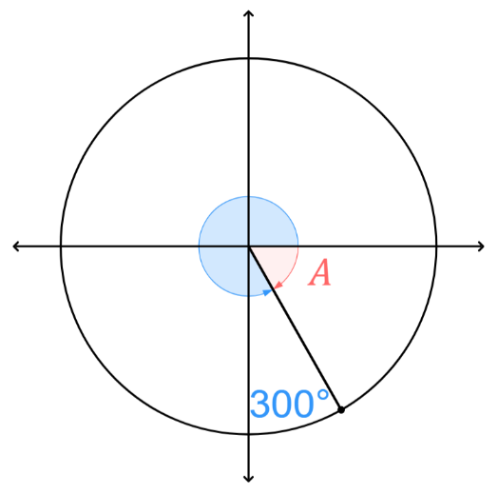  1. $\tan{300°}=-\tan{60°}$  2. $=-\sqrt{3}$ | Find the exact value of $\sin{(-210)}°$  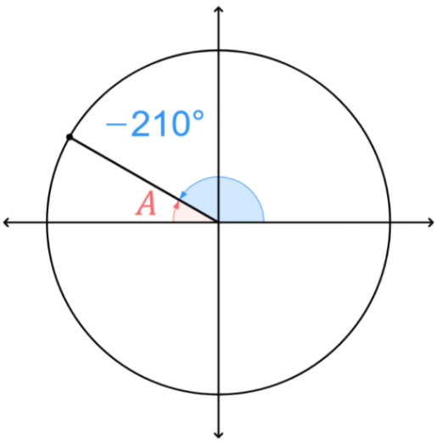  1. $\sin{(-210)°}=\sin{150°}$  $=\sin{30°}$  2. $=$ $\frac{1}{2}$

- Guided Practice
Find the exact value of:
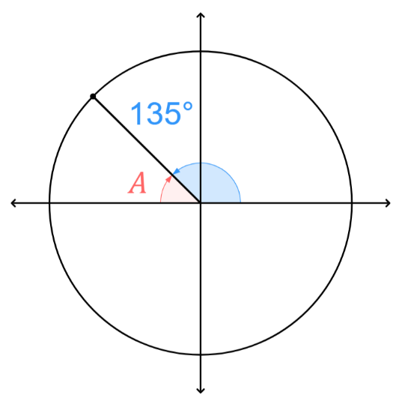  - $\sin{135°}$  $$\frac{1}{\sqrt{2}}$$ | 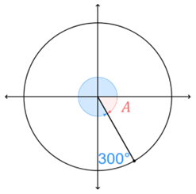  - $\cos{300°}$  $$0.5$$
- $\sin{270°}$  $$-1$$ | - $\tan{(-60)°}$  $$-\sqrt{3}$$

Foundation
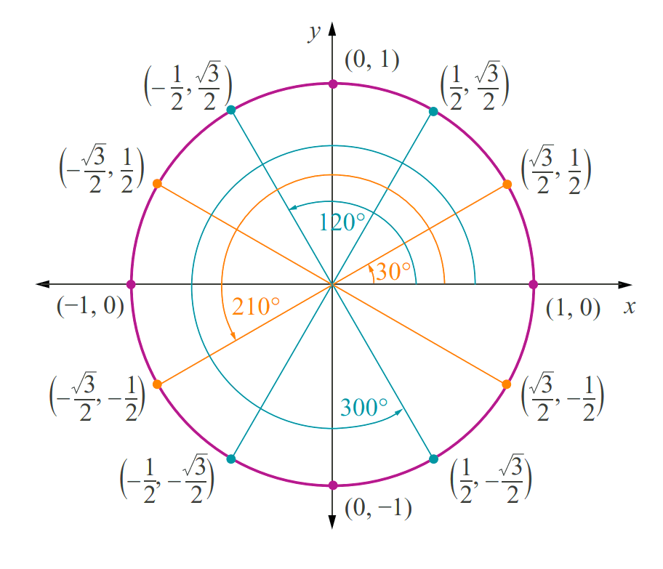
- The unit circle shown has exact values.
Use the unit circle to find the exact value of these trigonometric functions.
 |  |  | - $\sin{0°}$  0 | - $\cos{0°}$  1 | - $\tan{0°}$  0
 |  |  | - $\sin{120°}$  $$\frac{\sqrt{3}}{2}$$ | - $\cos{120°}$  $$-\frac{1}{2}$$ | - $\tan{120°}$  $$-\sqrt{3}$$
 |  |  | - $\sin{300°}$  $$-\frac{\sqrt{3}}{2}$$ | - $\cos{300°}$  $$\frac{1}{2}$$ | - $\tan{300°}$  $$-\sqrt{3}$$
 |  |  | - $\cos{210°}$  $$-\frac{\sqrt{3}}{2}$$ | - $\sin{240°}$  $$-\frac{\sqrt{3}}{2}$$ | - $\tan{150°}$  $$-\frac{1}{\sqrt{3}}$$
 |  |  | - $\sin{60°}$  $$\frac{\sqrt{3}}{2}$$ | - $\cos{30°}$  $$\frac{\sqrt{3}}{2}$$ | - $\tan{240°}$  $$\sqrt{3}$$
- $\cos{150°}$  $$-\frac{\sqrt{3}}{2}$$ | - $\cos{90°}$  $$0$$ | - $\sin{180°}$  $$0$$ | - $\sin{210°}$  $$-\frac{1}{2}$$ | - $\tan{330°}$  $$-\frac{1}{\sqrt{3}}$$ | - $\tan{270°}$  undefined

- Use the unit circle to find all the angles $0°≤θ<360°$ that have these values:
- $\cos{θ}=\frac{\sqrt{3}}{2}$  $θ=30°$ and ……$°$  30° and 330° | - $\sin{θ}=\frac{1}{2}$  30° and 150° | - $\sin{θ}=-\frac{1}{2}$  210° and 330°
- $\sin{θ}=\frac{\sqrt{3}}{2}$  60° and 120° | - $\sin{θ}=-\frac{\sqrt{3}}{2}$  240° and 300° | - $\cos{θ}=\frac{1}{2}$  60° and 300°
- $\cos{θ}=0$  90° and 270° | - $\sin{θ}=-1$  270° | - $\cos{θ}=1$  0°

- Complete the table.
Expression | Diagram | Reference Angle | Positive or Negative | Equivalent Expression | Exact Value
- $\sin{210°}$ |  | $$30°$$ | $$-$$ | $$-\sin{30°}$$ | $$-\frac{1}{2}$$
- $\sin{150°}$ |  | 30° | + | $$\sin{30°}$$ | $$\frac{1}{2}$$
- $\sin{225°}$ |  | 45° | − | $$-\sin{45°}$$ | $$-\frac{1}{\sqrt{2}}$$
- $\cos{300°}$ |  | 60° | + | $$\cos{60°}$$ | $$\frac{1}{2}$$
- $\cos{150°}$ |  | 30° | − | $$-cos{30°}$$ | $$-\frac{\sqrt{3}}{2}$$
- $\cos{300°}$ |  | 60° | + | $$\cos{60°}$$ | $$\frac{1}{2}$$
- $\tan{300°}$ |  | 60° | − | $$-\tan{60°}$$ | $$-\sqrt{3}$$
- $\tan{135°}$ | 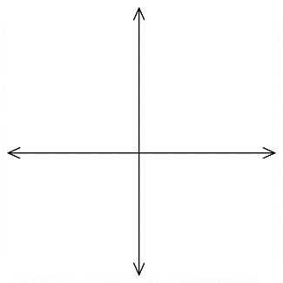  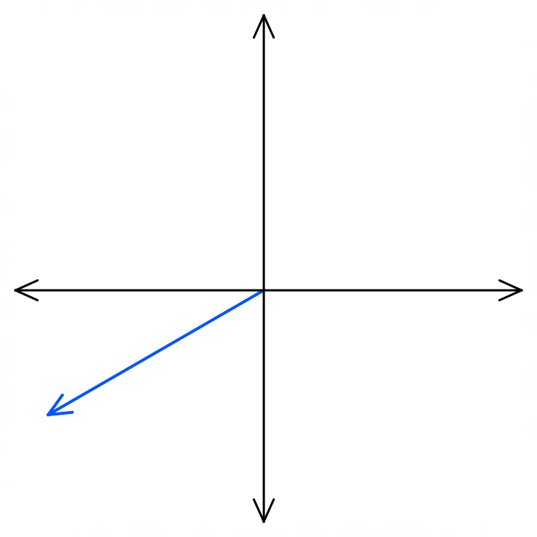  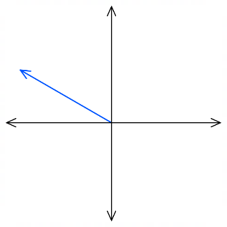  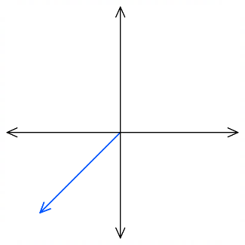 | 45° | − | $$-\tan{45°}$$ | $$-1$$
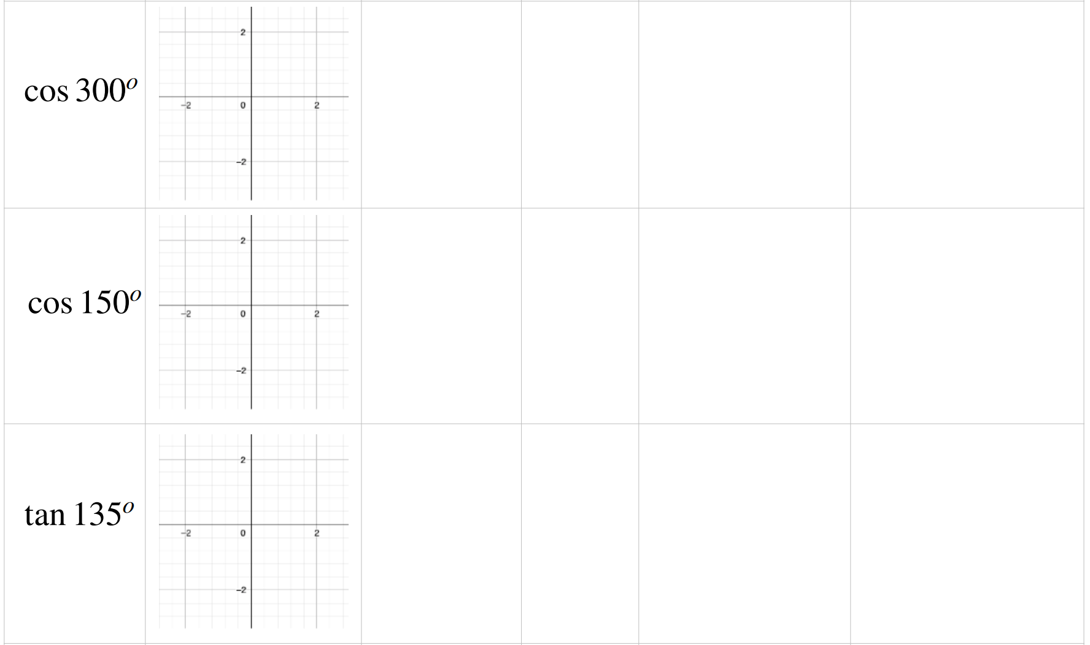  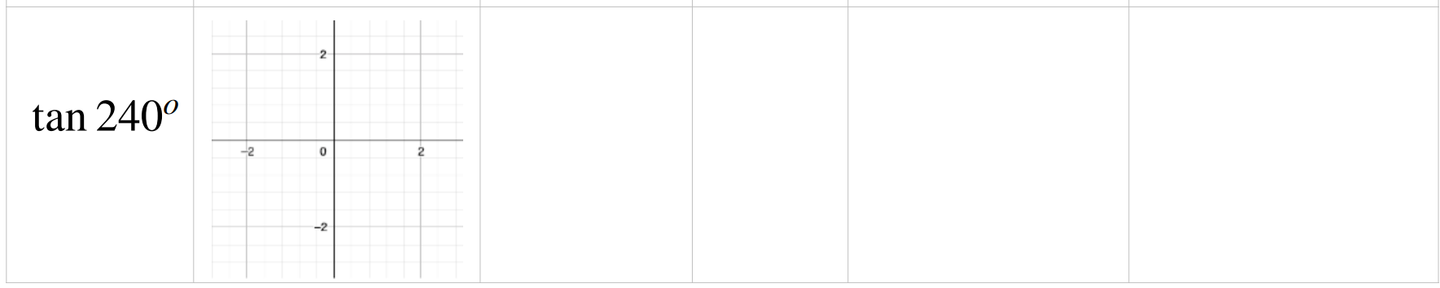  - $\tan{240°}$ |  | 60° | + | $$\tan{60°}$$ | $$\sqrt{3}$$

Development
- Find the exact value of these trigonometric ratios.
- $\sin{60° }$  $$\frac{\sqrt{3}}{2}$$ | - $\sin{120°}$  $$\frac{\sqrt{3}}{2}$$ | - $\sin{240°}$  $$-\frac{\sqrt{3}}{2}$$ | - $\sin{300°}$  $$-\frac{\sqrt{3}}{2}$$
- $\cos{45° }$  $$\frac{1}{\sqrt{2}}$$ | - $\cos{135°}$  $$-\frac{1}{\sqrt{2}}$$ | - $\cos{225°}$  $$-\frac{1}{\sqrt{2}}$$ | - $\cos{315°}$  $$\frac{1}{\sqrt{2}}$$
- $\tan{30° }$  $$\frac{1}{\sqrt{3}}$$ | - $\tan{150°}$  $$-\frac{1}{\sqrt{3}}$$ | - $\tan{210°}$  $$\frac{1}{\sqrt{3}}$$ | - $\tan{330°}$  $$-\frac{1}{\sqrt{3}}$$

- Find the exact value of these trigonometric ratios.
- $\cos{120°}$  $$-\frac{1}{2}$$ | - $\tan{225°}$  $$1$$ | - $\sin{300°}$  $$-\frac{\sqrt{3}}{2}$$ | - $\sin{135°}$  $$\frac{1}{\sqrt{2}}$$
- $\tan{240°}$  $$\sqrt{3}$$ | - $\cos{210°}$  $$-\frac{\sqrt{3}}{2}$$ | - $\tan{315°}$  $$-1$$ | - $\cos{300°}$  $$\frac{1}{2}$$
- $\sin{225° }$  $$-\frac{1}{\sqrt{2}}$$ | - $\cos{150°}$  $$-\frac{\sqrt{3}}{2}$$ | - $\sin{210°}$  $$-\frac{1}{2}$$ | - $\tan{300°}$  $$-\sqrt{3}$$

- Find the exact value of these trigonometric ratios.
- $\cos\left(-60°\right)$  $$\frac{1}{2}$$ | - $\sin\left(-120°\right)$  $$-\frac{\sqrt{3}}{2}$$ | - $\tan\left(-120°\right)$  $$\sqrt{3}$$ | - $\sin\left(-315°\right)$  $$\frac{1}{\sqrt{2}}$$
- $\tan\left(-210°\right)$  $$-\frac{1}{\sqrt{3}}$$ | - $\cos\left(-225°\right)$  $$-\frac{1}{\sqrt{2}}$$ | - $\tan{420°}$  $$\sqrt{3}$$ | - $\cos{510°}$  $$-\frac{\sqrt{3}}{2}$$
- $\sin{495°}$  $$\frac{1}{\sqrt{2}}$$ | - $\sin{690°}$  $$-\frac{1}{2}$$ | - $\cos{600°}$  $$-\frac{1}{2}$$ | - $\tan{585°}$  $$1$$
- When the radius of the circle is not 1, the coordinates of a point on the circumference is given by $\left(r\cos{θ}, r\sin{θ}\right)$. Find the coordinates of the point $P$ in each diagram in exact form.
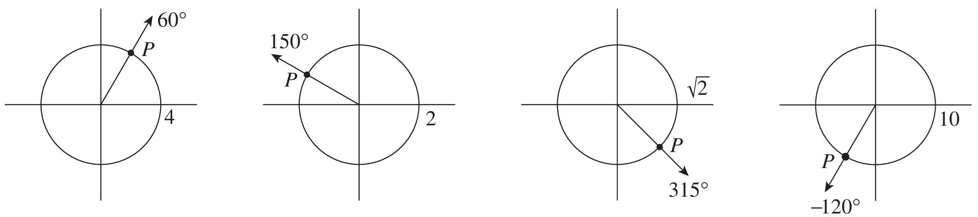  $$\left(4\cos{60°},4\sin{60°}\right)$$  $$\left(2, 2\sqrt{3}\right)$$ | $$\left(2\cos{150°},2\sin{150°}\right)$$  $$\left(-\sqrt{3}, 1\right)$$ | $$\left(\sqrt{2}\cos{315°},\sqrt{2}\sin{315°}\right)$$  $$\left(1, -1\right)$$ | $$\left(10\cos{-120°}, 10\sin{-120°}\right)$$  $$\left(-5, -5\sqrt{3}\right)$$

- Find the exact value of:
- $\tan{225°}$  1 | - $\tan{300°}$  $$-\sqrt{3}$$ | - $\cos{120°}$  $$-\frac{1}{2}$$ | - $\cos{330°}$  $$\frac{\sqrt{3}}{2}$$
- $\cos\left(-300°\right)$  $$\frac{1}{2}$$ | - $\cos\left(-45°\right)$  $$\frac{1}{\sqrt{2}}$$ | - $\cos{570°}$  $$-\frac{\sqrt{3}}{2}$$ | - $\sin{480°}$  $$\frac{\sqrt{3}}{2}$$
- $\sin{300°}$  $$-\frac{\sqrt{3}}{2}$$ | - $\cos\left(-225°\right)$  $$-\frac{1}{\sqrt{2}}$$ | - $\tan\left(-300°\right)$  $$\sqrt{3}$$ | - $\sin\left(-60°\right)$  $$-\frac{\sqrt{3}}{2}$$
- $\sin{690°}$  $$-\frac{1}{2}$$ | - $\sin{495°}$  $$\frac{1}{\sqrt{2}}$$ | - $\tan{675°}$  $$-1$$ | - $\cos{135°}$  $$-\frac{1}{\sqrt{2}}$$

Mastery
- The points $P,Q,R,S$ are on the unit circle. $A\left(1,0\right)$ and $O$ is the origin.
Find the exact coordinates of $P,Q,R,S$ if:
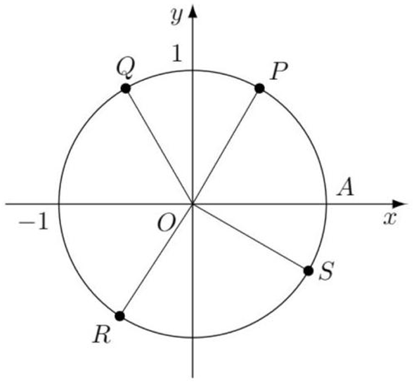
$∠AOP=60°$ $∠AOQ=120°$ $∠AOR=240°$ $∠AOS=30°$

$$P=\left(\frac{1}{2},\frac{\sqrt{3}}{2}\right), Q=\left(-\frac{1}{2},\frac{\sqrt{3}}{2}\right), R=\left(-\frac{1}{2},-\frac{\sqrt{3}}{2}\right), S=\left(\frac{\sqrt{3}}{2},-\frac{1}{2}\right)$$
- Prove, using exact values, that:
  - $\sin{330°}\cos{150°}-\cos{390°}\sin{390°}=0$

$$LHS=-\sin{30°}\left(-\cos{30°}\right)-\cos{30°}\sin{30}$$
$$=\sin{30°}\cos{30°}-\cos{30°}\sin{30°}$$
$$=0=RHS$$
  - $\sin{420°}\cos{405°}+\cos{420°}\sin{405°}=$ $\frac{\sqrt{3}+1}{2\sqrt{2}}$

$$LHS=\sin{60°}\cos{45°}+\cos{60°}\sin{45°}$$
$$=\frac{\sqrt{3}}{2}\left(\frac{1}{2}\right)+\frac{1}{2}\left(\frac{1}{\sqrt{2}}\right)$$
$$=\frac{\sqrt{3}}{2\sqrt{2}}+\frac{1}{2\sqrt{2}}$$
$$=\frac{\sqrt{3}+1}{2\sqrt{2}}=RHS$$
  - $\frac{\sin{135°}-\cos{120°}}{\sin{135°}+\cos{120°}}$ $=3+2\sqrt{2}$
$$LHS=\frac{\sin{45°}-\left(-\cos{60°}\right)}{\sin{45°}+\left(-\cos{60°}\right)}$$
$$=\frac{\left(\frac{1}{\sqrt{2}}+\frac{1}{2}\right)}{\left(\frac{1}{\sqrt{2}}-\frac{1}{2}\right)}$$
$$=\frac{\left(\frac{2+\sqrt{2}}{2\sqrt{2}}\right)}{\left(\frac{2-\sqrt{2}}{2\sqrt{2}}\right)}$$
$$=\frac{2+\sqrt{2}}{2-\sqrt{2}} \frac{×2+\sqrt{2}}{×2+\sqrt{2}}$$
$$=\frac{4+4\sqrt{2}+2}{4-2}$$
$$=\frac{6+4\sqrt{2}}{2}$$
$$=3+2\sqrt{2}=RHS$$
  - ${\left(\sin{150°}+\cos{270°}+\tan{315°}\right)}^{2}=\sin^{2}{135°}\cos^{2}{225°}$
$$LHS={\left(\sin{30°}+0+\left(-\tan{45°}\right)\right)}^{2}$$
$$={\left(\frac{1}{2}-1\right)}^{2}$$
$$=\frac{1}{4}$$
$$RHS=\sin^{2}{45°}\left(--\cos^{2}{45°}\right)$$
$$={\left(\frac{1}{\sqrt{2}}\right)}^{2}{\left(-\frac{1}{\sqrt{2}}\right)}^{2}$$
$$=\frac{1}{4}$$
$$∴LHS=RHS$$

  - $\frac{\sin{120°}}{\tan{300°}}$ $-$ $\frac{\cos{240°}}{\left(\frac{1}{\tan{315°}}\right)}$ $=\tan^{2}{240°}-$ $\frac{1}{\sin^{2}{330°}}$

$$LHS=\frac{\sin{60°}}{-\tan{60°}}-\frac{-\cos{60°}}{\left(\frac{1}{-\tan{45°}}\right)}$$
$$=\frac{\left(\frac{\sqrt{3}}{2}\right)}{-\sqrt{3}}-\frac{\left(-\frac{1}{2}\right)}{-1}$$
$$=-\frac{1}{2}-\frac{1}{2}$$
$$=-1$$
$$RHS=\tan^{2}{60°}-\frac{1}{\sin^{2}{30°}}$$
$$={\left(\sqrt{3}\right)}^{2}-\frac{1}{{\left(\frac{1}{2}\right)}^{2}}$$
$$=3-\frac{1}{\left(\frac{1}{4}\right)}$$
$$=3-4$$
$=-1$
$$∴LHS=RHS$$

- Prove that
$$\frac{\cos{(90°-θ)} \sin{(180°}-θ) }{\cos\left(180°+θ\right) \cos\left(-θ\right)}=-\tan^{2}{θ}$$
$$LHS=\frac{\sin{θ}\sin{θ}}{-cos{θ}\cos{θ}}$$
$$=\frac{\sin^{2}{θ}}{-\cos^{2}{θ}}$$
$$=-\tan^{2}{θ}=RHS$$

Graphs of Trigonometric Functions

- Investigation The graph of $\sin{θ}$
The table has been completed for $\sin{θ}$(you can use a calculator to find these values)
Sketch a graph of this table.

$$θ$$ | $$0°$$ | $$30°$$ | $$60°$$ | $$90°$$ | $$120°$$ | $$150°$$ | $$180°$$ | $$210°$$ | $$240°$$ | $$270°$$ | $$300°$$ | $$330°$$ | $$360°$$
$$\sin{θ}$$ | $$0$$ | $$0.5$$ | $$0.87$$ | $$1$$ | $$0.87$$ | $$0.5$$ | $$0$$ | $$-0.5$$ | $$-0.87$$ | $$-1$$ | $$-0.87$$ | $$-0.5$$ | $$0$$
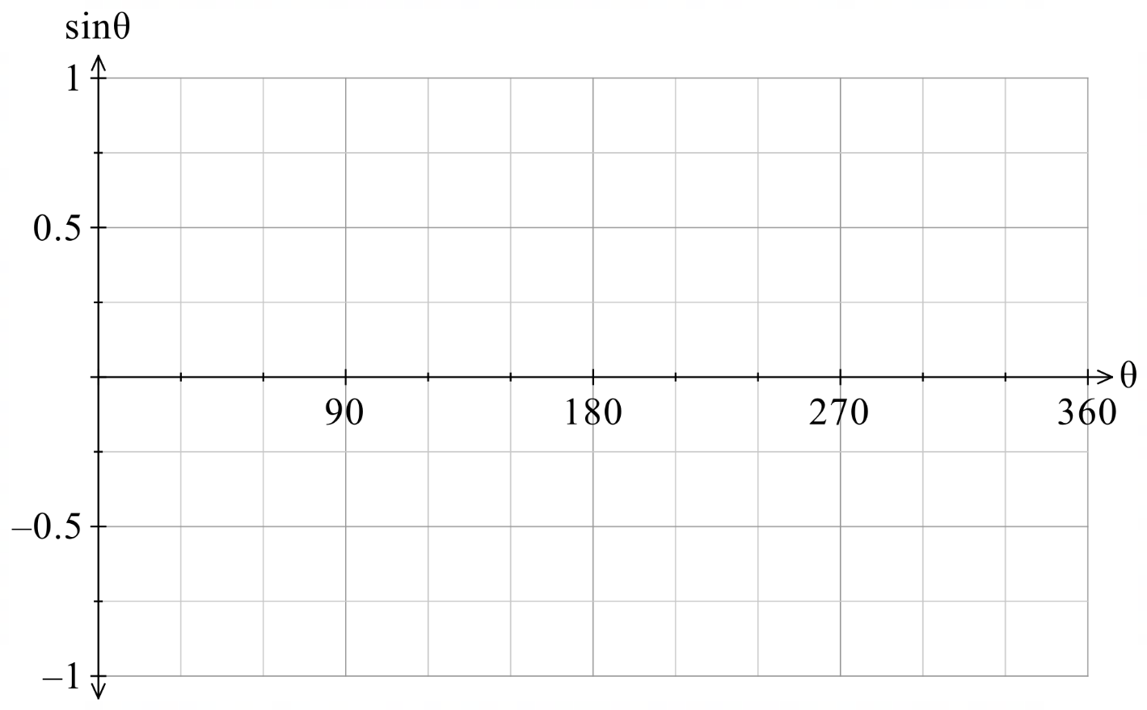

We can also graph the sine function by considering the $y$ coordinates on a unit circle.
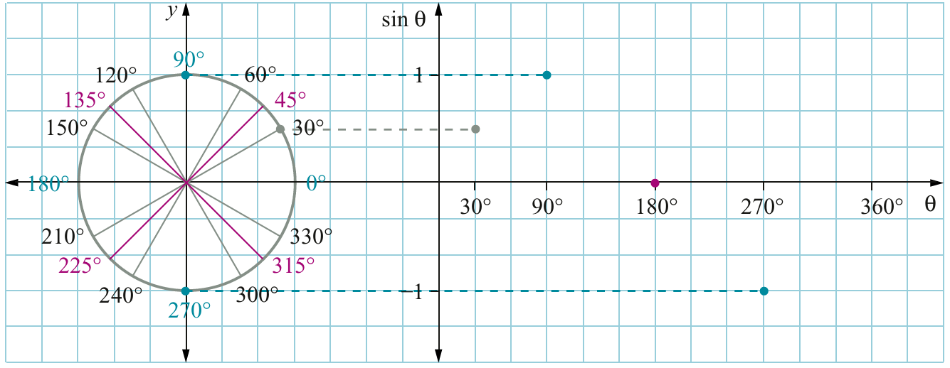

Properties of the sine curve $\sin{θ}$:
- The $\sin{θ}$ value oscillates (swings repeatedly) between ……… and ………
- The period (time to complete one cycle) is ………°, so the graph repeats every ………°
- In $0°<θ<180°,$ the value of $\sin{θ}$ is positive | negative, confirming the ASTC rule that sine is positive in quadrants …… and ……
- In $180°<θ<360°,$ the value of $\sin{θ}$ is positive | negative, confirming the ASTC rule that sine is negative in quadrants …… and ……
- In $0°≤θ≤360°$, when $θ=$ ……, ……, and ……, the value of $\sin{θ}$ is ……

- Investigation The graph of $\cos{θ}$
The table has been completed for $\cos{θ}$
$$θ$$ | $$0°$$ | $$30°$$ | $$60°$$ | $$90°$$ | $$120°$$ | $$150°$$ | $$180°$$ | $$210°$$ | $$240°$$ | $$270°$$ | $$300°$$ | $$330°$$ | $$360°$$
$$\cos{θ}$$ | $$1$$ | $$0.87$$ | $$0.5$$ | $$0$$ | $$-0.5$$ | $$-0.87$$ | $$-1$$ | $$-0.87$$ | $$-0.5$$ | $$0$$ | $$0.5$$ | $$0.87$$ | $$1$$
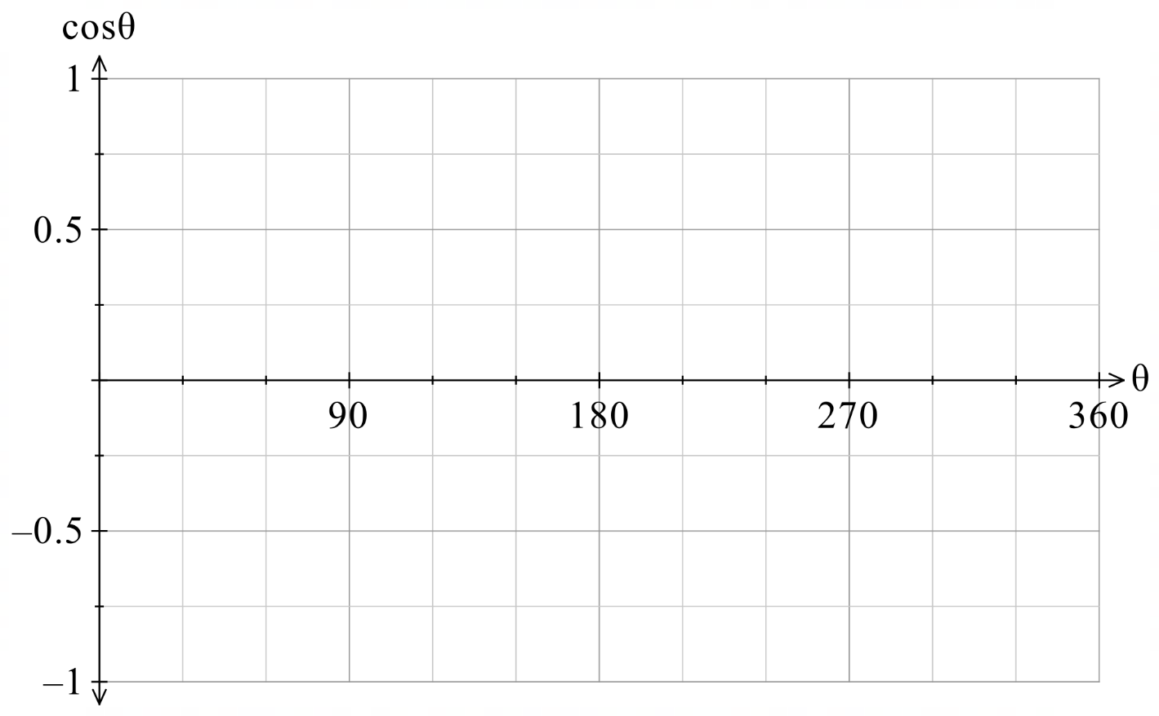
Sketch a graph of this table.

Graph $\cos{θ}$ by considering the $x$ coordinates on a unit circle.
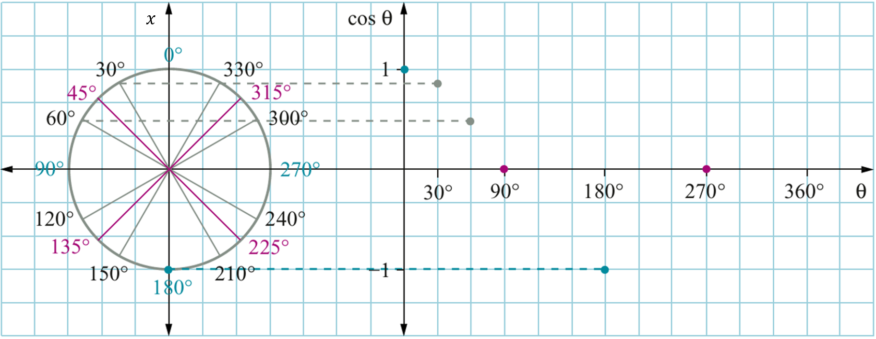

Properties of the cosine curve $\cos{θ}$:
- The $\cos{θ}$ value oscillates (swings repeatedly) between ……… and ………
- The period (time to complete one cycle) is ………°, so the graph repeats every ………°
- In $0°<θ<90°,$ the value of $\cos{θ}$ is positive | negative, confirming the ASTC rule that cos is positive in quadrant ……
- In $90°<θ<270°,$ the value of $\cos{θ}$ is positive | negative, confirming the ASTC rule that cos is negative in quadrants …… and ……
- In $270°<θ<360°,$ the value of $\cos{θ}$ is positive | negative, confirming the ASTC rule that cos is positive in quadrant ……
- In $0°≤θ≤360°$, when $θ=$ …… and …… the value of $\cos{θ}$ is ……
- Comparing the circle diagrams for $\sin{θ}$ and $\cos{θ}$, the circle diagram for $\cos{θ}$ has been rotated …………-wise by ……°, as a result, the graph of $\cos{θ}$ is the graph of $\sin{θ}$ shifted by ……°. This agrees the with the identity $\cos{θ}=\sin{(}$……° $- θ$)

- Investigation The graph of $\tan{θ}$
We will do the same thing for $\tan{θ}$:
$$θ$$ | $$0°$$ | $$30°$$ | $$60°$$ | $$90°$$ | $$120°$$ | $$150°$$ | $$180°$$ | $$210°$$ | $$240°$$ | $$270°$$ | $$300°$$ | $$330°$$ | $$360°$$
$$\tan{θ}$$ | $$0$$ | $$0.58$$ | $$1.73$$ | und | $$-1.73$$ | $$-0.58$$ | 0 | $$0.58$$ | $$1.7$$ | und | $$-1.7$$ | $$-0.58$$ | 0
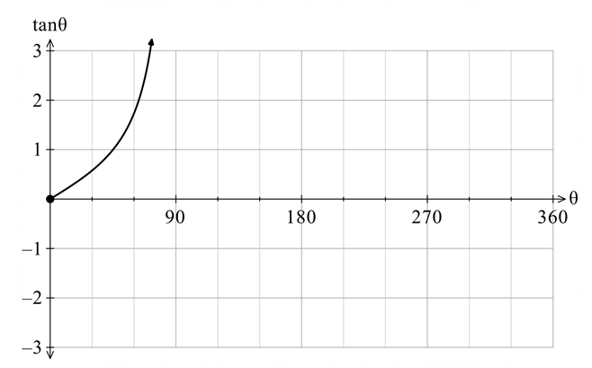

Properties of the tan curve $\tan{θ}$:
- The $\tan{θ}$ value has ……… maximum nor minimum.
- The period (time to complete one cycle) is ………°, so the graph repeats every ………°
- $\tan{θ}$ is positive when …… $<θ<$ …… and …… $<θ<$ ……, confirming the ASTC rule that tan is positive in quadrants …… and ……
- $\tan{θ}$ is negative when …… $<θ<$ …… and …… $<θ<$ ……, confirming the ASTC rule that tan is negative in quadrants …… and ……
- There are vertical ………………… at $θ=90°$ and $270°$. These are values where $\cos{θ}=0$.
- These asymptotes occur because $\tan{θ}=$ $\frac{\sin{θ}}{\cos{θ}};$ when $\cos{θ}=0$, dividing by 0 is …………

- Graphs of the Trigonometric Functions
The graphs of the trigonometric functions are periodic, they keep repeating.
$\cos{x}$ is $\sin{x}$ shifted by $90°$: $\cos{x}=\sin{(90-x})$.
$\sin{x}$ and $\cos{x}$ are called sinusoidal, they occur when you analyse waves.
- https://www.geogebra.org/m/mynd2psx
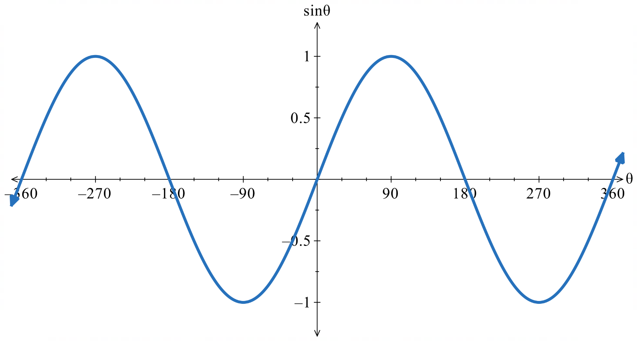
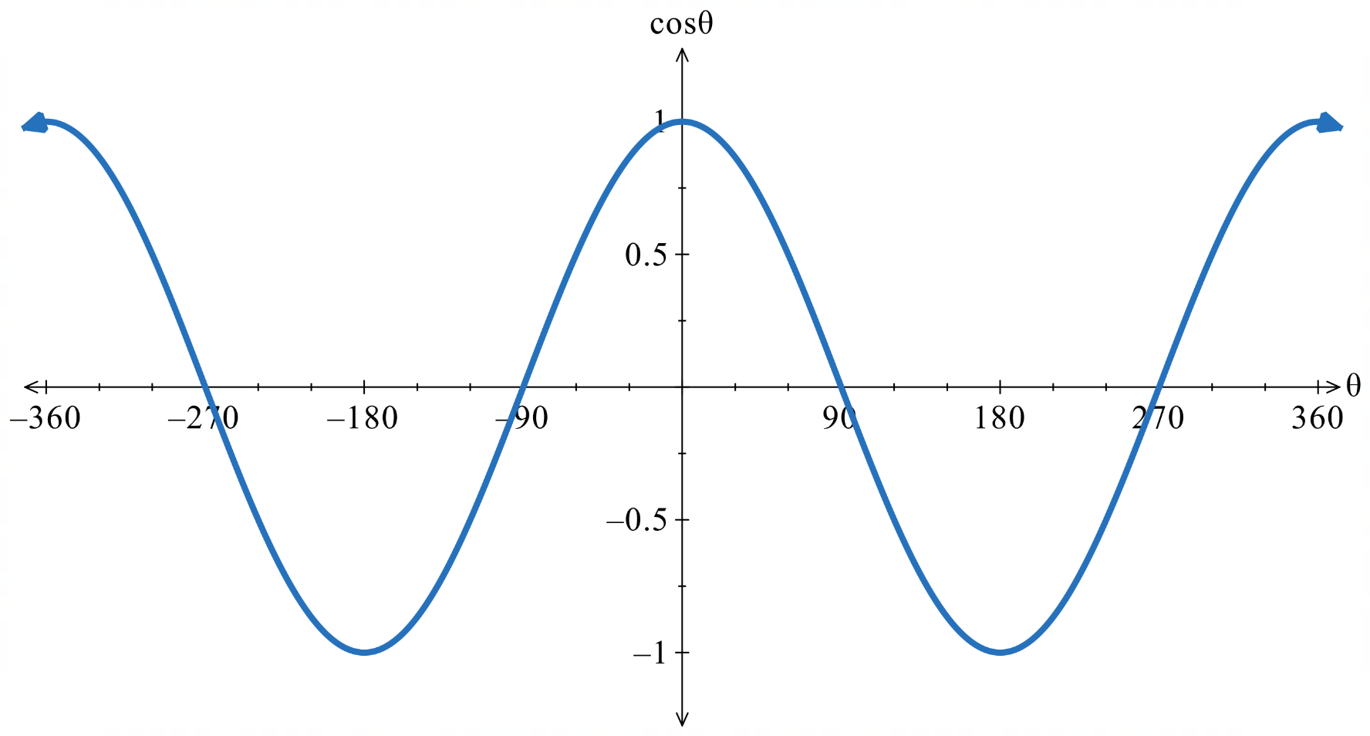
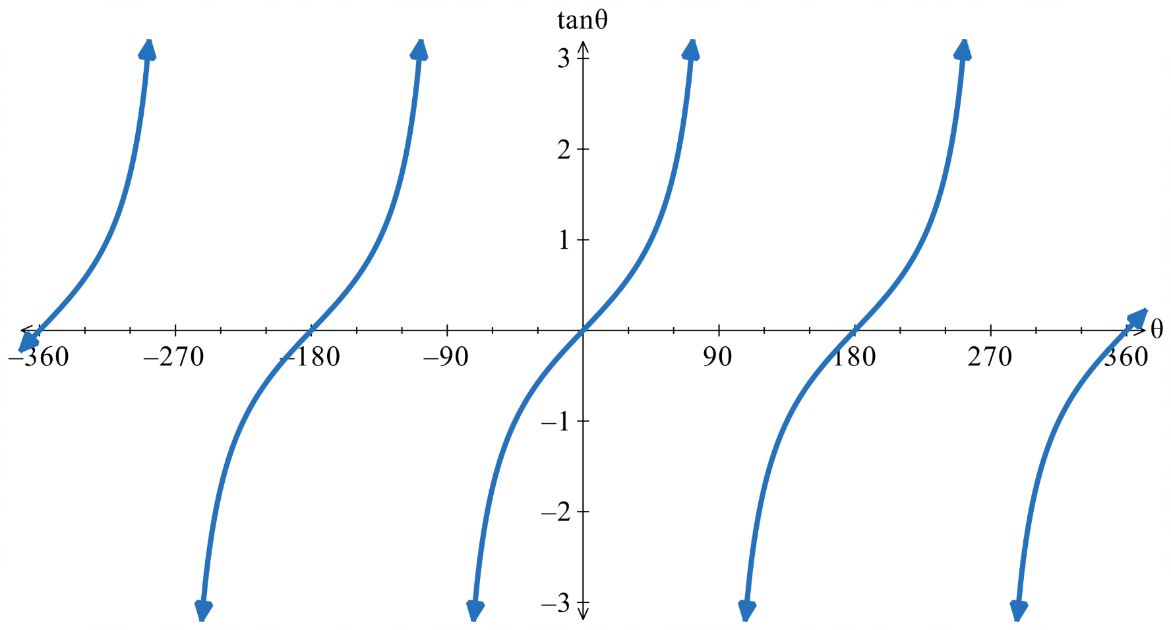
- Using the Trigonometric Graphs to Evaluate and Solve Equations
We can use the trigonometric graphs to estimate values of $\sin{θ}$ and solve equations.
They are also useful because we can quickly determine how many solutions there are in a given interval of $θ$.

- Example Interpret graphs of trigonometric functions
Estimate $\sin{200°}$ using the graph  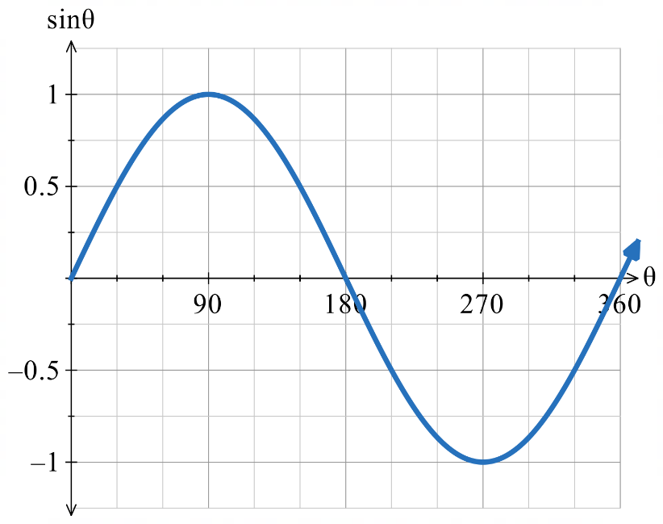  $$-0.35$$  $$\sin{200°}≈-0.35$$ | 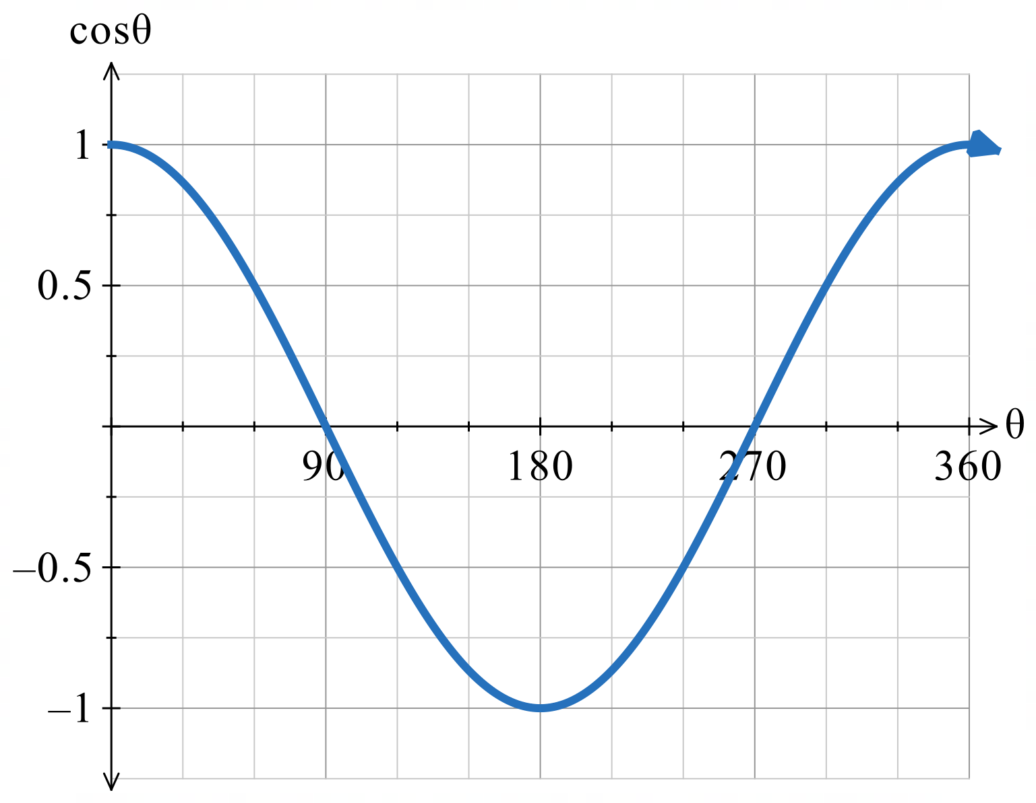  Find values of $θ$ in $0≤θ<360°$ where $\cos{θ}=0.5$ using the graph.  $θ=60°$ or $300°$

- Guided Practice
- Use the graph to estimate $\cos{100°}$  $$≈-0.2$$ | - Find values of $θ$ in $0≤θ<360°$ where $\sin{θ}=-0.5$ using the graph.  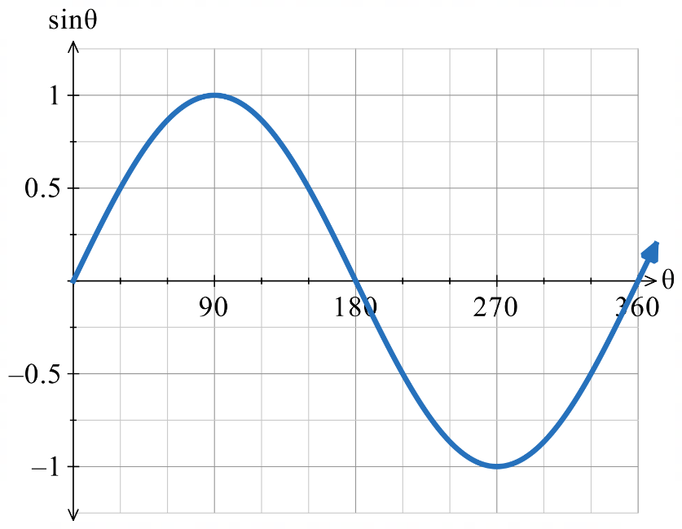  $$210°, 330°$$
- Find values of $θ$ in $0≤θ<360°$ where $\tan{θ}=2$ using the graph.  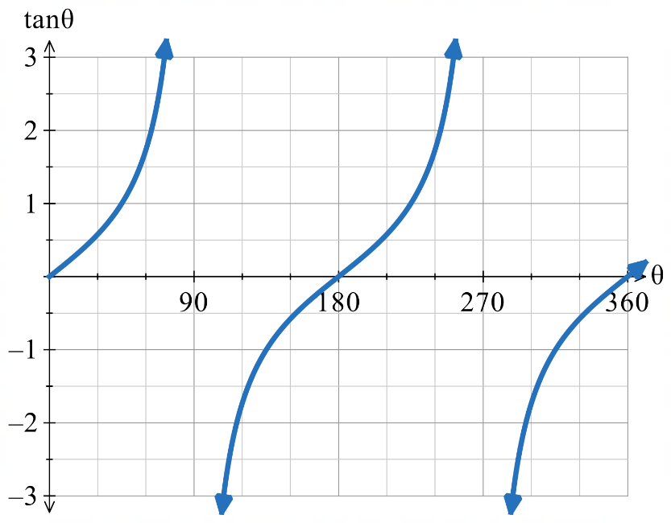  $$≈60°, 240°$$ | - How many values of $θ$ in  $-360°<θ<360°$ satisfy $\sin{θ}=0.75$?  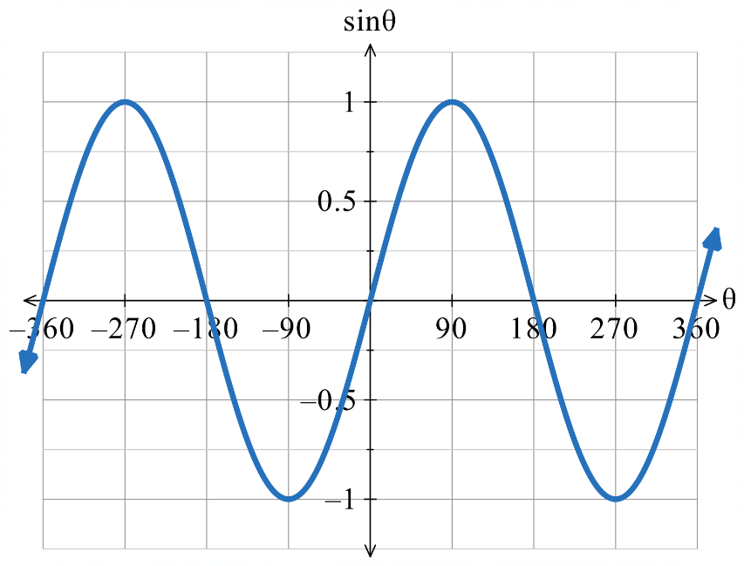  4

Foundation
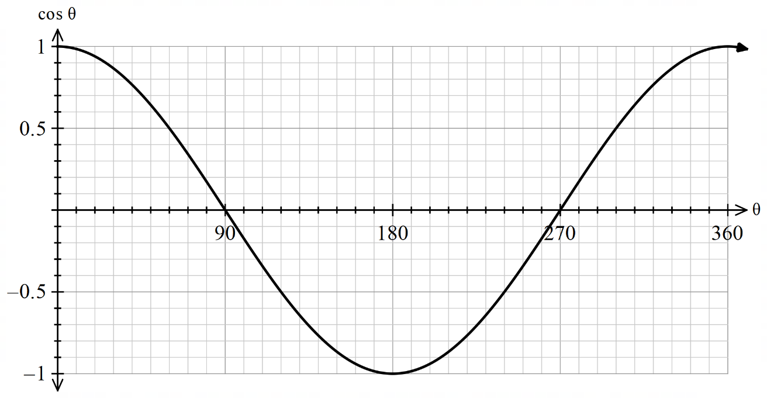
- This graph shows $\cos{θ}$. Use it to estimate the following to 2 d.p.

- $\cos{35°}$  0.82 | - $\cos{190°}$  − 0.98 | - $\cos{330°}$  0.87 | - $\cos{140°}$  − 0.77

- Use the same graph as in Q1 to estimate the values of $θ$ between 0$°$ and 360$°$ for:
- $\cos{θ}=0.8$  37°, 323° | - $\cos{θ}=0.6$  53°, 307° | - $\cos{θ}=0$  90°, 270° | - $\cos{θ}=-0.4$  114°, 246°

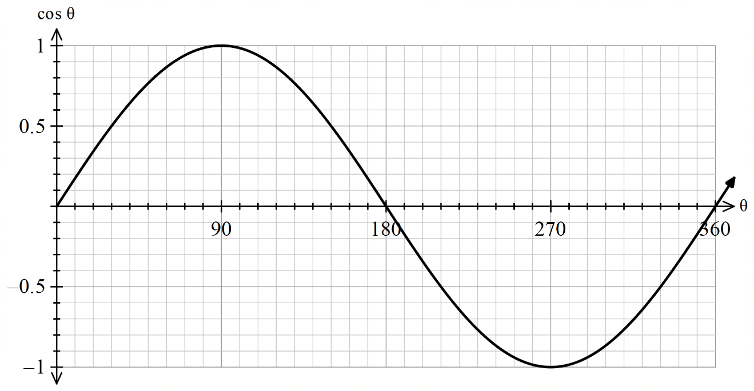
- Use the graph of $\sin{θ}$ to evaluate/solve:

- $\sin{25°}$  0.42 | - $\sin{115°}$  0.91 | - $\sin{220°}$  − 0.64 | - $\sin{310°}$  − 0.77
- $\sin{θ}=0.6$  37°, 143° | - $\sin{θ}=0.2$  12°, 168° | - $\sin{θ}=-0.4$  204°, 336° | - $\sin{θ}=-0.7$  233°, 307°

- Use the trigonometric graphs to find the values (if they exist) of these trigonometric ratios of boundary angles.
- $\sin{0°}$  0 | - $\cos{180°}$  −1 | - $\cos{90°}$  0 | - $\tan{0°}$  0
- $\sin{90°}$  1 | - $\cos{0°}$  1 | - $\sin{270°}$  −1 | - $\cos{270°}$  0
- $\sin{180°}$  0 | - $\tan{270°}$  undefined | - $\tan{90°}$  undefined | - $\tan{180°}$  0

Development
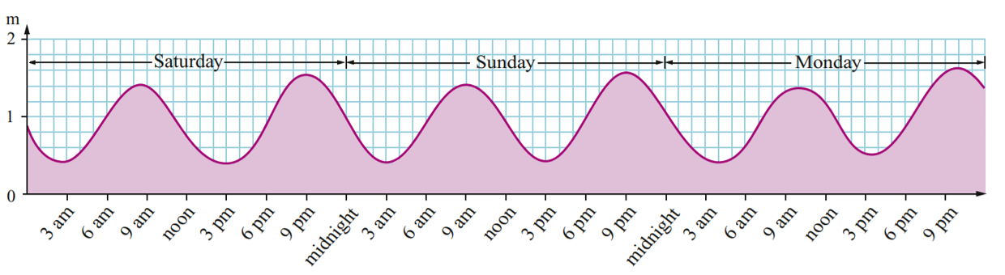
- A tidal chart is shown below.

  - How many low tides occur in a day?
2
  - How many high tides occur in a day?
2
  - What word is used to describe graphs of this shape?
sinusoidal
  - Estimate the low tide height and high tide height for Sunday between noon and midnight.
low tide: 0.4 m, high tide: 1.6 m
  - Estimate the period for the tide graph.
Around 12 hours
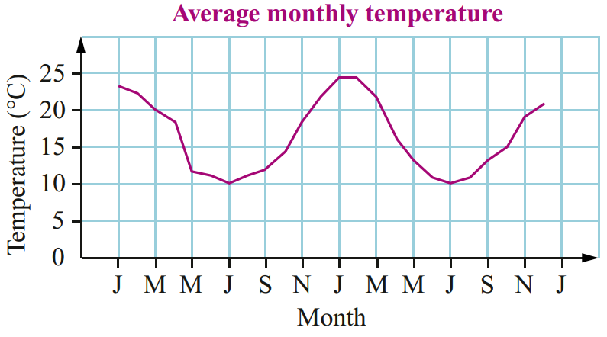
- The graph shows the average monthly temperature of a city over 2 years, starting in Jan.

  - Would you expect this city to be in the Northern or Southern Hemisphere?
Southern, temperatures are high in January.
  - Which trigonometric graph does this resemble? A cosine or sine graph?
Cosine
  - If temperatures of a city in the Northern hemisphere were graphed, what graph would you expect, and why?
Sine; temperatures would be cold in January.
  - What is the difference between the highest and lowest values?
Around 14$°$C
  - What is the period of this graph?
1 year

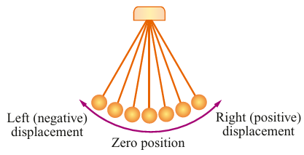
- The diagram shows the motion of a
swinging pendulum and its graph.
What is the period if this graph?

5 seconds
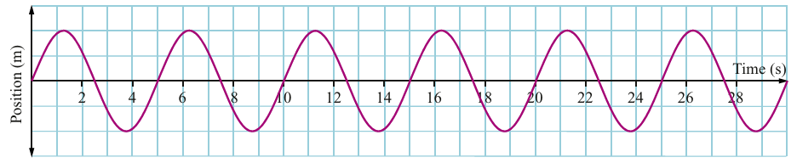

- Consider the graphs of $y=\cos{x}$ and $y=\sin{x}$ on the same axis:
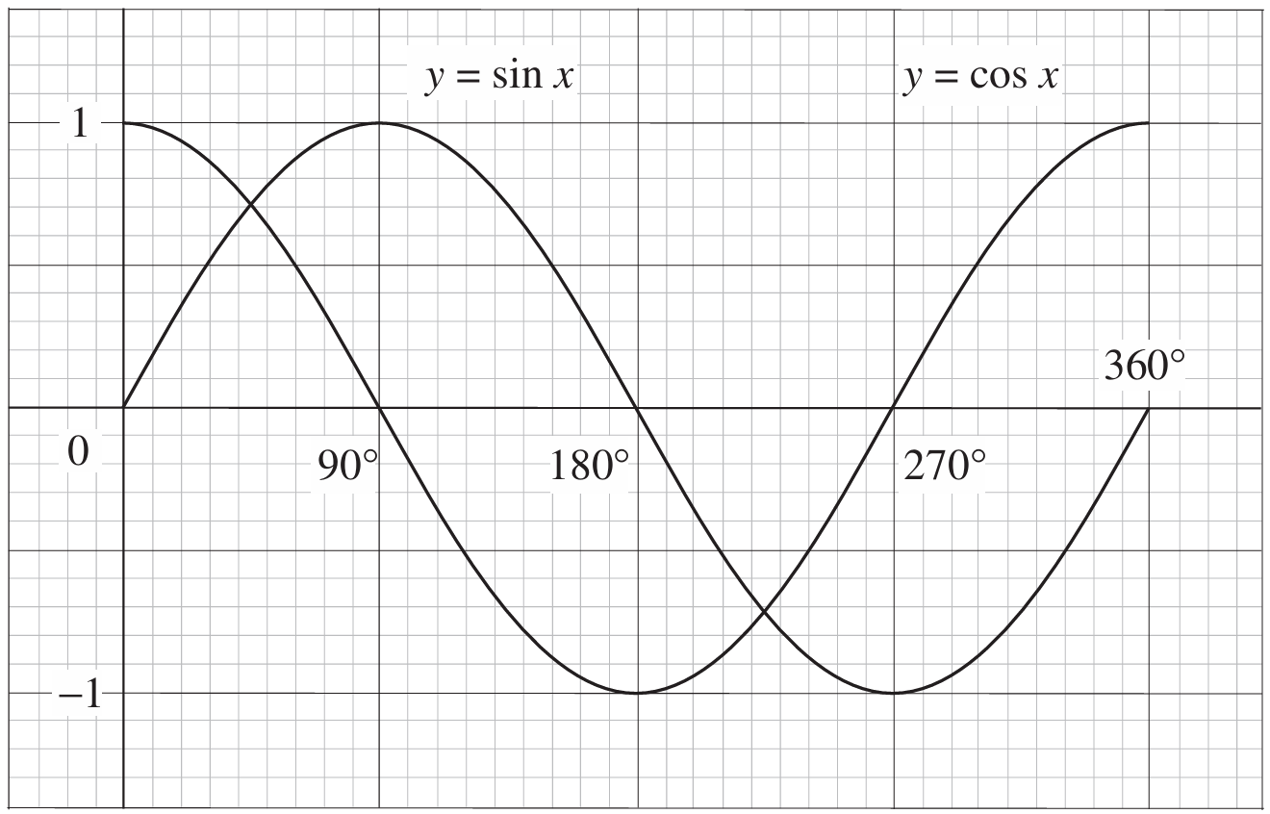

Decide whether the following statements are true or false.
- sin 60° > sin 200°  T | - sin 100° < sin 300°  F | - sin 135° < sin 10°  F
- sin 200° = sin 340°  T | - cos 70° < cos 125°  F | - cos 315° > cos 135°  T
- cos 310° = cos 50°  T | - cos 95° > cos 260°  T | - sin 90° = cos 360°  T
- cos 180° = sin 180°  F | - sin 210° > sin 285°  T | - cos 15° >cos 115°  T

- Using the graph in the previous question, for what angles are the values of $\sin{x}$ and $\cos{x}$ equal in the domain $0°≤x<360°$?

45$°$ and 135$°$

Odd and Evenness of Trigonometric Functions

- Symmetry of Trigonometric Functions
$\sin{x}$ and $\tan{x}$ are odd |  | $\cos{x}$ is even
$$\sin\left(-x\right)$$  $=-\sin{x}$ | $$\tan\left(-x\right)$$  $=-\tan{x}$ | $$\cos\left(-x\right)$$  $=\cos{x}$

Foundation
- What is the domain and range of $y=\sin{θ}$?
D: all real $θ$
R: $[-1,1]$
- What is the domain and range of $y=\cos{θ}$?
D: all real $θ$
R: $\left[-1,1\right]$
- Explain why no values of 𝜃 satisfy sin 𝜃 = 2.

No solution as $2$ is not in the range of $y=\sin{θ}$.
- How many values of 𝜃 satisfy cos 𝜃 = −4? Give a reason.

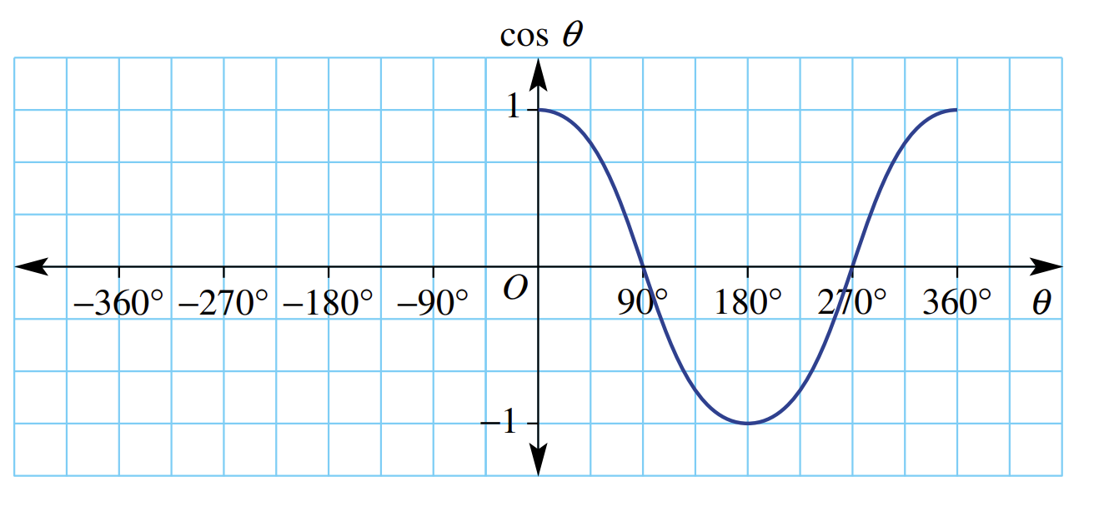
None. $-4$ is not in the range of $y=\cos{θ}$.
- $y=\cos{θ}$ is an even function as $\cos{(-θ})=\cos{θ}$.
Complete the graph for the domain $-360°≤θ≤360°$

- $y=\sin{θ}$ is an odd function as $\sin\left(-θ\right)=-\sin{θ}$.
Complete the graph for the domain $-360°≤θ≤360°$
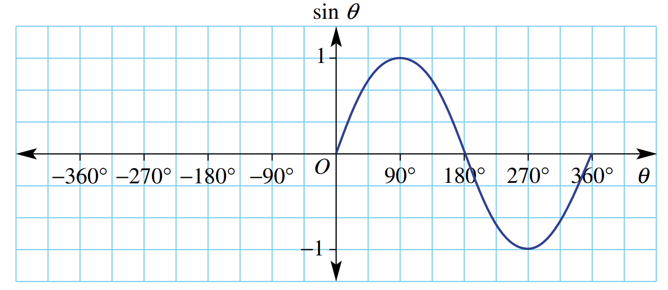

Development
- If $\sin{x}=0.8$, find $\sin\left(-x\right)$.

$$-0.8$$
- If $\tan\left(-x\right)=\sqrt{7}$, find the value of $-\tan{x}$.

$$\sqrt{7}$$
- If $\cos\left(-x\right)=0.3$, find the value of $\cos{x}$.

$$0.3$$
- Simplify $\tan\left(-α\right)-\tan\left(α\right)$.

$$-2\tan{α}$$
- Simplify $\cos\left(-θ\right)-\cos{θ}$.

0
- $f\left(x\right)=\sin{x}+\cos\left(90°-x\right)$. Decide whether $f\left(x\right)$ is odd, even, or neither.

$$f\left(x\right)=\sin{x}+\sin{x}=2\sin{x}$$
$$f\left(-x\right)=2\sin\left(-x\right)$$
$$f\left(-x\right)=-2\sin{x}$$
$$=-f\left(x\right)$$
$$∴odd$$
- $g\left(x\right)= x\sin\left(-x\right)+\cos\left(-x\right)$. Decide whether $g\left(x\right)$ is odd, even, or neither.

$$g\left(x\right)=-x\sin{x}+\cos{x}$$
$$g\left(-x\right)=-\left(-x\right)\sin\left(-x\right)+\cos\left(-x\right)$$
$$g\left(-x\right)=-x\sin{x}+\cos{x}$$
$$=g\left(x\right)$$
$$∴even$$
Sketch this on Desmos, it looks really cool!

- $f\left(x\right)=x^{2}\sin\left(-x\right)+x\cos\left(-x\right)$. Decide whether $f\left(x\right)$ is odd, even, or neither.

$$f\left(x\right)=-x^{2}\sin{x}+x\cos{x}$$
$$f\left(-x\right)=-{\left(-x\right)}^{2}\sin\left(-x\right)+\left(-x\right)\cos\left(-x\right)$$
$$=x^{2}\sin{x}-x\cos{x}$$
$$=-f\left(x\right)$$
$$∴odd$$
Sketch this on Desmos, it looks really cool!

Solving Trigonometric Equations

- Investigation Solving trigonometric equations
Consider $\sin{θ}=0.5$. To solve this equation, we can use the inverse trigonometric function:
$$\sin{θ=0.5}$$
$θ=$ …………

The calculator will return only one value: $\sin^{-1}\left(0.5\right)=30°$.

However, using the unit circle, or the graph, there are two solutions for $0≤θ<360°$.
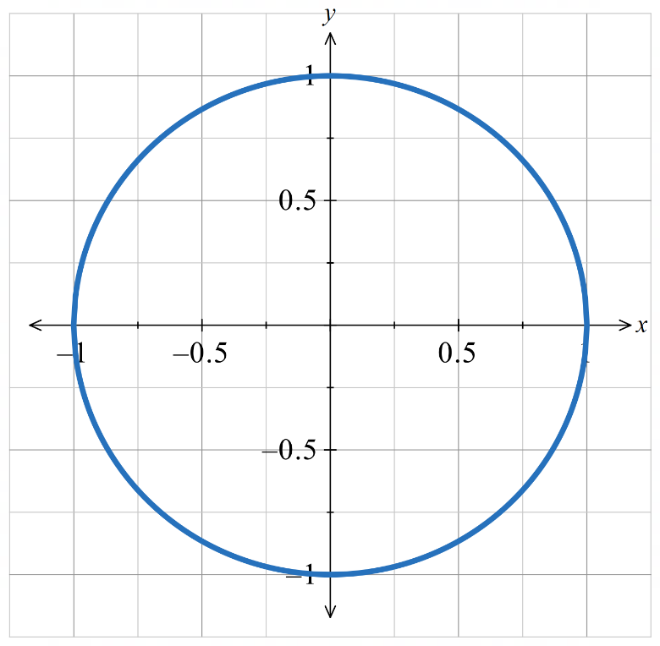

To solve trigonometric equations without sketching an accurate unit circle and graph, we need another method.
It involves finding the acute reference angle and identifying the relevant quadrants.

- Finding the Reference Angle from a Calculator
To find the acute reference angle $A$:
- Use the relevant inverse trigonometric function: $\sin^{-1}{( )}, \cos^{-1}{( )}, \tan^{-1}{( )}$
- Always enter the positive value of the ratio.
- The calculator returns the acute reference angle $A$.

The calculator's inverse functions give results in restricted ranges that may include negative angles.
By entering the positive value, we always get a positive acute angle and this leads to fewer mistakes.
You will learn more about the inverse trigonometric functions in the Year 12 Advanced course.

- Determine reference angle from a calculator
$$\sin{θ}=\frac{1}{\sqrt{2}} \\ A=\sin^{-1}\left(\frac{1}{\sqrt{2}}\right) \\ =45°$$ | $$\cos{θ}=-\frac{\sqrt{3}}{2} \\ A=\cos^{-1}\left(\frac{\sqrt{3}}{2}\right) \\ =30°$$ | $$\tan{θ}=-0.5 \\ A=\tan^{-1}\left(0.5\right) \\ ≈26°34'$$
Find the acute reference angle for these trigonometric ratios.
- $\sin{θ}=$ $-\frac{1}{2}$ | - $\tan{θ}=-1$ | - $\cos{θ}=$ $\frac{1}{\sqrt{2}}$
- $\tan{θ}=\sqrt{3}$ | - $\tan{θ}=-$ $\frac{1}{\sqrt{3}}$ | - $\sin{θ}=-0.6$

- Identifying the Quadrant from a Trigonometric Ratio
We identify the quadrants from the sign of the trigonometric ratio:
Condition | sin θ > 0 | sin θ < 0 | cos θ > 0 | cos θ < 0 | tan θ > 0 | tan θ < 0
Quadrants | Q1, Q2 | Q3, Q4 | Q1, Q4 | Q2, Q3 | Q1, Q3 | Q2, Q4
Diagram | 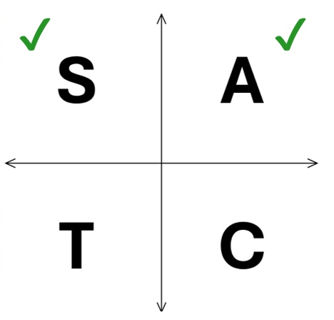 | 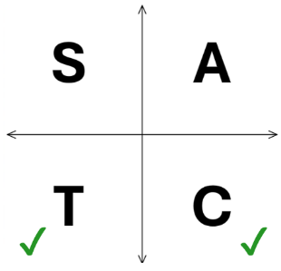 | 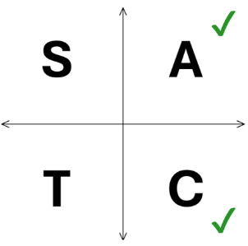 | 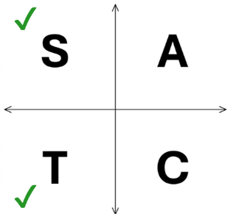 | 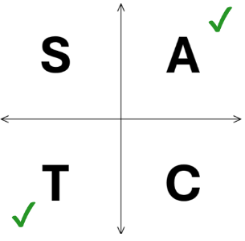 | 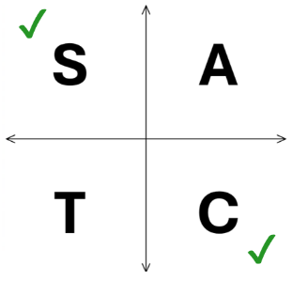

- Determine quadrants from a ratio
$$\sin{θ}=\frac{1}{\sqrt{2}}$$  $\sin{θ}>0$  $∴Q1, Q2$ | $$\cos{θ}=-\frac{\sqrt{3}}{2}$$  $\cos{θ}<0;$  $∴Q2, Q3$ | $$\tan{θ}=-0.5$$  $\tan{θ}<0;$  $∴Q2, Q4$
Find the acute reference angle for these trigonometric ratios.
- $\sin{θ}=$ $-\frac{1}{2}$ | - $\tan{θ}=-1$ | - $\cos{θ}=$ $\frac{1}{\sqrt{2}}$
- $\tan{θ}=\sqrt{3}$ | - $\tan{θ}=-$ $\frac{1}{\sqrt{3}}$ | - $\sin{θ}=-0.6$

- Solving Trigonometric Equations
To solve equations like $trig θ=value$:
            - Find the acute reference angle using the inverse function on the calculator.
Remember to always use the positive ratio. $A=trig^{-1}\left(\left|value\right|\right)$
            - Determine the quadrants using ASTC based on the sign of the value.
            - Calculate $θ$ for each quadrant.
- For now, you will only be asked to solve equations where $0≤θ<360°$

- Example Solve simple trigonometric equations where $0≤θ<360°$
Solve $\cos{θ}=\frac{\sqrt{3}}{2}$ for $0≤θ<360°$  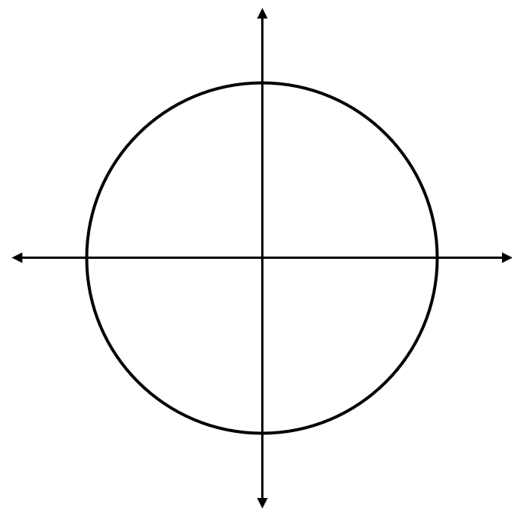  1. $A=\cos^{-1}\left(\frac{\sqrt{3}}{2}\right)=30°$  $$30°$$  $$30°$$  2. $\cos{x}>0,$  $θ$ is in Q1 or Q4.  3. $θ=30°$ or $330°$ | How did we know the second solution is $330°$?  Since cos is also positive in the …th quadrant  The reference angle of $30°$ in the …th quadrant represents an angle of inclination of ……$-30°=330°$
Solve $\tan{θ}=-1$ for $0≤θ<360°$  1. $A=\tan^{-1}{(1)}=45°$  $$45°$$  $$45°$$  2. $\tan{θ}<0,$  $θ$ is in Q2 or Q4.  3. $θ=135°$ or $315°$ | Why is $45°$ not a solution?  The question says $\tan{θ}=-1$, and tan is ……………… in the first quadrant.  Type in $\tan^{-1}\left(-1\right)$ into the calculator.  Why do we always use the positive ratio?  By using the positive ratio, the calculator always gives us the ……………… angle.

- Guided Practice
Solve these trigonometric equations for $0≤θ<360°$
- $\cos{θ}=$ $\frac{1}{\sqrt{2}}$  $$45°, 315°$$ | - $\sin{θ}=-$ $\frac{\sqrt{3}}{2}$  $$240°, 300°$$

Foundation
- For each equation, circle the quadrants that $x$ would be in.
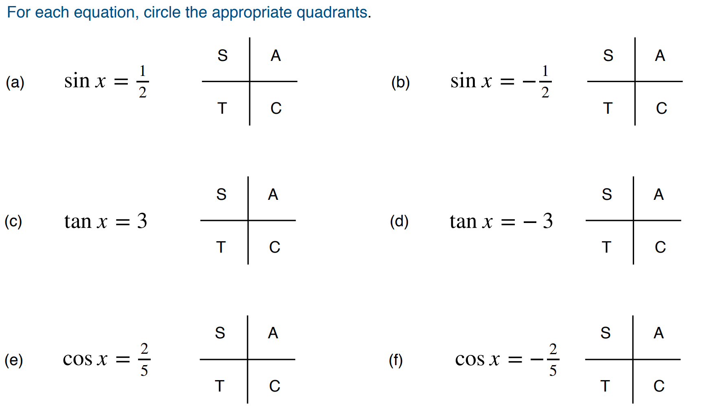  A S | T C | A T
S C | A C | S T

- Solve each of these equations for $0≤θ<360°$
- $\sin{θ}=\frac{\sqrt{3}}{2}$  1. Reference angle  2. Quadrants  3. Solutions  θ =60° or 120° | - $\tan{θ}=1$  θ =45° or 225° | - $\tan{θ}=\sqrt{3}$  θ =60° or 240°
- $\cos{θ}=-\frac{1}{\sqrt{2}}$  θ =135° or 225° | - $\tan{θ}=-\sqrt{3}$  θ =120° or 300° | - $\cos{θ}=-\frac{\sqrt{3}}{2}$  θ =150° or 210°

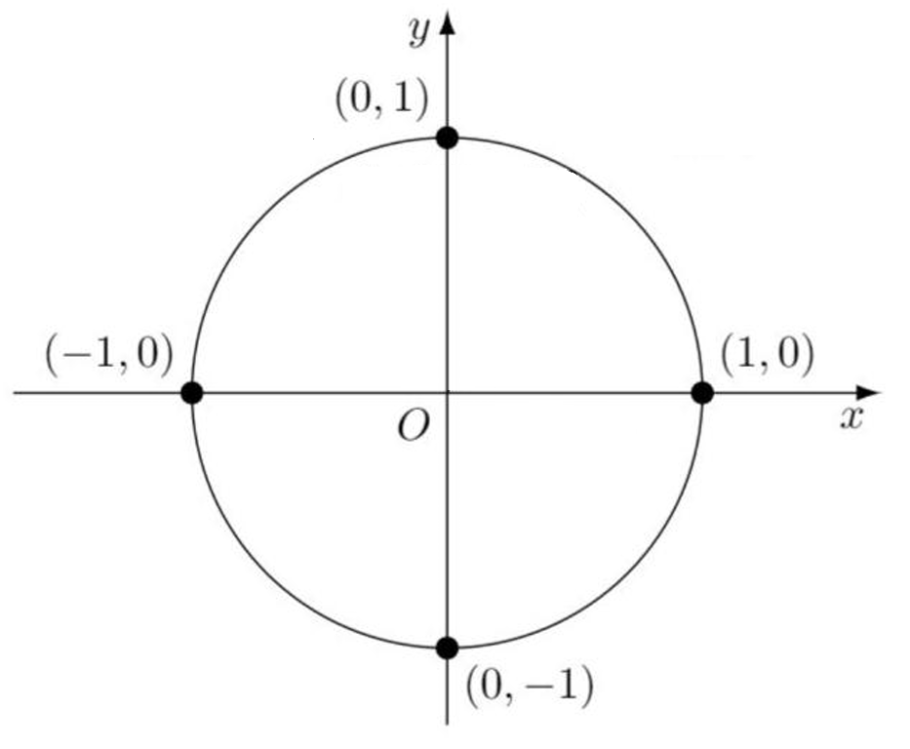
- These equations lie on boundary angles, i.e. they are on the edges of the quadrants.
We solve these using the graphs, a diagram of the unit circle, or knowledge of exact values.
Solve for $0≤θ<360°$
- $\sin{θ}=1$  θ =90° | - $\cos{θ}=1$  θ = 0° | - $\tan{θ}=0$  θ = 0°, 180°
- $\sin{θ}=-1$  θ = 270° | - $\cos{θ}=0$  θ = 90° or 270° | - $\sin{θ}=0$  θ = 0°, 180°

Development
- Solve each of these equations for $0≤x<360°$ to the nearest degree.
You will need to enter the inverse trigonometric function into a calculator.
- $\cos{x}=\frac{3}{7}$  65° or 295° | - $\sin{x}=0.1234$  7° or 173° | - $\tan{x}=7$  82° or 262°
- $\sin{x}=-\frac{2}{3}$  222° or 318° | - $\tan{x}=-\frac{20}{9}$  114° or 294° | - $\cos{x}=-0.77$  140° or 220°
- $\tan{x}=-0.3$  163° or 343° | - $\cos{x}=0$  90° or 270° | - $\sin{x}=-\frac{\sqrt{3}}{2}$  240° or 300°
- $\cos{x}=0.191$  79° or 281° | - $\tan{x}=1$  45° or 225° | - $\frac{1}{\cos{x}}$ $=\sqrt{2}$  45° or 315°

Mastery
- Solve for $θ∈\left[0°,360°\right)$.
- $2\sin{θ}-1=0$  30°, 150° | - $\sqrt{2}\cos{θ}-1=0$  45°, 315° | - $\sqrt{3}\tan{θ}=-2=-1$  30°, 210°
- $2\cos{θ}+\sqrt{3}=0$  150°, 210° | - $6\sin{θ}+3=0$  210°, 330° | - $1+\tan{θ}=0$  135°, 315°

- Solve for $θ∈\left[0°,360°\right)$. Remember to take positive and negative values when square rooting.
- $\sin^{2}{θ}=1$  90°, 270° | - $\cos^{2}{θ}=$ $\frac{3}{4}$  30°, 150°, 210°, 330° | - $\tan^{2}{θ}=3$  60°, 120°, 240°, 300°

- Solve for $θ∈\left[0°,360°\right)$. Remember, to solve quadratic equations we need to factorise.
- $2\cos^{2}{θ}-\cos{θ}=0$  60°, 90°, 270°, 300° | - $\sin^{2}{θ}+\sin{θ}=0$  0°, 180°, 270° | - $\tan^{2}{θ}=\tan{θ}$  0°, 45°, 180°, 225°
- $2\cos^{2}{θ}-1=0$  45°, 135°, 225°, 315° | - $3\tan^{2}{-1}=0$  30°, 150°, 210°, 330° | - $\left(2\sin{θ}-1\right)\left(\sin{θ}+1\right)=0$  30°, 150°, 270°
- Jimmy solved $\tan^{2}{θ}=\tan{θ}$ for $θ∈\left[0°,360°\right)$ by dividing both sides by $\tan{θ}$ first.
He got the solutions $45°$ and $225°$, which are not all the solutions.

The correct method is to move all terms to left side and factorise, then use null factor law.
By dividing both sides by $\tan{θ}$, he is assuming that $\tan{θ}$ is not 0.
Therefore, he is missing the solutions to $\tan{θ}=0$, which are $θ=0°$ and $θ=180°$

- Solve for $θ∈\left[0°,360°\right)$.
- $2\sin^{2}{θ}-3\sin{θ}+1=0$  30°, 90°, 150° | - $2\cos^{2}{θ}-\cos{θ}-3=0$  180°
- $2\cos^{2}{θ}=\cos{θ}$  $60°, 90°, 270°, 300$° | - $\frac{1}{\cos^{2}{θ}}$ $+$ $\frac{1}{\cos{θ}}$ $-2=0$  0°, 120°, 240°, 360°

- Solve for $θ∈\left[0°,360°\right)$. Answer to the nearest minute where necessary.
- $2\sin{θ}\cos{θ}=\sin{θ}$  $$0°, 60°, 180°, 300°, 360°$$ | - $2\sin^{2}{θ}+\sin{θ}=1$  $$30°, 150°, 270°$$
- $\frac{1}{\cos^{2}{θ}}+\frac{2}{\cos{θ}}=8$  $$60°, 300°, 104°{29}^{'}, 255°,31'$$ | - $3\cos^{2}{θ}+5\cos{θ}=2$  $$70°{32}^{'},289°28'$$
- $\frac{4}{\sin^{2}{θ}}-\frac{4}{\sin{θ}}-15=0$  $$23°{35}^{'}, 156°{25}^{'}, 22° {49}^{'}, 31° 11'$$ | - $4\sin^{3}{θ}=3\sin{θ}$  $$0°, 60°, 120°, 180°, 240°, 300°, 360°$$

- Solve $4\cos^{2}{θ}+2\sin{θ}=3$ for $0≤x<360°$ to the nearest degree.

$$\sin{θ}=\frac{1±\sqrt{5}}{4}$$
$$θ=54°, 126°, 198°, 342°$$

Gradient and Angle of Inclination

- Investigation Gradient and Tan
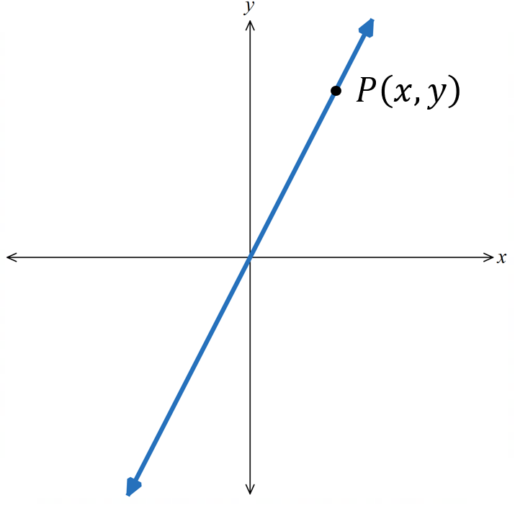
Consider a line through the origin. Choose any point $\left(x,y\right)$ on the line.
The gradient is: $m=$ $\frac{rise}{run}$ $=$

Construct a right-angled triangle, the ratio $\tan{θ}=$ $\frac{opp}{adj}$ $=$

Therefore, $m=\tan{θ}$.
We can extend this relationship to all lines, not just ones through the origin, since the gradient and angle of inclination does not change based on the location of the line.

- Gradient is Tan of Angle of Inclination
$$m=\tan{θ}$$
For acute angles, the gradient is positive.  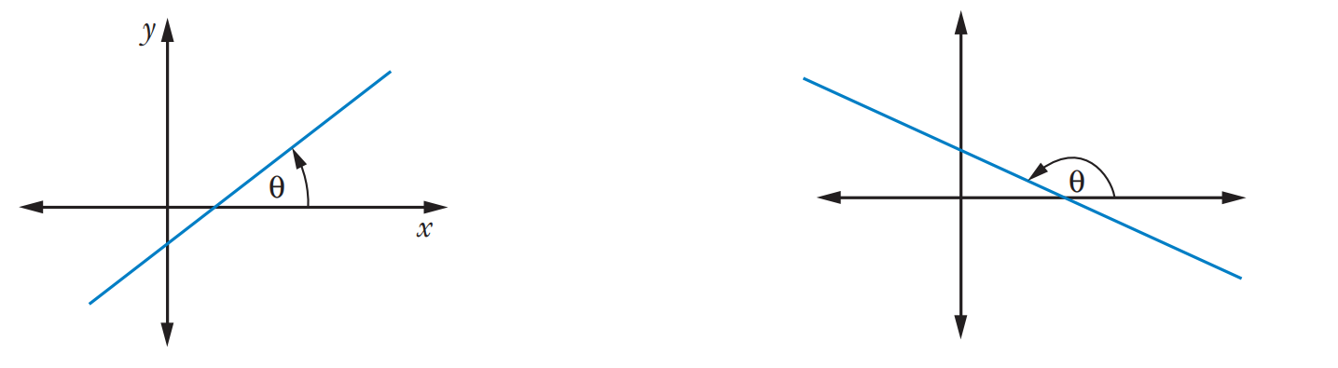 | For obtuse angles, the gradient is negative.

- Example Determine gradient of a line from the angle of inclination
Find the gradient of the line that makes an angle of inclination of $135°$
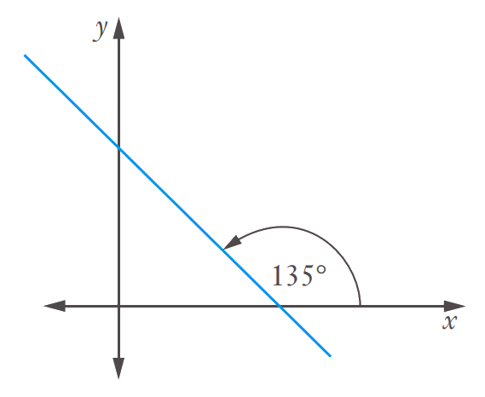
$m=\tan{θ}$
$=\tan{135°}$
$=-1$

- Guided Practice
- $θ=45°$  1 | - $θ=80°$  5.67
- $θ=155°$  $$-0.47$$ | - $θ=-45°$  $$-1$$
- Finding the Angle of Inclination from the Gradient
$$θ=\tan^{-1}\left(m\right)$$

If the calculator returns a negative angle, add 180° to the result.
- $\tan^{-1}\left( \right)$function always returns angles in the range $-90°<θ<90°$.
Angle of inclination of a line is an angle $0≤θ<180°$.We add 180° to the result because $\tan{θ}=\tan\left(180°+θ\right).$

- Example Determine angle of inclination from the gradient
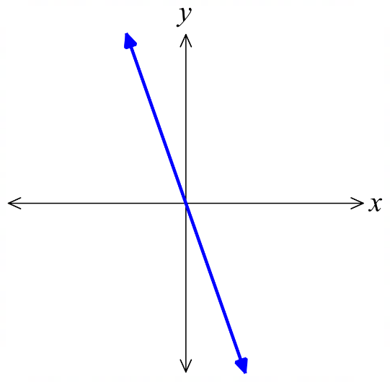
Find, correct to the nearest minute, the angle of inclination of a straight line with gradient:
$m=0.5$  $$\tan{θ}=m \\ \tan{θ}=0.5 \\ θ=\tan^{-1}{(0.5)} \\ θ≈26°{34}^{'}$$  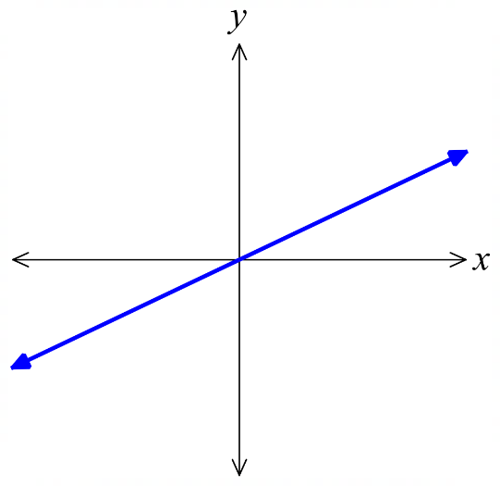 | $m=-3$  $$\tan{θ}=m \\ \tan{θ}=-3 \\ θ=\tan^{-1}{(-3)} \\ θ≈-71°35' \\ ≈108°26'$$

- Guided Practice
Find, correct to the nearest minute, the angle of inclination of a straight line with gradient:
- $m=1$  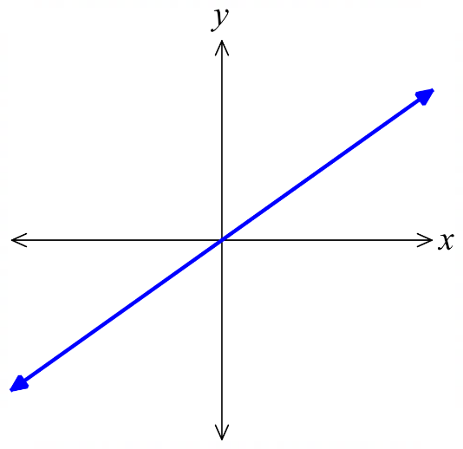  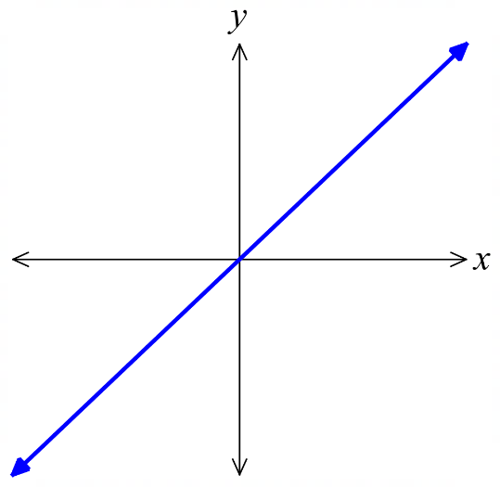  $$45°$$ | - $m=$ $\frac{3}{4}$  $$36° 52’$$
- $m=-2$  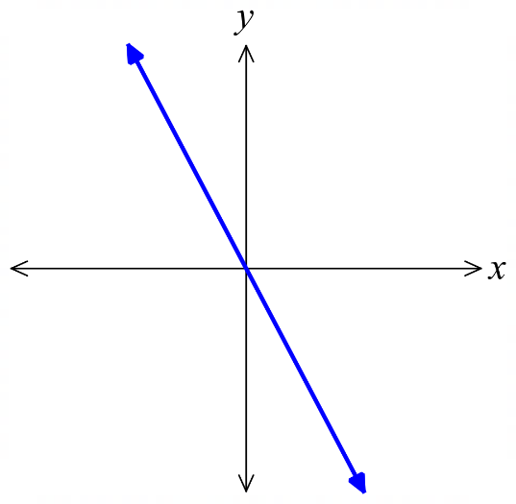  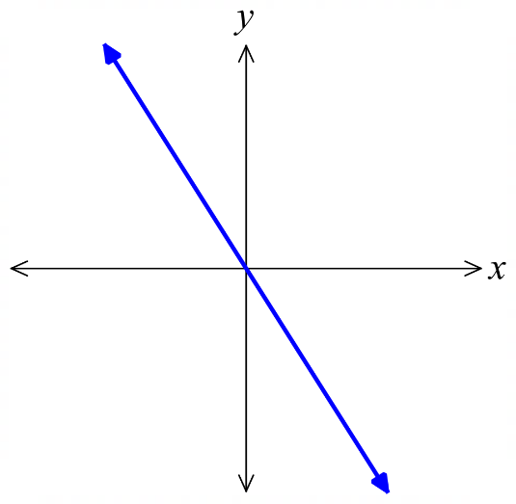  $$116°34'$$ | - $m=-$ $\frac{5}{3}$  $$300°58'$$

Foundation
- Use the formula $m=\tan{θ}$ to find the gradient of a line with these angles of inclination.
Answer to 2 decimal places.
- $θ=15°$  0.27 | - $θ=85°$  11.43 | - $θ=135°$  –1 | - $θ=180°$  0

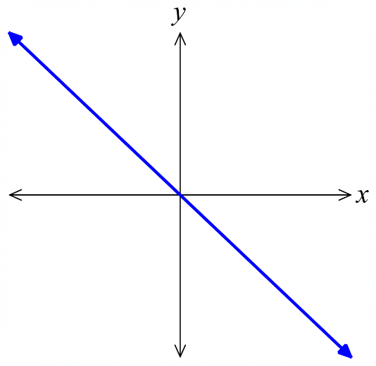
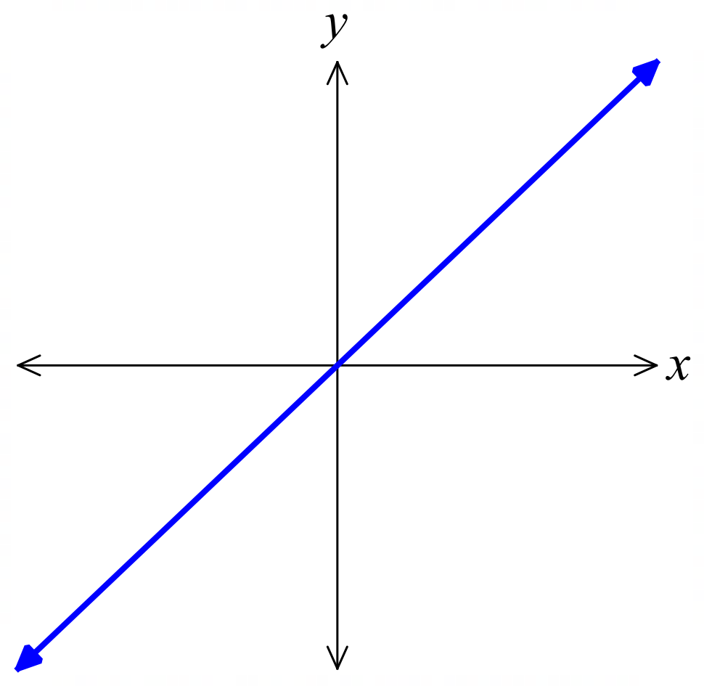
- Use the formula $\tan{θ}=m$ to find the angle of inclination of a line with these gradients.
Answer to the nearest degree. A sketch will help you visualise the problem.
- $m=1$  $\tan{θ}=1$  $θ=\tan^{-1}{( )}$  $=$  45° | - $m=-1$  135° | - $m=0.5$  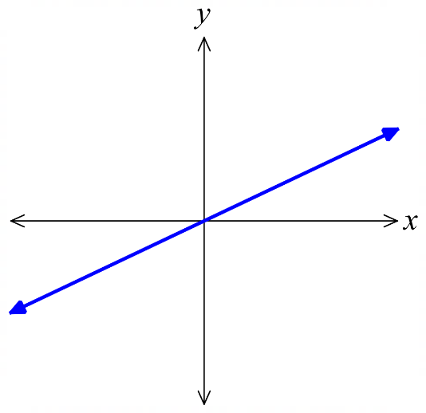  27°
- $m=-0.5$  153° | - $m=1.73$  60° | - $m=\frac{5}{2}$  68°
- $m=4$  76° | - $m=-0.58$  150° | - $m=-12$  95°

Development
- Sketch these lines then find the angle of inclination to the nearest degree.
- $y=3x+6$  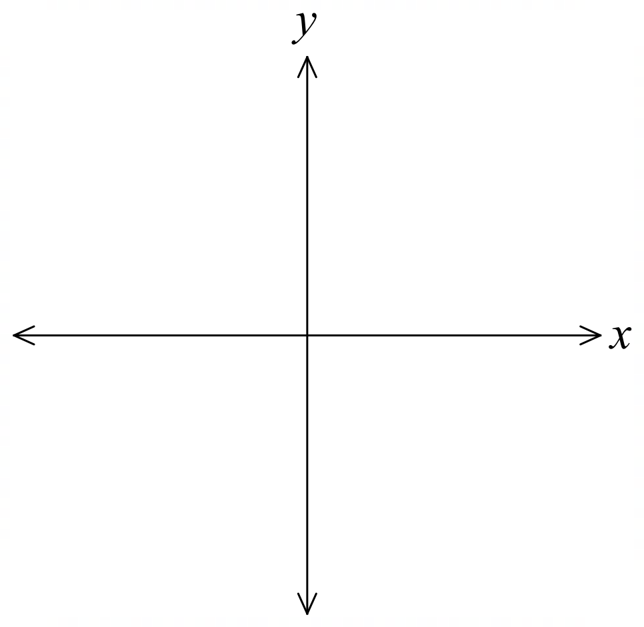  72° | - $y=-\frac{1}{2}x+1$  153°
- $3x+4y=-12$  143° | - $\frac{x}{3}-\frac{y}{2}=1$  34°

- What is the angle of inclination of the line $x=-2$?

$$90°$$
- The angle of inclination of a line is 135$°$ and passes through the point $\left(4,2\right)$ and $\left(x,-3\right)$.
Find the value of $x$.

$$m=\tan{135°}=-1$$
$$m=\frac{y_{2}-y_{1}}{x_{2}-x_{1}}=\frac{-3-2}{x-4}=-1$$
$$\frac{-5}{x-4}=-1$$
$$x=9$$

- Determine the equation of each straight line sketched below in exact general form.
$$x-y+4=0$$ | 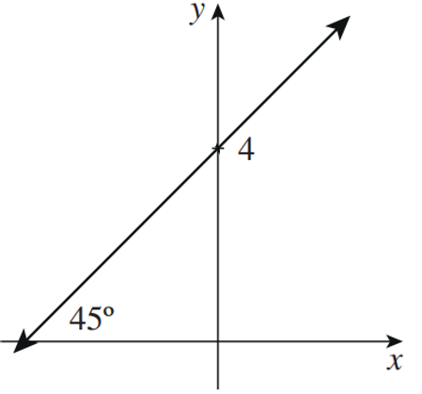  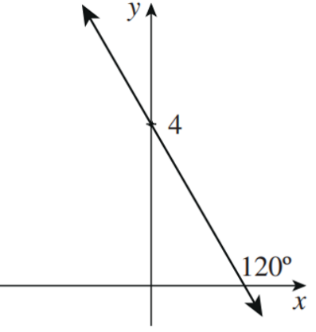  $$\sqrt{3}x+y-4=0$$ | 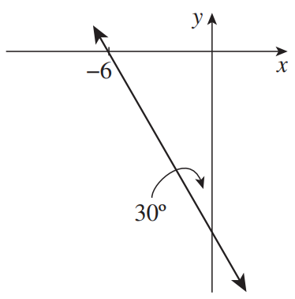  $$x\sqrt{3}+y+6\sqrt{3}=0$$

- In each part, the angle of inclination $α$ and the $y$-intercept $c$ of a line are given,
Use $m=\tan{α}$ to find the gradient of each line, then find its equation in exact general form.
- $α=45°$, $c=\left(0,3\right)$  $$x-y+3=0$$ | - $α=60°$, $c=\left(0,-1\right)$  $$-\sqrt{3}x+y+1=0$$
- $α=30°$, $c=\left(0,-2\right)$  $$x-\sqrt{3}y-2\sqrt{3}=0$$ | - $α=135°$, $c=\left(0,1\right)$  $$x+y-1=0$$

- In each part, the angle of inclination $α$ and a point $A$ on the line is given,
Use $m=\tan{α}$ to find the gradient of each line, then find its equation in exact general form.
- $α=45°$, $A=\left(1,0\right)$  $$x-y-1=0$$ | - $α=120°$, $A=\left(-1,0\right)$  $$\sqrt{3}x+y+\sqrt{3}=0$$
- $α=30°$, $A=\left(4,-3\right)$  $$x-y√3-4-3√3=0$$ | - $α=150°$, $c=\left(-2,-5\right)$  $$x+\sqrt{3}y+2+5\sqrt{3}=0$$

Mastery
- A triangle is formed by the $x$-axis and the lines $5y=9x$ and $5y+9x=45$.
  - Find, correct to the nearest degree, the angles of inclination of the two lines.
  - What sort of triangle has been formed?

a) They are about 61° and 119°
b) Since the two interior angles with the $x$-axis are equal, it is isosceles (a sketch really helps!)

- Consider the diagram.
  - Find the gradient of line $AC$ and hence determine $θ$, correct to the nearest degree.
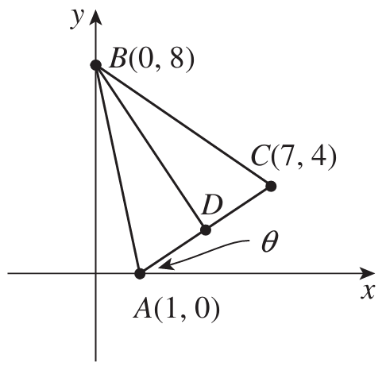
  - Derive the equation of $AC$.
  - Find the coordinates of the midpoint $D$ of $AC$.
  - Show that $AC$ is perpendicular to $BD.$
  - What type of triangle is $ABC$?
  - Find the area of this triangle.
  - Write the coordinates of a point $E$ such that $ABCE$ is a rhombus.

a) $\frac{2}{3}$, $34°$
b) $2x-3y-2=0$
c) $D\left(4,2\right)$
d) $m_{AB}×m_{BD}=\frac{2}{3}×-\frac{3}{2}=-1$
e) isosceles
f) $A=\frac{1}{2}×AC×BD=\frac{1}{2}\left(\sqrt{52}\right)\left(\sqrt{52}\right)=26$
g) $E\left(8,-4\right)$

Ambiguous Case of the Sine Rule

- Investigation Ambiguous triangles
Remember the sine rule:
$$\frac{\sin{A}}{a}=\frac{\sin{B}}{b}$$

Use it to find the unknown angle in the two triangles below.
The first triangle has an acute angle, and the second has an obtuse angle.
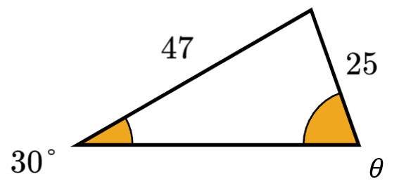 | 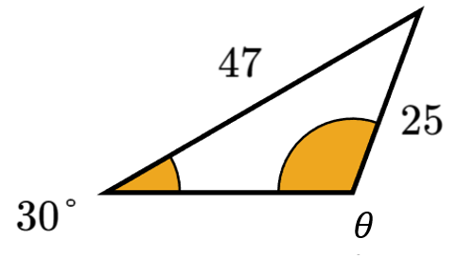
What do you notice about the given lengths and angles of the two triangles?

For some triangles, there are two angle possibilities, we call these triangles ambiguous.
This is due to the identity:
$$\sin{θ}=\sin{(180°-θ)}$$

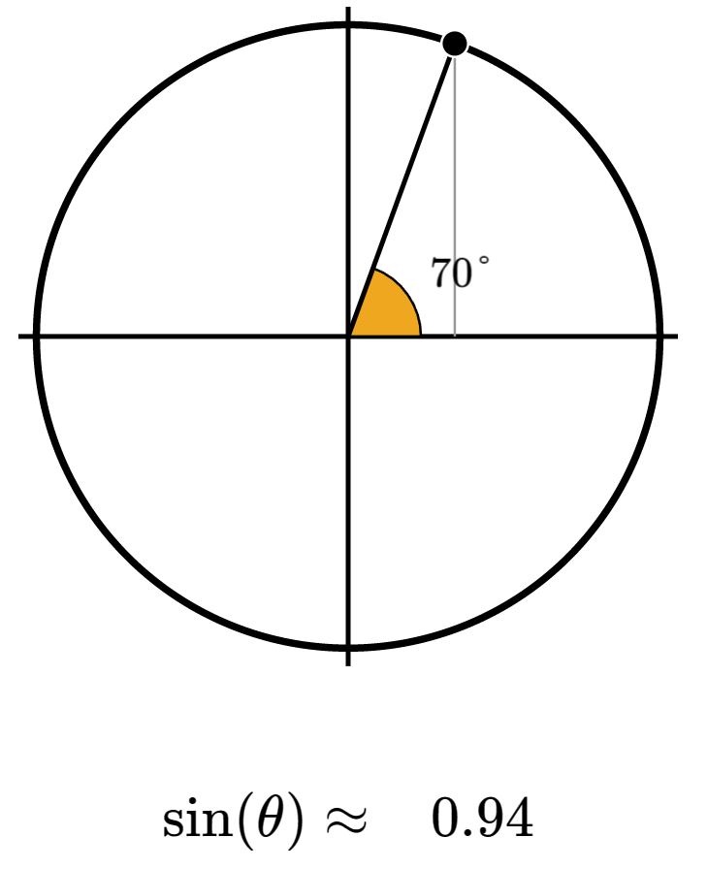 | 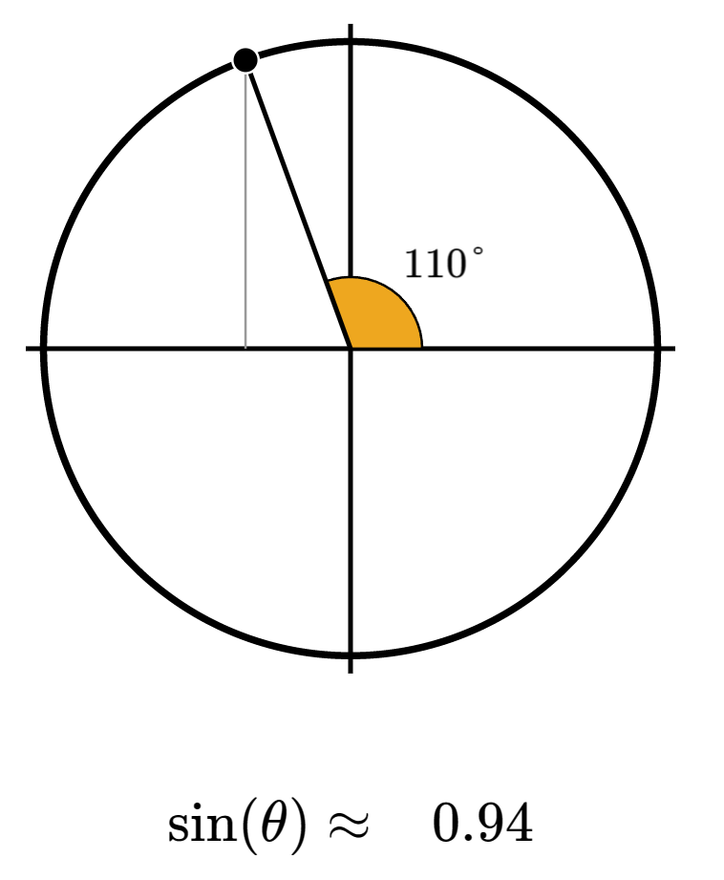

- Investigation Condition for ambiguous triangles
Suppose only side lengths $a$ and $b$ and angle $A$ of a triangle are given.
$b\sin{a}$ is the perpendicular height of the triangle.
- https://www.geogebra.org/m/n2wwggdp
$$a=b\sin{A}$$  Exactly one triangle is possible  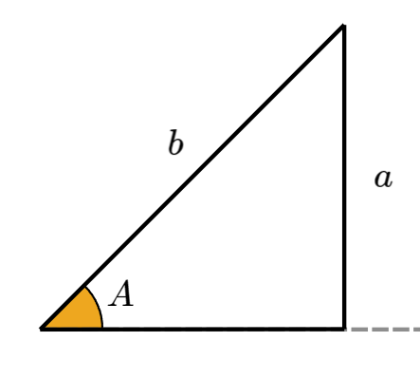 | $$a<b\sin{A}$$  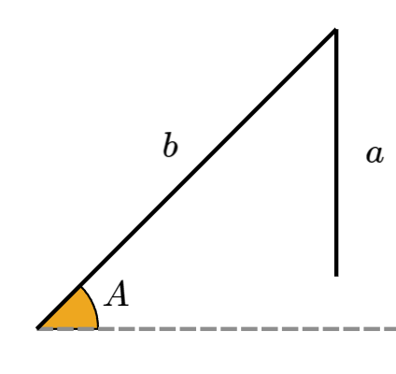  The triangle is not possible.
$$b\sin{A}<a<b$$  Two triangles are possible.  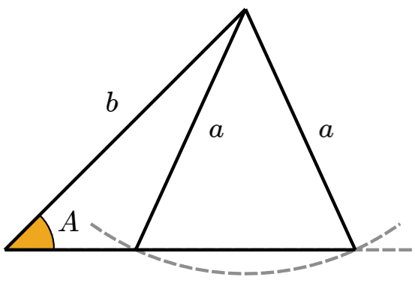  This is the ambiguous case. | $$a>b sin A$$  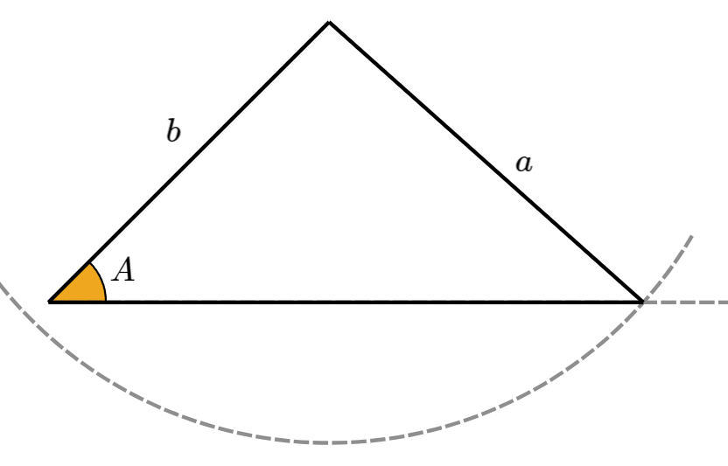  Exactly one triangle is possible.

- Solving Ambiguous Case Sine Rule Questions
If the question doesn’t tell you whether a triangle has an acute or obtuse angle:
            - Use sine rule to find the unknown acute angle $θ.$
            - Find the obtuse angle $θ^{'}=180°-θ$.
            - Add $θ'$ to the given angle. If the sum $>180°$, it is not a valid possibility
(angle sum of triangle cannot exceed 180°).
- Diagrams are never drawn to scale. In an exam, if you see a sine rule question worth 3 marks or more, it is likely the ambiguous case and marks will be awarded for justifying all possible answers.

- Example Calculate angles when the triangle is ambiguous
Find the value(s) of $θ$ to the nearest degree.
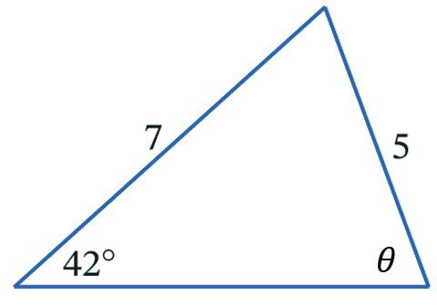
1.
$$\frac{\sin{θ}}{7}=\frac{\sin{42°}}{5} \\ \sin{θ}=\frac{7\sin{42°}}{5}$$ $θ≈70°$
2.
or $≈180°-70°$
$≈110°$
3.
$$110°+42°=142°<180°$$

$∴θ=70° or 110°$

- Guided Practice
- Find the value(s) of $θ$ to nearest degree  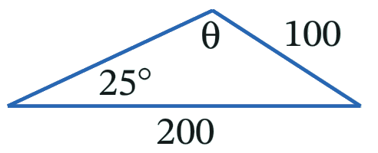  58° or 122° | - Find the value(s) of $θ$ to nearest degree  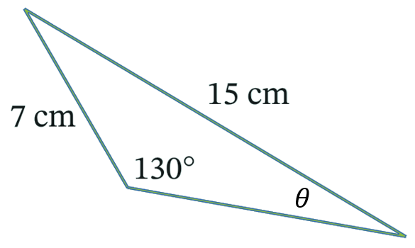  21° only

Foundation
- There are two triangles that have sides 9 cm and 5 cm. The angle opposite the 5cm side is 22°. Find, in each case, the size of angle opposite the 9 cm side, correct to the nearest degree.
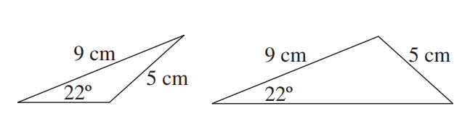

42°, 138°
- Two triangles are shown, with sides 6 cm and 4 cm. the angle opposite the 4cm is 36°.
Find, in each case, the angle opposite the 6cm side, correct to the nearest degree.
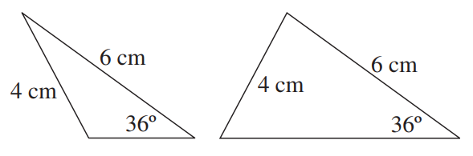

62°, 118°
- A triangle ABC has AB = 3 cm, AC = 2 cm and ∠B = 35°
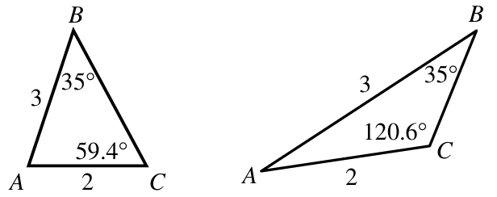
Find the two possible values of $∠C$ correct to 1 d.p and sketch the triangles.

59.4° or 120.6°
- Consider ΔPQR in which $p=7 cm$, $q=15 cm$ and $∠P=25°50'$.
  - Find the two possible sizes of $∠Q$ to the nearest minute then sketch the two triangles.

69°2′ or 110°58′
  - For each possible size of $∠Q$, find side length $r$ in cm.

16.0 cm or 11.0 cm

Development
- A triangle ABC has AB = 6 m, AC = 10 m and ∠B = 120°.
  - Find the two possible values of $∠C$ correct to the nearest degree.

31.3° and 148.7°
  - Explain why there is only one solution for $∠C$.

A triangle can only have one obtuse angle as the angle sum is limited to 180°
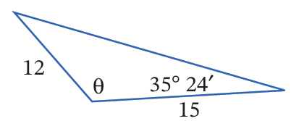
- Find $θ$ in this diagram, correct to the nearest minute.

98° 12ʹ
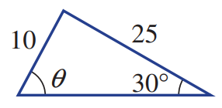
- Try to find the angle $θ$ in this triangle; explain why it is impossible.

$θ=\sin^{-1}\left(\frac{25\sin{30°}}{10}\right)$, which is impossible bas $\frac{25\sin{30°}}{10}>1$. Therefore, such a triangle is impossible to construct.
- Find the area of these two triangles, correct to 2 decimal places.
Triangle 1  129.9 cm² | 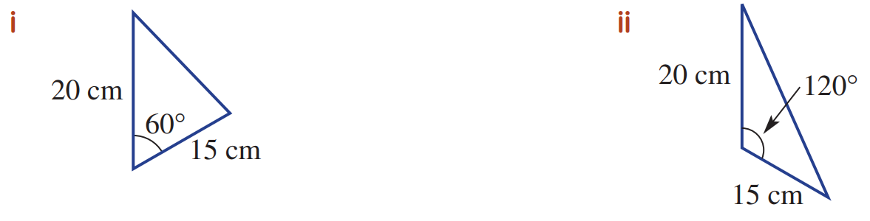  Triangle 2  129.9 cm²

What do you notice? How can you explain this?

They are equal as sin 60° and sin 120° are equal.

Mastery
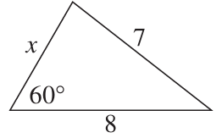
- Use the cosine rule to find the two possible values of $x$ in the diagram.

$$7^{2}=x^{2}+8^{2}-2\left(x\right)\left(8\right)\cos{60°}$$
$$49=x^{2}+64-\frac{16x}{2}$$
$$x^{2}-8x+15=0$$
$$\left(x-3\right)\left(x-5\right)=0$$
$x=$ 3 or 5

- Consider the diagram.
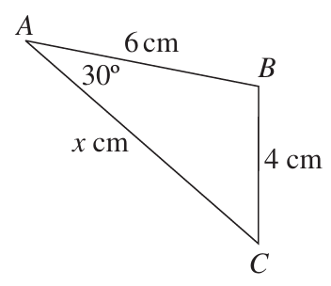
  - Use cosine rule to show $x^{2}-6\sqrt{3} x+20=0$

$$4^{2}=6^{2}+x^{2}-2\left(6\right)\left(x\right)\cos{30°}$$
$$16=36+x^{2}-\frac{12x\sqrt{3}}{2}$$
$0=20+x^{2}-6x\sqrt{3}$ as required
  - Use the quadratic formula to show $AC$ has length
$\left(3\sqrt{3}+\sqrt{7}\right)$ cm or $\left(3\sqrt{3}-\sqrt{7}\right)$ cm.

$$x=\frac{-\left(-6\sqrt{3}\right)±\sqrt{{\left(-6\sqrt{3}\right)}^{2}-4\left(1\right)\left(20\right)}}{2}$$
$$=\frac{6\sqrt{3}±\sqrt{28}}{2}$$
$$=\frac{6\sqrt{3}±2\sqrt{7}}{2}$$
$$=3\sqrt{3}±\sqrt{7}$$
  - Indicate on the diagram the other possible position of point $C$.

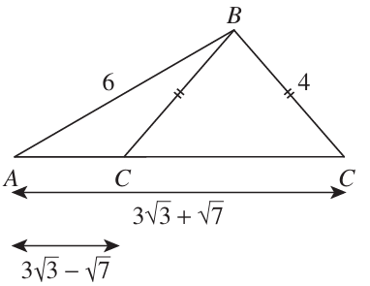

Exam Practice
- 2016 HSC Advanced Band 3
For the angle $θ$, $\sin{θ}=$ $\frac{7}{25}$ and $\cos{θ}=$ $-\frac{24}{25}$
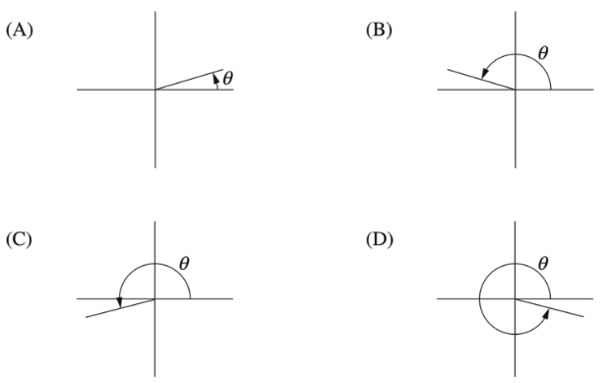
Which diagram best shows the angle $θ$?

Cos is negative, Sin is positive, so Q2
B
- HSC Advanced Sample Question Band 4
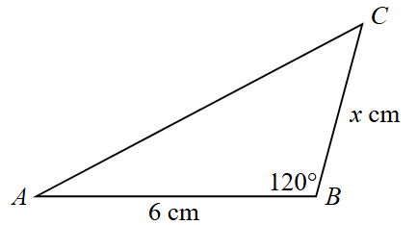
The triangle shown below has an exact area of $\left(12-\sqrt{3}\right)$ cm².
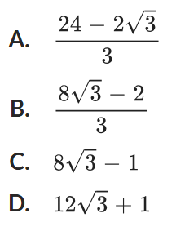
The exact value of $x$ is:

B
- 2013 HSC Band 4
The diagram shows line $l$. What is the slope of $l$?
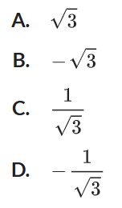
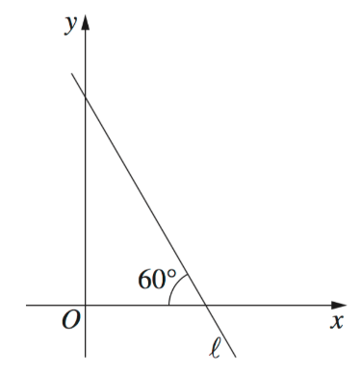

$$m=\tan{120°}$$
$$=-\tan{60°}$$
B
- HSC Sample Question Band 4
Find all possible lengths of the third side of triangle $ABC$ given
$AB=6.2$ cm, $∠ABC=35°$ and $AC=4.1$ cm.
Answer to 1 d.p.

The third length could be either 7.1 cm or 3.0 cm

- 2018 HSC Advanced Band 5
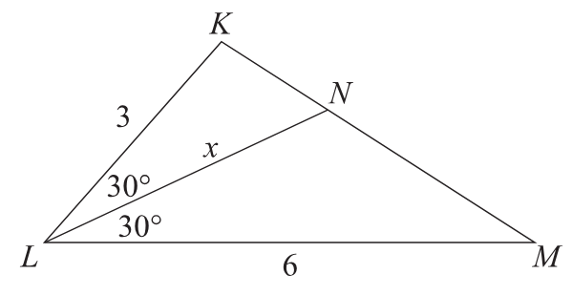
Find the exact value of the area of $ΔKLM$ and hence find the exact value of $x$.
$$Area ΔKLM=\frac{1}{2}\left(3\right)\left(6\right)\left(\sin{60°}\right)$$
$$=\frac{9\sqrt{3}}{2}$$

$$Area ΔKLN+Area ΔNLM=Area ΔKLM$$
$$\frac{3}{4}x+\frac{3}{2}x=\frac{9\sqrt{3}}{2}$$
$$\frac{9x}{4}=\frac{9\sqrt{3}}{2}$$
$$x=2\sqrt{3}$$

- HSC Sample Question Band 5
Find the values of $θ$ in $0°≤θ≤360°$ that satisfy the equation:
$$\left(\tan{θ}-\sqrt{3}\right)\left(\cos^{2}{θ}-1\right)=0$$

Using null factor law
$\tan{θ}=\sqrt{3}$
$$θ=60°, 240°$$
$$\cos^{2}{θ}=1$$
$$\cos{θ}=±1$$
$θ=$ 0, 180, and 360°
$$∴θ=0°,60°,180°,240°,360°$$

